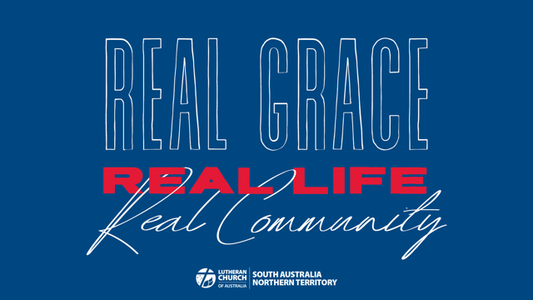

Week 2 Sunday School Activity Suggestions: Real Grace
Resources adapted from ministry-to-children.com

Memory verse: “God loves us deeply. He is full of mercy. So he gave us new life because of what Christ has done. He gave us life even when we were dead in sin. God’s grace has saved you.” (Ephesians 2:4-5 NIRV – shorten if necessary, depending on the ages of the children)

Bible Story Videos
Jesus’ Rescue https://crossroadskidsclub.net/gods-story-jesus-rescue/

Songs
Amazing Grace
Modern version with animation and lyrics https://youtu.be/EX8ktVVpOFk
Traditional hymn with animation and lyrics https://youtu.be/fLBR1aB7Z9I

Group Activities
Amazing Grace
Talk through the lyrics, explaining any old-fashioned words that are unfamiliar (e.g. wretch)
Share the story behind the song: author John Newton owned a slave ship and had wandered far from his faith prior to experiencing an amazing deliverance and writing the beloved hymn. After becoming very sick on one trip across the sea, he gave up being a slave trader, and devoted himself to living for God. He became a priest and wrote many hymns, including Amazing Grace. He later helped to abolish the African slave trade.
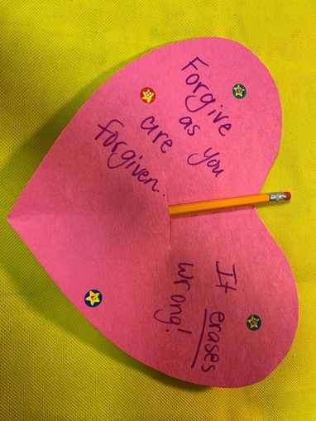
Craft activities
Forgiveness Erases Wrong
To help children understand what God’s grace and forgiveness does for us.

Supplies:
- Glue and/or tape
- Construction paper or cardstock
- Scissors
- Caption or verse (Optional)
- Markers or crayons
- Pencils with erasers

1. Cut the paper into a heart shape.
2. Decorate the heart with verses (use the memory verse if possible), stickers, colours, or other items as desired.
3. Cut a slit in the back of the heart, and insert a pencil with eraser.
4. Give the heart away as a gift, or attach a hanger to use as a reminder that forgiveness “erases” sins!

