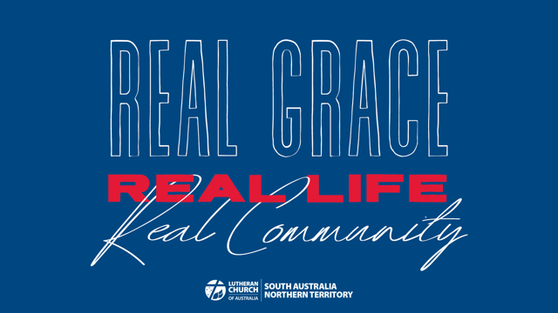

Week 4 Childrens Talk: Real Community

MAIN POINT
Every member of the Church is important. We all need each other, in good times and bad.

SCRIPTURE FOCUS
1 Corinthians 12: 12-27
“If one part suffers, every part suffers with it; if one part is honoured, every part rejoices with it.” (v26)

AID
A picture of a human body, cut up into smaller pieces which can be put together as a puzzle.

ADDRESS
Last week, we read part of Paul’s letter to the Romans, which talked about how we are transformed by believing in Jesus and being joined to Him in baptism. We are transformed from death to life.

This week, we are reading part of Paul’s first letter to the Corinthians (Christians who lived in a place called Corinth) which talks about how when we are transformed by Jesus we are not just transformed as individuals by ourselves, but we are joined together with other believers. This is what the Church is!

Paul calls the Church the body of Christ.

Can you help me put this puzzle together?
Distribute 1 or more pieces of the puzzle to each child.

Every piece of the puzzle, like every part of the body, is important and is needed to make the whole. If we were missing a piece, the puzzle would be incomplete.

In the same way, every person in the Church is important and is needed to make the whole!

Because of this, we are all joined and connected to each other, and we need each other!

We need each other in good times and bad times too.

Can everyone think of a time when someone they know, a family or friend, was sick or injured?
Just look for nods of assent, not sharing stories.

How did you feel?
Now invite sharing.

What about when somebody you love is really happy – maybe it’s their birthday, or they’ve won a sports game, or something else. How did you feel then?

Paul tells us that when one person in the church is hurting, the whole Church should share in the pain and care for them. And when one person in the Church is happy, we should share in their happiness and celebrate with them!

When we do this, we show each other that God is with us in bad times and good times too.

PRAYER
Thank you God, for making each and every one of us part of your Church. Thank you for giving us the gift of each other. Please help us to love and care for each other in good times and bad times, just as you love us in good times and bad times too. In Jesus’ name, Amen.

