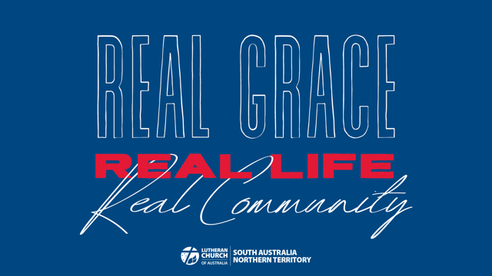

Week 3 Childrens Talk: Real Life

MAIN POINT
God’s love changes the way we live.

SCRIPTURE FOCUS
Romans 6:1-18
“We were therefore buried with him through baptism into death in order that, just as Christ was raised from the dead through the glory of the Father, we too may live a new life.” (v4)

AIDS
Pictures of a caterpillar, a chrysalis, and a butterfly.
Optional: a pair of dress-up fairy/butterfly wings.

ADDRESS
In today’s reading from Paul’s letter to the Romans (Christians who lived in Rome), he talks about how believing in Jesus and being joined to Him in baptism changes us so that we live a new life.

What creatures can you see in these pictures?
Hold up the pictures of the caterpillar, chrysalis, and butterfly

What comes first?
Encourage the children to crawl around like caterpillars.

What comes next?
Encourage the children to curl up like a chrysalis.

What comes last?
Encourage the children to fly like butterflies. If using costume wings, put them on now.

Once a caterpillar has been transformed in the chrysalis and come out as a butterfly, can it go back to being a caterpillar?

No! The caterpillar has changed into something new and wonderful that can do things that it could not do before – like fly! It would be very weird for a butterfly to choose to only crawl around after that!
If using costume wings, demonstrate this.

Christians also go through a special change or transformation. Being loved by God, knowing Jesus, and being joined to Him in baptism, changes how we see life and the way we live.

The big change that Paul talks about in Romans 6 is being set free from sin. Sin is all of the things we think, say, and do, that comes between us and God, or the good things that we don’t think, say, or do.

Do you think Paul is saying that Christians never sin?

No! We all still think about doing things we know are wrong, and often do them, and we all make mistakes. But sin is no longer the boss over us because Jesus has taken care of all our sin – past, present, and future.

Like the butterfly can’t actually go back to being a caterpillar, and it would be weird for it to act like a caterpillar, we have a new life and new identity in Jesus, and Paul encourages us not to act like we are still controlled by sin. Instead, we can live to God and do the things that He says are good for us and lead to life.

PRAYER
Dear God, thank you for setting us free from sin and giving us a new life in Jesus. Please forgive us for when we say and do wrongs thing, or don’t live the good way that Jesus has shown us to. Amen.

