530 Lane Street
Broken Hill NSW 2880
4 September 2018
ian_hutchinson@wycliffe.org.au
Hi family and friends!
Last Thursday, I heard from PNG that my Work Permit Application has been approved by the government, so now I can apply for my visa!
I don’t know how long it will take, but as soon as I receive the visa, I will then arrange my flights for Ukarumpa, in the Eastern Highlands Province, where I will be living at the SIL Centre in my new role as Highlands Audio Project Manager. I’ll let you know my departure date once it is organised.
Many of the 800 languages in PNG already have translated and published New Testaments. The problem is that many village people are non-readers. The answer is that people need to hear a recording of these translations. That’s where I’ll be focused, so that the WORD can be HEARD.
A verse that encouraged me last week was 1 Chronicles 16:24, “Declare his glory among the nations!” To me that was saying, “Share the good news of God’s love with the language groups (of PNG)!”
Thank you for continuing to pray that the Lord will be preparing the people with whom I will be working, so that many lives will be changed, for the glory of God. Many PNG people said to me in the 1980’s, “We are so glad that the missionaries came!”
Another email change! Please change my email address from Bigpond to the above Wycliffe one, so that we can keep in touch in PNG. Thank you!
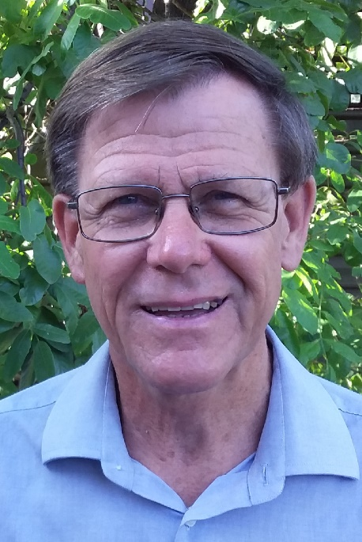
Rejoicing in God's goodness,
Ian Hutchinson

Australian National Centre
70 Graham Road
Kangaroo Ground Vic 3097
P: 03 9712 2777
E: info@wycliffe.org.au
W: wycliffe.org.au

