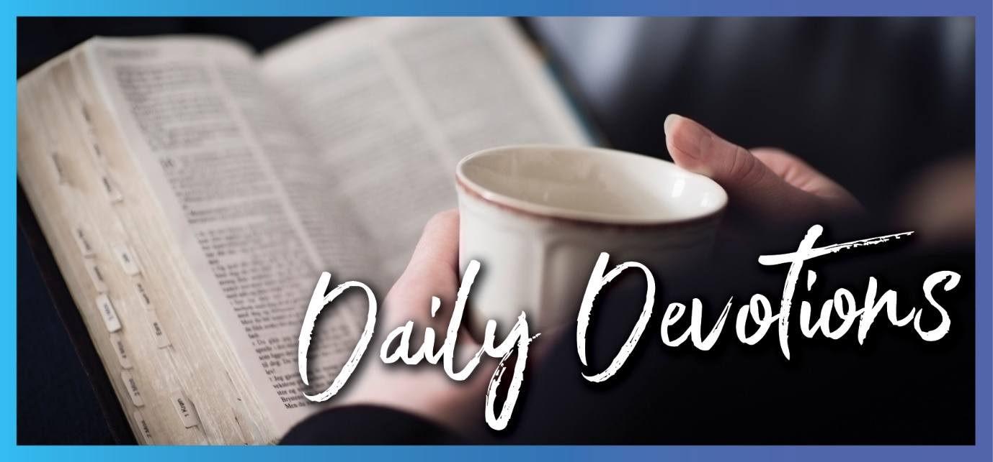

Sunday 3 January to Sunday 10 January
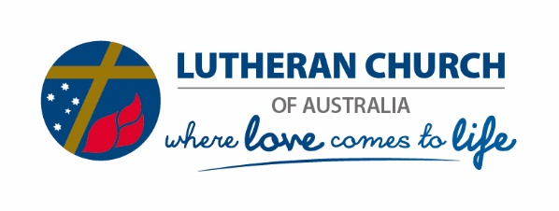
Sunday 3 January 2021

Through him all things were made (part 1)
by Sal Huckel
‘The Word became flesh and made his dwelling among us’ (John 1:14).
During the coming week, we will find a number of themes running through our devotions. Our Lord and Saviour as Creator, things we can see and those we can’t, and the call to walk in light and truth.
Read John 1:1–18
This first chapter of John is one to read slowly. Let it sink in, and see what stands out for you. Some of these words will be familiar to us from the Nicene Creed.
‘Through him all things were made …’
Are you surprised to find that Jesus, the Word, was present at creation? ‘He is, and was, and is to come’ … before he set foot on this earth, coming to us as a vulnerable baby boy.
We also see references here both to those not receiving the word today, as well as those who would not receive him when he was born – including the unwelcome start his family had finding a place for his birth.
‘God from God, Light from Light, true God from True God …’
Or perhaps all the glorious references to light stand out as we read. Jesus is the true light, who brings light to the world. Let us pray that as we journey through Scripture this week, the word comes to life and lights our path.
Lord, we pray that you will illuminate our steps in the coming days and the year ahead. May your true light crowd out the darkness in our hearts and be a beacon to those around us. In Jesus’ name, Amen.

Monday 4 January 2021

Through him all things were made (part 2)
by Sal Huckel
‘For in him all things were created: things in heaven and on earth, visible and invisible’ (Colossians 1:16).
Read Colossians 1:15–20
Today, we read again about Jesus as our creator God. He is supreme over all things.
Everything we can see, and cannot see, has been created through and for Jesus. Yet after creating all things, he was to reconcile himself to all things through his death on the cross. Jesus, who holds all things together, brings us back to himself and redeems us through his death and resurrection.
These things are hard for us to understand, but we have the Holy Spirit to help us and guide us as we read Scripture. We may wish that so many things of God were not invisible! We can, however, see his handiwork when we look around us, see the body of Christ working as his hands and feet, and trust that he remains supreme over all things.
What is our response? Do we worship Jesus as our creator God, or do we sometimes simply only remember to see him as our friend and redeemer? As he redeemed us, he was bringing us back to the purpose of our creation – through and for himself.
Lord, help us to meditate on these important passages of Scripture where you remind us that you are the supreme, all-powerful creator God, who came as a vulnerable infant to redeem your people and bring us back to yourself. May we respond fully, repenting of our earthly failures and responding to the call of the kingdom. In your name, Jesus, we pray, Amen.
Tuesday 5 January 2021

Searchlight
by Sal Huckel
Read 1 John 1:1–7
Don’t we wish we could see God? Here we have a book written by an eyewitness! While we can’t see these things ourselves, we have a blessing with the firsthand testimony in this letter! With such a preamble, we surely must sit up and listen to this message.
God is light. In him, there is no darkness at all! Amen! Hallelujah … but wait, there’s a challenge! Read on: ‘If we claim to have fellowship with him and yet walk in the darkness, we lie and do not live out the truth’.
We read, again and again, this week about the light shining in the darkness. We can’t hide away little parts of our lives we think no-one can see. The kindness we deny someone. The habit we think is secret. The behaviour we think we can justify. It’s time to admit to ourselves, and maybe to others, that the Light is indeed shining in these places, and we need to clean them up. God promises that if we do this, and we walk in the light, we will have fellowship with one another and be purified from our sin. If. We have to choose this.
Lord, I ask you to shine your light in my life. In your grace and mercy, illuminate changes I need to make, paths I need to take, and forgiveness I need to seek. May my confession of sins this week include all the secret darkness of my heart, and may I be fully restored to walk in the light. In Jesus’ name, Amen.

Wednesday 6 January 2021

Pray for an epiphany
by Sal Huckel
‘And having been warned in a dream not to go back to Herod, they returned to their country by another route’ (Matthew 2:12).
Read Matthew 2:1–12
Today is Epiphany! Is your Christmas tree still up?
When I was growing up, our decorations went up from Christmas Eve. They remained while we watched the Magi move around the church until finally arriving at the nativity scene at Epiphany.
Did the events of last year teach us to wait patiently, persist on our journey, and seek the Lord? Or perhaps we don’t want to wait. We want it all over now, and we’ve had enough of the journey.
Wherever this Epiphany finds us, may we find an epiphany of our own. When the Magi asked the enemy for directions, God still had his hand on them as well as the Messiah. The Magi were simply alerted to the trouble through a dream and went back a different way. It’s the last simple line of the account. The peril was of no consequence because God had everything covered.
As we go on with our journeys this year, may we have the faith and confidence that our Lord has his hand on us and will send us on an alternative route when he needs to. May we trust and listen to him – even if we inadvertently sometimes ask the enemy for directions.
Lord, we know you are sovereign over our lives! May we seek you, journey to get closer to you this year, and remain discerning to the changes of plan you would have us make to bring your will to pass in our lives. In Jesus’ name, Amen.
Thursday 7 January 2021

We look for your coming in glory (part 1)
by Sal Huckel
‘Come, descendants of Jacob, let us walk in the light of the Lord’ (Isaiah 2:5).
Read Isaiah 2:1–5
Today we read this prophecy about the last days, and yet again find the theme of walking in the light.
While we await Jesus coming in glory and fixing all things, we are urged to learn the Lord’s ways and walk in the light of the Lord. Henri Nouwen wrote an insightful devotion called ‘Enough light for the next step’.
The theme for 2020 has really been taking only one day at a time. My husband and I made plans for 2020: places we would visit, overseas trips for a conference, family visits overseas, respite breaks from ministry life. What a waste of a day (though the time together was fun)! Booking a day to just enjoy the moment, the weather, and the beach would actually have been more productive than a year of cancelled plans.
Lesson learned. Living in the moment like never before, this year we will all, as Henri Nouwen pointed out, need to learn to ‘enjoy what we can see, and not complain about what remains in the dark’. Plans we make will be cancelled. Steps we didn’t know we could take may suddenly be our very next move. Rather than find this daunting, let’s enjoy the people around us, slow down, plan less, get to know others better, and allow God’s light to shine on our small plans and use us for his great kingdom.
Lord, we look for your coming in glory. In the meantime, guide our baby steps with your true light. We ask you to continue to guide us, whatever the terrain and however fast or slow it turns out to be. May we get busy really loving one another, bringing your love and light to those around us. Amen.
Friday 8 January 2021

We look for your coming in glory (part 2)
by Sal Huckel
‘It will be a unique day—a day known only to the Lord—with no distinction between day and night’ (Zechariah 14:7).
Read Zechariah 14:6–11
My husband went on a trip to Greenland years ago. One of the most interesting things about Greenland was that there was no night-time. He spent time in the ‘midnight sun’ and stayed up until 3.00am with no indication that it was supposed to be dark. This picture comes to mind as we read here about the unique day where there is no distinction between day and night.
While tourism in Greenland seems like amazing fun, the day described in today’s Scriptures bears no resemblance. The entire prophecy makes for difficult reading, but we can trust in our God that ‘Jerusalem will be secure’, and living water will flow out from it. The Lord will be king over the whole earth, and his name will be the only name. That is the Lord we serve; the Lord who loves us and makes us his own. He redeems us through his one and only Son, Jesus the Messiah, who came to us through the dark of night in the lowliest of circumstances.
We wait for his coming – and also think of those who don’t yet know him. Daylight at 3.00am going on for weeks has a flip side. The rest of the year there is very little daylight in the daytime. Let’s not allow those we love, or those we meet, to chance eternity in a place like that.
Lord, we look for your coming in glory. We pray that we will bring your light to those around us so that they may join us with you there. In Jesus’ name, Amen.

Saturday 9 January 2021

The splendour of the king
by Sal Huckel
‘Ascribe to the Lord the glory due his name; worship the Lord in the splendour of his holiness’ (Psalm 29:2).
Read Psalm 29
We finish our week of readings with a psalm of praise to our mighty God! Underline or highlight in your Bible all the adjectives used here to describe our creator God and the effects of his voice!
We get such a picture of power, majesty, might, splendour, and glory – even the mere voice of God has mighty effects on his creation!
Do you ever struggle to find ways, words or reasons to praise God simply for who he is? The Book of Psalms never disappoints! There is so much there, ready to be used as a springboard for our own prayers and praise. If it’s been hard to praise God in the last 12 months because of what we have experienced or see happening around us, perhaps it’s time to reconnect with God as creator, all-powerful Lord and Redeemer. Just as we read all of these rich, powerful words about God’s glory and how we need to ascribe to him glory and splendour, so we also read that this same God gives us strength! This God blesses his people with peace! This God is with us, empowering us, and blessing us this year as we walk in his light day by day! That is our God! Hallelujah!
Lord, this year may we focus on you more than we do on ourselves. We pray for worshipping hearts and noticing eyes. May we look for your hand on your creation, discover your mighty works anew, and worship you in the splendour of your holiness. We praise you and thank you that you give strength and bless your people with peace. In Jesus’ mighty name, Amen.

Sunday 10 January 2021

Care of the new believer
by Tom Brennen
‘I have baptised you with water; but he will baptise you with the Holy Spirit’ (Mark 1:8).
Read Mark 1:4–11
I came to faith as an adult. The first Christian community I encountered was welcoming, understanding, encouraging and supportive. However, not all of them were like that. I have a clear memory of a time before I was baptised. I was part of a travelling music group that was visiting a congregation when one church member told me: ‘Wrong, wrong, you have it wrong! You can't be a Christian and be a part of a church until you repent properly and are baptised.’ Even many years later, I feel the cut of those words.
Baptism is an integral part of being a Christian. In baptism, we receive the gift of faith. We join the community of believers that reaches back into the generations. We join our church mothers and fathers in declaring the glory of God.
Let us never forget that ultimately baptism isn't our doing – God is at work. As John 15:16 reminds us, we do not choose God; he chooses us.
As God's people, may we act and speak carefully and lovingly as we mentor those new to the faith. May we be that welcoming community where people can safely explore faith as guided by the Spirit. Let us never cease praying for the gospel to bring forth great fruit.
Lord, we give thanks for your Spirit who works in all people to bring about faith. May we see the world through your eyes and support those new to the faith. Amen.

