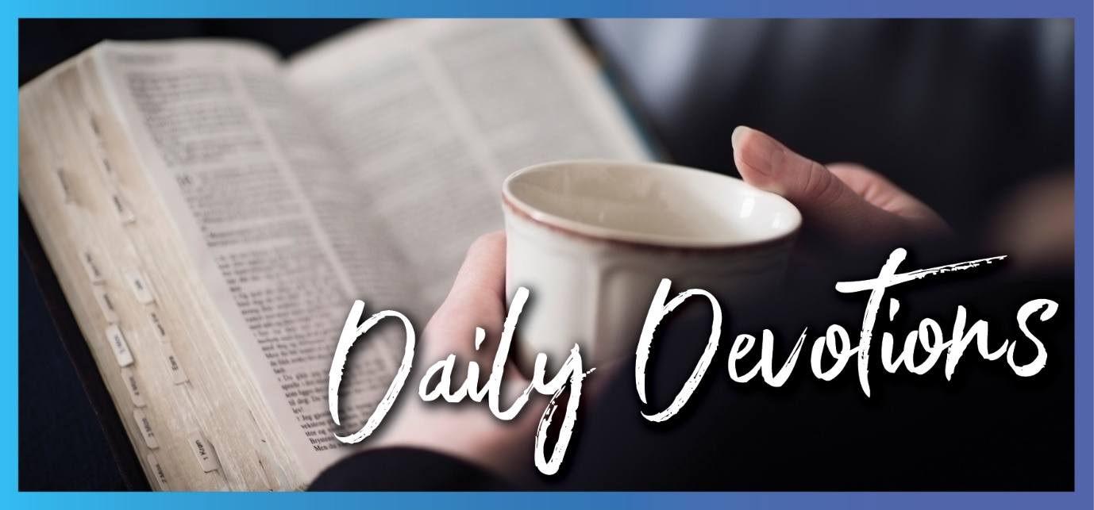

Sunday 27 December to Sunday 3 January
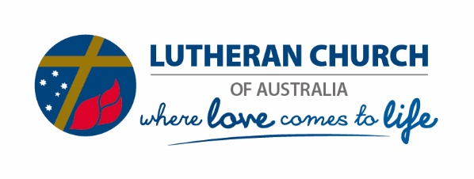
Sunday 27 December 2020

Heartache and hope
by Pastor Mark Lieschke
‘This child is destined to cause the falling and rising of many in Israel, and to be a sign that will be spoken against’ (Luke 2:34b).
Read Luke 2:22–40
It’s amazing how fast the joy of the Christmas can fade and the challenges of everyday life can crowd right back in on us. In a sense, it is back to the real world now.
I suppose it should not surprise us. If we look at the words to some Christmas carols, we find, among the warm images of the Saviour’s birth, the stark reality of his suffering and death. In the carol, Anna’s Song, we sing the words:
Place this child in the shade, hang this child ‘neath a tree;
with his hand on the wood
may this child set us free.
And then in What Child is This, we sing:
Nails, spear shall pierce him through
the cross be borne for me, for you.
Soon after Jesus’ birth, Mary and Joseph travelled to Jerusalem to present him at the temple for the Jewish rites of purification. There Simeon told them of God’s plan for his people. Simeon knew that God was at work in this baby. In this child was God’s personal presence with and for his people. In his baby, God had come to live with us.
But Simeon also said to Mary that Jesus was ‘destined to cause the falling and rising of many in Israel … and a sword will pierce your own soul too’ (Luke 2:34,35).
These words of Simeon, and their fulfilment, are just as much a part of the Christmas story as those about the angels and the shepherds. The Christmas story is not a delightful fairytale; it is the celebration of the birth of Christ – Christ who humbled himself and became obedient unto death, even death on a cross. His birth marks the beginning of a hard and bitter struggle for him, because of our sin.
But he was prepared to do this – for us. And he promises that as we endure suffering and pain, he will be at work in us and will give us what we need to be strong, faithful, and full of joy.
There is heartache on the other side of Christmas. But there is also hope. We have the cross – a symbol of the greatest pain that Jesus endured for us, but also a reminder of his sacrificial love, and the sure hope we have of eternal life.
Loving Lord Jesus, you came as a baby in Bethlehem, but you also came to live, serve, suffer, die, and rise again for us. Help us remember and celebrate your whole life, and the certain hope that we have because of it. In your name, we pray. Amen.

Monday 28 December 2020

God’s saving power in weakness
by Pastor Mark Lieschke
‘She became pregnant and gave birth to a son. When she saw that he was a fine child, she hid him for three months’ (Exodus 2:2).
Read Exodus 2:1–10
Moses was a fine (special) child. His life was endangered by a tyrant (Pharaoh), and so his mother hid him. He was rescued, but many other children were killed. He was chosen to be the deliverer of his people from slavery.
Jesus also was a special (unique) child, whose life was endangered by a tyrant (King Herod). His parents fled to Egypt to hide him, but many other children were killed. He too was chosen to be the deliverer of his people from slavery to sin.
In his commentary on the book of Exodus (Freed to Follow), Dr Dean Zweck makes the comment:
Exodus 2 and Matthew 2 both witness how God’s saving power is made perfect in weakness (cf 2 Cor 12:9). The power of tyrants is impressive, and that power is unleashed cruelly against the fragile beginnings of God’s saving plan. In both stories rescue from an impossible situation is effected through the most unlikely people: an Egyptian princess and Persian astrologers. And finally, in both stories, the coming deliverance is accompanied by the suffering of people.
God’s plan for the rescue of his people runs right through the Scriptures. He has always had the best interests of his people in mind. He has worked in and through many people over many years. But as Satan has had his influence, suffering has always accompanied this plan. And even today, we face difficult and trying circumstances in our lives as the evil one creates chaos.
God’s grace, though, is not suppressed. It continues. In the middle of tragedy and loss there is always hope – sometimes coming through most unlikely people or circumstances.
God’s ultimate plan is for us to know his love and experience his grace and share this with others. That plan came to its climax and fulfilment with the birth, life, death, resurrection, and ascension of Jesus. It is what we have recently celebrated at Christmas and will again at Easter – and every day in between.
Praise God for his plan, completed in Christ, but ongoing through us even in the middle of weakness and suffering.
Gracious Lord Jesus, reassure us that in the middle of difficult things beyond our understanding, you are present with us. Thank you for your power working within us in all circumstances, so that we can reflect your grace. In your precious name, we pray, Amen.
Tuesday 29 December 2020

Good looking
by Pastor Mark Lieschke
‘The Lord will surely comfort Zion and will look with compassion on all her ruins’ (Isaiah 51:3).
Read Isaiah 51:1–6
Look to the rock; look to the quarry; look to Abraham; look to Sarah; lift your eyes to the heavens; look at the earth beneath. These are all words of encouragement from the prophet Isaiah to people who were looking ahead to God’s promised deliverance. They were in exile but knew of God’s promise to take them home.
Those words of encouragement are there for us also as we look to find the strength to endure and to keep moving forward. Look back to see where you have come from and who made you; look around to see those whom God is blessing you though; look down to the firm foundation that has been given to you in Christ; look up and recognise the one who has created the heavens and the earth; look forward to the promises that have made to you.
But in the middle of the words from Isaiah, we read: ‘The Lord will surely comfort Zion and will look with compassion on all her ruins’ (Isaiah 51:3). The Lord will look! He does and will look upon us.
Our looking back, around, down, up, etc is all fine. We can and need to do that. But the most significant looking is that which our Lord does. He looks at us. He has us in his sights. He searches for us. He fixes his attention on us. He gazes upon us. With compassion.
We are not people who are sought out for punishment (for what we deserve). We are not people who need to feel that God is watching and waiting for us to put a foot wrong and then come down on us like a ton of bricks. We are his special people on whom he has compassion.
And as we are joined to the Father in and through Jesus Christ, we can be confident that his promises to us, his salvation for us, and his righteousness with which we are clothed will never fail.
He looks out for us, and so we can be filled with joy, gladness, thanksgiving, and the sound of singing.
Thank you, Lord, that you continue to look out for us and see us as precious in your eyes. Fill us with joy and gladness in your presence and help us to reflect that in our living and serving as your people. Amen.
Wednesday 30 December 2020

New beginnings
by Pastor Mark Lieschke
‘For I am God, and not man – the Holy One among you. I will not come in wrath’ (Hosea 11:9).
Read Hosea 11:1–4,8,9
Jesus told the story of a wayward son who had arrogantly left his father's house and wandered his own way. Finally, he realised how far he had gone and decided to return as a slave. Yet, his father stood with open arms ready to accept him again as a son. He gave his son a new beginning.
It was not a new story. It had been played out nearly 800 years earlier in the book of Hosea. The message of Hosea and the parable of the Waiting Father (Luke 15:11–32) is that God loves humanity so much that he has committed himself to us totally and beyond all expectations.
‘For God so loved the world that he gave his only son, so that everyone who believes in him may not perish but may have eternal life’ (John 3:16). That is the extent of his love.
In God, the Father for his Old Testament people, and for Jesus Christ with us, there are new beginnings. While we deserve nothing from him, and ought to be punished by him, our Lord has and continues to come to us in love and grace. He refuses to let his people go, even though we abandoned him.
Just like Hosea went to extreme lengths to call his adulterous wife back to him, so God in Christ has called, and continues to call, his disobedient and rebellious children back to him.
This is a message of love that will go to any lengths to bring reconciliation and restoration – so that we can have a new beginning every day.
It is also a message of hope to those who have given up because of what they have done or what has happened to them. This is a message that there are no such things as hopeless cases with God. All are special to him, and he sees all as being precious to him.
The good news for Israel was that they were given many new beginnings. The good news for us is the same. That goes beyond the boundaries of our human thinking. But then God is not a human being; he is the Holy One among us.
Loving Lord Jesus Christ, we come humbly into your presence – not deserving anything from you – but receiving all we need to have peace, joy and hope. Give us a new start every day, free from any fear of your judgement, and confident in your mercy. In your name, we pray. Amen.
Thursday 31 December 2020

God’s patience
by Pastor Mark Lieschke
‘Leave it alone for one more year, and I’ll dig around it and fertilise it. If it bears fruit next year, fine! If not, then cut it down’ (Luke 13:8,9).
Read Luke 13:6–9
Jesus does not just give us one crack at coming to faith. He patiently continues to work within us, his field, bringing the fruits of his death and resurrection to us over and over and over again – the forgiveness of sins, eternal life, new life in the flesh, the ability to bear fruit for him.
As we think about our individual weaknesses and mistakes, we may wonder at times if God’s patience with us might come to an end and our time of grace be over. We might feel as if we have been expected to produce more fruit than what we have and wonder whether should have been more faithful than what we have been.
Doubts and questions can arise in our minds about our being true believers and authentic disciples.
Focusing on ourselves can bring serious fears. But turning to see who Jesus is and what he has done, and continues to do, gives us hope and security. He never stops working in us and on us. His word is always available to us. We have not had his baptismal promises stripped from us. Communion with him at his holy supper is there for us regularly.
We have constant access to these gifts of God, which he says we need. They turn us from worthless, fruitless plants into trees laden with abundant produce.
When the gardener digs and fertilises, and when the gardener takes time and is patient, good things can happen in his garden. When Christ provides for his people, when he forgives, nurtures, encourages, and feeds his children, they are given every opportunity to grow and bear fruit.
His patient, persistent cultivation gives us hope for the future. He is committed to serving us so that we, in turn, can produce fruit for him.
Lord Jesus, thank you for your patience with us. Come to us each day with the reminder that we are precious to you. As we look back and see our mistakes and weaknesses, cover us with your forgiveness and give us a new start every day. In your name, we pray. Amen.

Friday 1 January 2021

God’s surprise gift
by Pastor Mark Lieschke
‘On the eighth day, when it was time to circumcise him, he was named Jesus’ (Luke 2:21).
Read Luke 2:15–21
For centuries, Hebrew parents had brought their children to be circumcised and named on the eighth day of life. So, Joseph and Mary brought Jesus to the temple as the law required.
The name Jesus means ‘Saviour’ or ‘the Lord saves’! The angel of the Lord had announced what his name would be because he would ‘save his people from their sins’. God’s people were expecting someone to come with impressive power; instead, God came in weakness, in a baby, laid in a manger. What a surprise!
Surprises can come when we least expect them. When things look their worst, when we think that life has dealt us a bad hand, God can come through with a big surprise. In fact, the whole nature of the gospel is a big surprise. We normally expect that nothing is free and everything must be earned and worked for. And that is true of all, except this: God’s free gift of eternal life in Jesus.
Think about all the surprises in the Bible. Noah’s neighbours realised that it was beginning to rain. When up in years, Sarah told her husband Abraham that she was going to have a baby. Moses saw a burning bush and the voice of God coming out of it. The walls of Jericho came tumbling down. The angel came to Mary, and then to Joseph, to tell them they would have a baby, conceived by the Holy Spirit. Jesus grew up to be nailed to a cross and the one in whom his disciples had believed lay stone-cold dead in a grave.
But soon followed that great and grand surprise when Mary saw him again in the resurrection. He was alive!
And there is the surprise of our guilty lives when we hear the Lord Jesus tell us again and again, ‘Your sins are forgiven. You did not earn it, you cannot earn it, but I give it to you. You are free. Go in peace!’
There will be one more surprise that comes to us who confess Jesus to be our Saviour and live under his blessing. This will be a big one. He’s coming back!
That will be the greatest surprise of all. And for those of us who know Jesus, it will be the greatest occasion to celebrate.
Lord Jesus, thank you that you have come to us and for us. We don’t deserve your grace; we deserve the exact opposite. But you have come, and you still come to us daily with your gifts and promises. Enable us to live in this grace every day of this new year. In your name, we pray. Amen.
Saturday 2 January 2021

Not a remote God
by Pastor Mark Lieschke
‘The Lord builds up Jerusalem; he gathers the exiles of Israel. He heals the broken-hearted and binds up their wounds’ (Psalm 147:2,3).
Read Psalm 147
Psalm 147 describes the majesty of the Creator God – the God who knows the stars by name, the God who controls the weather, the God whose powerful word makes water flow and energises the breezes. It describes the majesty of the Creator God who forms the clouds and gives rain to the grass, providing food for the cattle and the birds.
Psalm 147 also makes the important point that this Creator God is not remote and impersonal. He brings healing and restoration to the broken-hearted – to those who fear him and put their trust in his unfailing love.
Psalm 147 tells us that this God understands human beings far better than we understand ourselves! In his word, he tells us what we need. More than that, he offers us what we need. He provides us with spiritual strength.
Psalm 147 shows us that those things human beings see as powerful and important are sure to let us down. It reminds us that God is both our Creator and our Redeemer. Our God is a God who cares. Our God sends rain in due season, he causes the grass to grow and he gives food to birds and beasts alike. He blesses his people.
As Jesus said in the Sermon on the Mount, ‘Look at the birds of the air, they do not sow or reap or store away into barns, and yet your heavenly Father feeds them. Are you not much more valuable than they?’ (Matthew 6:26).
The power who made the stars, the power who controls the snow and the frost, the wind and the waves, is the one who builds us up in Christ. He gathers us together into his church. He heals the broken-hearted and binds up their wounds.
Our God – through his Son, Jesus Christ – has done for us what we could never have done for ourselves. That gives us good reason to thank and praise him, and to reflect that in our lives.
Dear Heavenly Father, remind us often of your incredible power – power evident in the cosmos, in our world and in our lives. Bless us, heal us and forgive us through your Son, Jesus Christ our Lord. Strengthen us so that we may face whatever comes our way. When this life comes to an end, gather us into your everlasting kingdom. In Jesus’ name, we pray. Amen.

Sunday 3 January 2021

Through him all things were made (part 1)
by Sal Huckel
‘The Word became flesh and made his dwelling among us’ (John 1:14).
During the coming week, we will find a number of themes running through our devotions. Our Lord and Saviour as Creator, things we can see and those we can’t, and the call to walk in light and truth.
Read John 1:1–18
This first chapter of John is one to read slowly. Let it sink in, and see what stands out for you. Some of these words will be familiar to us from the Nicene Creed.
‘Through him all things were made …’
Are you surprised to find that Jesus, the Word, was present at creation? ‘He is, and was, and is to come’ … before he set foot on this earth, coming to us as a vulnerable baby boy.
We also see references here both to those not receiving the word today, as well as those who would not receive him when he was born – including the unwelcome start his family had finding a place for his birth.
‘God from God, Light from Light, true God from True God …’
Or perhaps all the glorious references to light stand out as we read. Jesus is the true light, who brings light to the world. Let us pray that as we journey through Scripture this week, the word comes to life and lights our path.
Lord, we pray that you will illuminate our steps in the coming days and the year ahead. May your true light crowd out the darkness in our hearts and be a beacon to those around us. In Jesus’ name, Amen.

