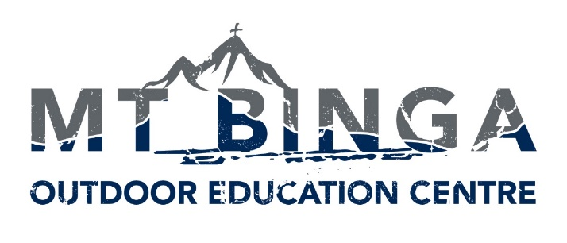

Mt Binga Outdoor Education Centre is owned and operated by Immanuel Lutheran College. It specialises in month long residential programs for groups in Years 9 and 10. Programs include outdoor adventure styles activities along with other activities that would normally be involved in a farm and residential environment.

The main goal of the outdoor education program is that students experience community living and growing in their own self-sufficiency and confidence in who they are.

Mt Binga’s Values are that all participants will:-

- Show Initiative
- Persevere
- Collaborate
- Challenge Themselves
- Take Responsibility
- Respect Our Environment
- Have Gratitude
- Engage in Community

Evening Program Supervisor
1.0 FTE
Contract with the option of Permanency
Commencing January 2022

Key requirements:
- Applicants must be able to live and work within the Christian ethos of the Centre
- Background in working with youth in a pastoral care role
- Experience in residential care would be highly regarded
- Food preparation experience and/or qualifications
- Ability to recognise potential risks and emergency situations in a rural and residential setting, and coordinate responses where required
- Hold current Senior First Aid certificate
- Experience in or willingness to learn basic animal care (horses, dairy cows, chickens)

About Working at Mt Binga:
The Centre is a former logging camp and has been an Outdoor Education Centre since 1982.
Mt Binga is a small community of staff that live on site in modern accommodation. The closest country town is Blackbutt (24kms), with the closest city being Toowoomba (76km). You can expect to live a farm lifestyle, with some modern conveniences.

Further information including the position description is available here.
Electronic applications including the names of three current referees, and addressing the Selection Criteria as outlined in the Job and Person Specification to:

The Principal -Immanuel Lutheran College
Email: manager@mtbinga.com.au
Website: www.immanuel.qld.edu.au/our-college/employment
www.mtbinga.com.au/about/employment

Applications close 9am, Friday, 17 December 2021
Where: Mt Binga Outdoor Education Centre, near Blackbutt, Southern Queensland

