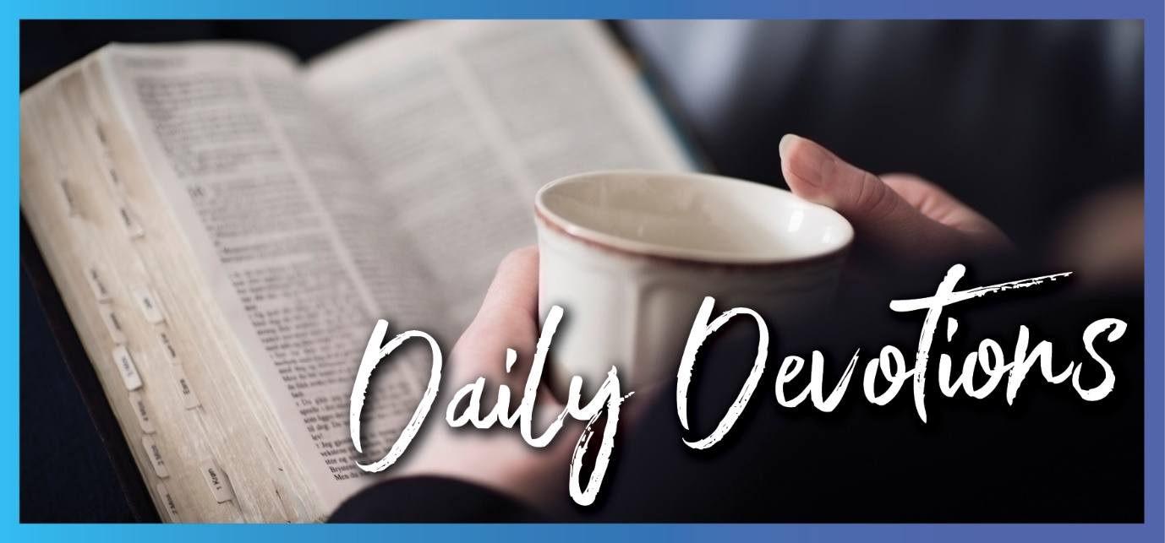

Sunday 23 August to Sunday 30 August
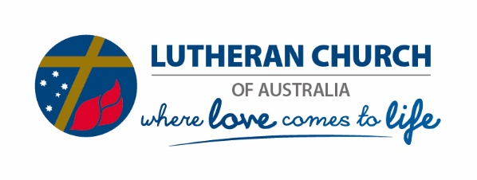
Sunday 23 August 2020

Seeing Jesus
by Ruth Olsen

‘Who do you say that I am?’ (Matthew 16:15)
Read Matthew 16:13–20
Jesus and his disciples had been travelling in the country regions. They were in a remote area near the Sea of Galilee (Matthew 15). There the disciples had seen the seven loaves and a few small fish that Jesus had blessed and miraculously multiply as the disciples distributed them to the crowd.
Pharisees and Sadducees came to Jesus, asking for ‘a sign from heaven’. Jesus then warned the disciples to be discerning of the ‘yeast’ (teaching) of the Pharisees and Sadducees (Matthew 16:1–12), and they came to the region of Caesarea Philippi, north of the Sea of Galilee – observing, learning, struggling to understand, asking questions along the way.
Here Jesus asked the disciples, ‘Who do people say the Son of Man is?’ They gave various replies. ‘But what about you? Who do you say I am?’ And Jesus said Peter’s response was revealed by his Father in heaven, not from people.
Who do you say that Jesus is? Have you been in conversation about your walk with Jesus and heard yourself say something new and significant about that? You recognise you didn’t think that up; it was given and revealed to you as you were speaking it. Like what happened to Peter!
Like those first disciples, there’s so much for us to learn to walk in, exercising faith in using the keys of the kingdom of heaven to change things here on earth as we bind and loose, in the authority Jesus gives us, for God’s kingdom purposes. As with Peter, though, it’s not in our own strength but by the Holy Spirit teaching and training us (Zechariah 4:6; John 14:25–27; 16:12–15).
Holy Spirit, open the eyes of our hearts … to see Jesus more clearly!

Monday 24 August 2020

A choice
by Ruth Olsen
Choose this day whom you will serve (Joshua 24:15a).
Read Joshua 24:1,2a,14–18
After Joshua had been the leader of the people of Israel in the Promised Land for a long time, he summoned all the leaders and gave them wisdom for the years to come: be very strong. Be careful to keep your focus on the Lord. Be faithful to him, for he is faithful to you. But if you turn away to other gods, you are asking for trouble (Joshua 23). Their mission was to be the people of God’s kingdom in the world.
Next, in our reading for today, Joshua summoned all the people together, with all their leaders, and urged them to be careful to fear the Lord and serve him faithfully; to discard and not turn back to any other gods worshipped by their forefathers. But they got to choose; the Lord does not force people to worship him. As for Joshua and his household, they served the Lord. So the people recounted how the Lord protected them and provided for them; they would not forsake the Lord to serve other gods.
None of us can remain faithful to the Lord in our own strength! It’s beyond our fallen nature. Our spiritual enemy schemes to distract and divert us in whichever way will work. Knowing our opposition, Jesus calls us to remain or abide in him, in close relationship with him, for apart from him, we can do nothing (John 15:4–8). And Jesus has sent another Counsellor, the Spirit of truth, to be with us forever, our Teacher from within (John 14:15–21). The Lord does not leave us to our own devices, yet, we need to choose to learn to rely on Jesus and the Helper he has given us.
Lord Jesus, draw me closer to you. Holy Spirit, help me grow in being faithful to the Lord. Amen.
Tuesday 25 August 2020

It’s not about me
by Ruth Olsen
He must become greater; I must become less (John 3:30).
Read John 3:25–36
The setting for today’s reading is in the Judean countryside, not far from where John the Baptist was baptising people coming to him. Some of John’s disciples were concerned that there was some competition happening by ‘the one’ that John had testified about (in John 1:29–34), although it was not Jesus doing the baptising, his disciples were (John 4:1–2).
Can you identify with John’s disciples? And are you surprised by John’s response, so different from what you might have expected? ‘It’s not about me’, John declares. John knows and lets it be known that he is not the Christ or Messiah. Instead, his assignment is to prepare the way for the Messiah, like the friend who helps the bridegroom. It has been revealed to John who Jesus really is, and John is content, and full of joy at what is unfolding. John realises he has nearly completed his job. It’s now time for Jesus to be the focus and for John to ‘become less’.
What’s it like for you when acknowledgement goes to someone else, and when it seems like you are left in the background, forgotten and overlooked? That can be painful until you recognise that God is working a bigger picture. Listening for the Lord’s voice helps us walk in his peace and acknowledge the One who gives real peace. Coming to realise ‘it’s not about me’ can be a major breakthrough!
John recognised the presence of God in Jesus, yet, although God sent Jesus, so many do not accept his testimony. We are responsible for our choices. But whoever believes in the Son has eternal life – now.
Lord, I believe. Help me overcome my unbelief! Amen.

Wednesday 26 August 2020

Holy boldness
by Ruth Olsen
We must obey God rather than any human authority (Acts 5:29).
Read Acts 5:27–32
Oh, what jealousy can do when we give way to it! See how the angel of the Lord intervened when the high priest and his associates had the apostles arrested and put in the public jail (Acts 5:17–26). Jealousy can blind us and harden our hearts to what the Lord is doing!
Put yourself into the apostles’ shoes. Led out of jail and given instructions on what to do the next day, they followed through. Then they were taken from the temple courts where they were teaching, but not by force, and were escorted back to the waiting Sanhedrin gathering. Imagine the tension. ‘We gave you strict orders … Yet you have [done the opposite]’ (verse 28). To which Peter and the other apostles replied, ‘We must obey God rather than men! The God of our fathers …’
If you can still imagine being in the apostles' shoes, what might you be thinking? What is it that makes the difference, giving the apostles courage and ‘holy’ boldness? By ‘holy’ boldness, I mean boldness that is submitted to the Lord, empowered by him and not the boldness of human strength.
The apostles declared they were witnesses to what they testified, ‘and so is the Holy Spirit, whom God has given to those who obey him’ (verse 32). That’s the same Holy Spirit given to any follower of Jesus! He is the power of God within us! Of ourselves, we are pushovers; but he is not! Jesus relied on him (Luke 4:1–21). Let’s learn of Jesus to do likewise.
Lord Jesus, please show me more of what it means that your Holy Spirit dwells in me. Amen.
Thursday 27 August 2020

Such as I am
by Ruth Olsen
I pray to God that not only you but also all who are listening to me today might become such as I am (Acts 26:29).
Read Acts 26:19–29
During his last visit to Jerusalem, the authorities had arrested Paul of Tarsus. When the Roman commander brought him before the assembled chief priests and Sanhedrin, Paul appealed to his Pharisee heritage, declaring that he was on trial because of his hope in the resurrection of the dead. The Sadducees instead believed there was no resurrection, neither angels nor spirits. The subsequent uproar became so violent that the commander had Paul rescued by force. Such was the behaviour of the religious leaders! The following night, the Lord told Paul he must testify in Rome (Acts 23:6–11).
Foiling a plot to have him killed, Paul was taken to the governor Felix at Caesarea on the coast. Over the next few years, Paul appeared before Felix, and then later before Festus, the next governor, who invited King Agrippa to provide an assessment of Paul’s case. Agrippa was well acquainted with all the Jewish customs and controversies (Acts 26:3). Paul explained he had been a strict Pharisee, vehemently opposing the name of Jesus of Nazareth until he dramatically encountered Jesus, who commissioned him to tell his own people and the Gentiles the message of forgiveness of sins and new life from God now available through Jesus (verses 4–18).
It’s because of his hope of the resurrection for any believer – that the Christ (Messiah) would suffer and be the first to rise from the dead – that Paul was calling people to repent and turn to God in words and deeds. That’s why he was seized in the temple courts. Paul now boldly confronted Agrippa, saying that the same message applied to him too!
Lord Jesus, I am not Paul, but enable me to step into your call on my life and walk with you. Amen.
Friday 28 August 2020

Living stones
by Ruth Olsen
Like living stones, let yourselves be built into a spiritual house, to be a holy priesthood (1 Peter 2:5).
Read 1 Peter 2:4–10
Peter begins this letter with praise to God for the living hope we have through the resurrection of Jesus Christ from the dead, and with it, an inheritance that can never perish, spoil or fade. That doesn’t mean we won’t suffer grief in all kinds of trials, including during our current pandemic, but rather, we are purified and refined in the process.
Beginning a series of imperatives with the call to ‘be holy’ (1 Peter 1:13), through the next chapters, Peter urges his readers to be intentional in their Christian walk. Like newborn babies desire food, we must eagerly desire spiritual food. As we grow, of course, we need to learn to take in solid food too (see Hebrews 5:12–14).
But there’s purpose in us growing! For our identity comes from Christ Jesus, the living and life-giving Stone; ‘living’ in that it is personal. Followers of Jesus are also like living stones, deriving life from Christ, the living capstone or cornerstone; made alive by the Holy Spirit, being built into a spiritual house and a royal priesthood.
For ‘stones’ to fit and work together well, refining, chipping away, and polishing is needed. In the natural realm, different kinds of stone are used for different purposes. The Lord knows exactly what kind of ‘stone’ he has created and called us to be, and our purpose in where we can serve others best. As ‘living stones’, God is also building us as royal priests, people indwelt by the Spirit of God, belonging to God. A holy nation who declare his praises!
Lord God, we declare that you are good, for you called us out of darkness into your wonderful light. Bless others through us, wherever we are. Amen.

Saturday 29 August 2020

Search my heart
by Ruth Olsen
Prove me, O Lord, and try me; test my heart and mind (Psalm 26:2).
Read Psalm 26:1–8
Yesterday we saw that, in his first letter, Peter urged his readers to be intentional in their Christian walk. If possible, perhaps on the free Bible Hub app, try to read today’s psalm in several translations. Hearing or reading a different translation can awaken us to truths that we can gloss over when using a familiar translation.
In this psalm, David is so forthright and open in his relationship and communication with the Lord. He has experienced God’s help and has learned to trust him and rely deeply on him. Many other psalms express that as well.
Because he has experienced God’s faithfulness, David knows it is safe for him to say, ‘Put me on trial, Lord, and cross-examine me. Test my motives and my heart’ (verse 2, NLT). Wow, that’s very intentional!
We see this also in Psalm 139, with David inviting God to ‘search his heart’ (verses 23,24). That requires both courage and willingness to trust the Lord. I recall, back along the track, being strongly challenged by this. Is it actually safe to invite the Lord to search my heart? Once one realises that he already knows what’s there, that it’s actually me hiding from the truth of what’s in me because he is my Refuge, it is indeed safe to invite him to search my heart. I discovered it’s absolutely the safest place to be, for his love holds me as his Spirit shows me anything that needs attention, and I can ask him to change my heart and renew my mind. Have you discovered that too?
Lord, you are compassionate and gracious, slow to anger, abounding in love and faithfulness. Fill me afresh with your love, and show me whatever you want to show me? Amen.
Sunday 30 August 2020

Out of control!
by Ruth Olsen
For those who want to save their life will lose it, and those who lose their life for my sake will find it (Matthew 16:25).
Read Matthew 16:21–28
Jesus explains the path ahead of him to his disciples (see verse 21). But they cannot comprehend. To human understanding, it was inconceivable that such things could happen to the Son of God from the hands of the elders, chief priests and teachers of the law.
‘Never, Lord! This shall never happen to you!’ exclaimed Peter.
‘Get behind me, Satan! You are a stumbling block to me …’ was part of Jesus’ reply to Peter.
Does that set you back in your seat? Our human perspective is so small, so limited. Have you ever recognised how something you have said just may have been you speaking Satan’s words aimed to hinder someone or yourself from taking steps of faith? For that is part of Satan’s schemes (see 2 Corinthians 2:11; Ephesians 6:11), for us to be doing his dirty work for him. We are blind to it until we ask the Holy Spirit to enable us to recognise what we are doing; then repent and intentionally speak encouragement.
Likewise, it’s instinctive for us to want to save our lives. To let go of my plans and dreams, my control; surely that’s counterintuitive? Yet it is as we yield our lives to Jesus, making ourselves available to him, that we begin to discover the enriching fullness and adventure he leads us into.
Holy Spirit, I need you, your training and equipping – desperately! Of myself, I am blind to what is of you, Jesus and Abba Father, and what isn’t. Renew my vision. Cause me to grow in using discernment that you give, and the courage to speak the things of God rather than the things of human thinking, for Jesus’ sake. Amen.

