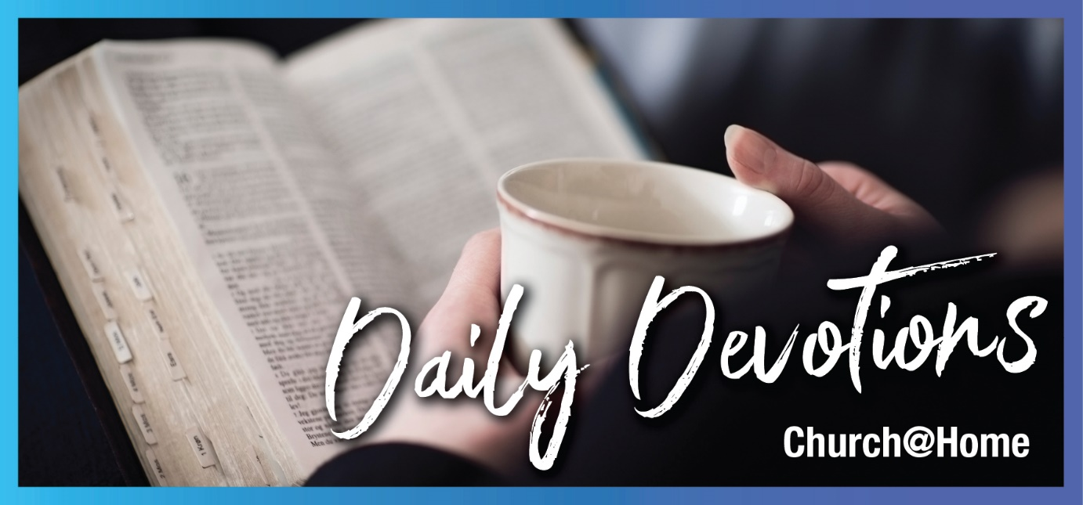

Sunday 24 September 2023 to
Sunday 1 October 2023
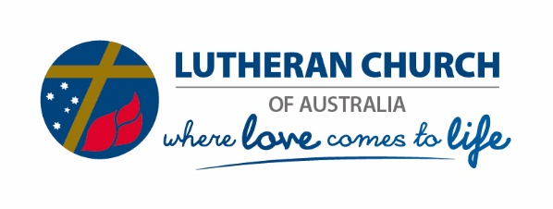
Sunday 24 September 2023
The age of entitlement
by Sal Huckel
‘Don’t I have the right to do what I want with my own money? Or are you envious because I am generous?’ So the last will be first, and the first will be last (Matthew 20:15,16).
Read Matthew 20:1–16
Sometimes, I wonder whether we live in a culture that has redefined entitlement. Upon reading this parable, though, I note that Jesus tells a story that presses all the right buttons and shows that he understood humans were dealing with the same issues while he was walking on this earth.
There’s the entitlement of those standing around waiting to be given work. There’s the entitlement of those who later find that workers have done less than them but are paid the same. A figure they agreed to as a fair wage from the outset. The order in which they were paid. Ouch!
While we can find many ways to look at this parable (let the Holy Spirit show you the angle for you today), we must focus on the core message: The last will be first, and the first will be last. We find Jesus turning our expectations upside down so many times in Scripture. Here, the general cry is, ‘It’s not fair’.
We don’t get to make the rules; God does. Grace and salvation are available to all of us, whatever time we arrive – and however slack we may have been for ‘part of the day’ if we are some of those standing around waiting to be told what to do. On that point, also take away from this parable: The vineyard is the kingdom of God, and there is work to be done. Don’t expect the ‘few’ who started early to do it all. Roll up your sleeves, be thankful to be included in this heavenly workforce, and your reward has already been named. If you feel you arrived a little late, don’t worry! He wants you here; you have been chosen and are just as precious.
Father God, thank you for calling me to work in your vineyard! Help me to continue with the work you have for me, be faithful to you, and remember to put others before myself, wanting the best for them. In Jesus’ name, Amen.

Sal is married to Pastor Matthew Huckel, and they live in Victoria with their six children. Music, theology, literature and languages are passions the family share and explore together. Sal loves writing, speaking, and walking to the beach at every opportunity.

Monday 25 September 2023
Getting into God’s word!
by Sal Huckel
Other seed fell among thorns, and the thorns grew up and choked it, and it yielded no grain. Other seed fell into good soil and brought forth grain (Mark 4:7,8a).
Read Mark 4:1–20
I recently heard about someone who was daunted to read the Bible and didn’t know where to start. Perhaps sometimes we feel unqualified to read and understand God’s word, which is, of course, freely available to us in Australia and New Zealand – on our shelves and online. Or perhaps we don’t feel daunted so much as preoccupied by many things. We may not even notice that we are being distracted away from God’s word. Some of these thoughts and distractions could be considered the weeds that grow around the plants, choking them.
If you’re a person who enjoys these devotions but doesn’t know where to start in the Bible for your own personal reading, let this parable encourage you. We can hear the words and teachings of Jesus right here. He tells a story and explains it!
Sometimes, we are encouraged to consider which type of soil we are. I also like to think we are gardeners, flinging about seeds and letting God judge the soil and the types of plants that spring up. Where do you place yourself today?
Perhaps we are all, at times, the plants themselves that are springing up but are at the risk of being dwarfed or strangled by weeds. Let’s do some weeding today! If God’s word is the seed, what’s stopping it from bearing more fruit in your garden?
Lord God, thank you for the privilege of your word, available to me, to enable me to grow and bear fruit in your kingdom. Help me identify the weeds that stop me from reaching the potential growth you want for me. In Jesus’ name, Amen.

Tuesday 26 September 2023
Let your li’l light shine!
by Sal Huckel
Do you bring in a lamp to put it under a bowl or a bed? Instead, don’t you put it on its stand? For whatever is hidden is meant to be disclosed, and whatever is concealed is meant to be brought out into the open (Mark 4:21,22).
Read Mark 4:1–20
I have wonderful memories of a family event in the Barossa Valley in South Australia when our children decorated candles, which we still light as a family (thanks, St Petri!), and sang a very modern version of ‘Let your little light shine’. I hope the vision of a walking and singing light bulb pops up in my children’s minds forever when they read this verse!
It’s easy to sing these things to our children, though it’s clear from Jesus’ words that we need to remember what they mean to us at all stages of our Christian journey.
I also remember the words from the staple Anglican prayer of my own childhood: ‘Lighten our darkness, we beseech thee, O Lord.’
We can probably find many Scriptures about light and darkness. We are reminded here that the light reveals what is hidden in the dark and brings it out into the open. Jesus is the light of the world and shines in our own darkness. He reveals what is hidden in us; we cannot hide anything from him. We also are to be light. We may need to speak God’s truth simply in a conversation with a friend, family member or work colleague – or we may need to speak in a public meeting or wider context where we know there is truth that needs to be shone.
Be encouraged. Don’t hide your light or allow it to be dimmed. Those who have ears will hear the truth. If we don’t speak it, they will never hear it either. We are not in charge of whether they have ears – but we must give them the opportunity. Let your li’l light shine!
Lighten our darkness, Lord! Help us hear what you have to say to us and bring the truth to others. In the name of Jesus Christ, light of the world, Amen.

Wednesday 27 September 2023
'Why isn’t God doing anything?'
by Sal Huckel
A furious squall came up, and the waves broke over the boat, so that it was nearly swamped. Jesus was in the stern, sleeping on a cushion. The disciples woke him and said to him, ‘Teacher, don’t you care if we drown?’ (Mark 4:37,38).
Read Mark 4:35–41
Sometimes I read this account and wonder, ‘What if?’ What if the disciples hadn’t woken Jesus up? How does the storm resolve, then? It is hard to imagine any outcome for this story except waking Jesus up. The disciples sound pretty unimpressed with Jesus’ choice to sleep – who can blame them? We know how the story ends; we have the benefit of hindsight, and we may find ourselves being a little too hard on the disciples, who could possibly have had more faith in their teacher at the time.
On the other hand, have you ever felt like Jesus is sleeping through the storm your boat is sailing in? We might ask our closest family, friends or pastor, ‘What is God doing? Why isn’t he doing anything?’ We might read this story and feel like we are in the stormy boat with Jesus, shaking him to wake him up.
Friend, we know that, of course, Jesus cared whether the disciples drowned or not. At that moment, their fear came out as an angry question. We know Jesus loved them all the same. If you are in a stormy sea right now, perhaps you feel Jesus is sleeping through it or, for whatever reason, is not calming the waters you know he can. Forgive yourself if you’ve asked him angry questions out of fear or expressed your frustration to others that way.
Jesus knows your fear. Your life is in his hands. You are safe with him. While we know Jesus was asleep in this boat, we also know from Psalm 121 that the Lord who watches over us neither slumbers nor sleeps (verses 3 and 4). There is some mystery here, but know this: The Lord is in the boat with you. We are never alone.
Lord, thank you for your presence in my storms. Please forgive me for the times I have asked whether you are even in the storm with me, never mind the boat. Help me remember that you are with me whatever I go through, and I pray that you will help me to encourage others with grace when they are struggling through their own stormy waters. In Jesus’ name, Amen.

Thursday 28 September 2023
The holy name
by Sal Huckel
He shouted at the top of his voice, ‘What do you want with me, Jesus, Son of the Most High God? In God’s name don’t torture me!’ (Mark 5:7).
Read Mark 5:1–20
Do read this account of Jesus healing the demon-possessed man. It is likely very challenging for many. Stories about healing are much easier to think about than a demon being recognised by Jesus and begging to be sent into a herd of pigs.
If this passage feels hard to read as anything more than a story, sit with the discomfort. There’s a lot to draw out of it.
Let’s talk about the powerful name of Jesus. At a time when it was not widely known that Jesus was the Son of God, we read the spirit called Legion recognised Jesus and named him straight away. Legion knew who Jesus was and the power and authority that Jesus had. The demon did not dispute Jesus’ identity and declared him ‘Jesus, Son of the Most High God’.
We have access to the Father, Son and Holy Spirit as children of God through our baptism. As we celebrated the Sacrament of Baptism in a recent service, we welcomed a little child who can confidently say, ‘Abba, Father’. Familiar, affectionate words for our Almighty God. Contrast this with the Jewish people who knew God to be so holy and powerful that they could not even say the name of Yahweh (YWH). There was no more power in the name of YWH than in the name of Jesus Christ, risen from the dead. Jesus, who, in his resurrection power, lives in us. The holy God, who is our friend, brother and Saviour!
Today, celebrate the holy, most powerful name of Jesus. Treasure and revere this name. Use it wisely. We can see that even the demons use it. It’s poorly used by many today. However, we have access to our holy and Almighty God through Jesus and the Holy Spirit. At his name, the demons flee. We are saved.
Holy God, you are almighty and all-powerful, and everything on heaven and earth is under your authority. Thank you for the authority I have through your Son, Jesus Christ, and in his name. May my use of your name glorify you, bring healing, and set captives free. Amen.

Friday 29 September 2023
Dead … or asleep?
by Sal Huckel
He went in and said to them, ‘Why all this commotion and wailing? The child is not dead but asleep.’ But they laughed at him (Mark 5:39,40a).
Read Mark 5:21–43
We have come to this account in Mark of the healing of Jairus’ daughter after two very public healings: the demon-possessed man and the woman healed in the crowd by simply touching Jesus’ garment.
Now, we have a very odd situation. Jesus is ‘late’ for the healing of Jairus' daughter (we know God is never late, but sometimes we wonder, don’t we?!), and she has already died. Or has she? Jesus tells the mourners in their wailing that the girl is asleep. He knows she is no longer alive – and he also knows she is about to be raised to life. Jesus can call that sleeping if he wants – he is God!
Sure enough, Jesus clears the house and raises the girl from the dead. So why did he say she was asleep? Next, we also learn that Jesus gave strict orders not to tell about the miracle.
Who knows whether they kept this or not? Why would he do this? Perhaps it had to do with his own ministry plans. Maybe it was to also protect Jairus from controversy since he was a synagogue leader.
His ways are higher than our ways. (Read Isaiah 55:8,9.) Sometimes, the work in our lives is just for us. We may pray or minister privately to a person who may never tell of the work God has done in them. Other times, there is a public testimony and news to share far and wide. There is a time for both. The outcome is the same: The power of God is moving in our lives, and he has his hand on us.
Praise be to him for that!
Lord God, thank you that your resurrection power, which raised Jesus from the dead, is working in my life! I praise you that nothing can separate us from your love! In Jesus’ powerful name, I pray, Amen.

Saturday 30 September 2023
'Trust, repeat!'
by Sal Huckel
In you, Lord my God, I put my trust. I trust in you; do not let me be put to shame (Psalm 25:1,2a).
Read Psalm 25:1–9
The first two verses of this psalm set us up with a declaration of trust in God – and then a repeat. Rinse, repeat! Or perhaps that should be ‘trust, repeat’! Yes, I like that much more. Memory verses are wonderful, and this one would be worthy to commit to memory. Let’s explore why.
The first prayer here is asking God that the psalmist is not put to shame. Trusting God is the protection from that shame. Note also that this means God never shames us. If you are feeling, hearing or fearing shame at the moment, turn to this psalm and use this prayer!
Where does shame come from, then? If we read on, we see there is shame from our enemies. Sometimes, in real life, people triumph over us, or we are accused without cause or misunderstood. Many, many things can cause shame. Perhaps sometimes we are our own worst enemy, too. Just as the refrain at the beginning of this psalm is trust in God, and then again, we may need to attach a new saying for ourselves to overwrite those feelings of shame. Trust God, repeat! Either memorise the verses or that little saying. God knows! An arrow prayer in your back pocket is a wonderful thing. Follow it up with deeper time with the Lord when you can.
Another way we can overwrite shame is by not allowing it to isolate us. I often say that isolation is the number one tactic of the enemy. When you share your feelings with a trusted person, you weaken the hold the shame has over you. Light shines in the darkness, and we have support and accountability in our resolve to trust God.
Do go on with the rest of the psalm. Don’t get stuck in this shame cycle. We go on to read (pray) the petitions for walking in God’s ways (continue to shine God’s light on your path) and the goodness and teaching of the Lord. We are not made to do this alone. Walk the path with his people, and his church, and if you need help to ‘trust, repeat’ today, ask a friend to pray with you.
Show me your ways, Lord, teach me your paths. Guide me in your truth and teach me, for you are God my Saviour, and my hope is in you all day long. Thank you for being a God of healing, hope and forgiveness and never putting me to shame. I trust you, Lord. I trust in you! In Jesus' name, Amen.

Sunday 1 October 2023
How about ‘Yes-then-yes’?
by Pastor Matt Bishop
Which of the two did what his father wanted? (Matthew 21:31a)
Read Matthew 21:23–32
We find ourselves back in Holy Week today. Jesus has just entered Jerusalem. By God’s authority, he has cleansed his house from greed and self-interest, clearing the way for divine prayer and connection. 'By what authority are you doing these things?' The question comes from jealous, sceptic, threatened religious elites.
Jesus isn’t stalling for time when he demands they answer his question first: ‘John’s baptism – where did it come from? Was it heaven or from men?’ It’s a not-too-subtle demonstration of his authority; ‘authority’ being his innate and sole right as God’s Son to do everything he has been doing, not least forgiving sin. His refusal to answer their question when they won’t answer him confirms his authority. So is his parable that follows.
In the parable, an initially disobedient son ends up doing his father’s will. A case of ‘no-then-yes’! The other son is obedient to his face but skives off. ‘Yes-then-no’! The first is a picture of ‘sinners’ initially rejecting the Lord, then believing and repenting. And the opposite is a picture for the religious types who have all the right words but don’t do the Father’s will.
Jesus rounds out his words with the hard-hitting verse 32 (ESV), ‘For John came to you in the way of righteousness, and you did not believe him, but the tax collectors and the prostitutes believed him. And even when you saw it, you did not afterward change your minds and believe him’. Three times, Jesus mentions belief. Clearly, believing God’s message is what turns things around!
And us? We hate the duplicitousness of the religious elites. We identify more with the ‘no-then-yes’ of the repentant. In fact, it’s a tight summary of the Christian life. Disobedience, but the gift of belief turning things around. Yet it’s also a good time with this reminder of Holy Week to honestly examine our tendency to be the religious elite. We are ‘yes-then-no’ more often than we’d admit. ‘No-then-no’ too! And rather than settling on ‘no-then-yes’ as good a model of our reality and ongoing rescue by Christ that it is, couldn’t we be a little more ‘yes-then-yes’? Thank God Jesus was! ‘Yes’ to the Father’s plan and ‘yes’ to following through with it. A ‘yes-then-yes’ life is what he has won for us and calls us to.
Dear Lord Jesus, keep me living in your Holy Week grace so that I continue to know my need for you and live out of your work on the cross. Lead me to repent and believe – then to be a ‘yes-then-yes’ as I serve you in your vineyard. Through your Holy Spirit, I pray. Amen.

Pastor Matt Bishop serves the St Paul Lutheran Church and co-located primary school at Blair Athol in Adelaide. He delights in his wife Mel, three young adult daughters and, soon, a son-in-law. He would like to spend more time fishing but loves being a pastor and sharing the gospel with everyone God puts in his path, not least the nomads, prodigals, exiles and sceptics of the Christian faith.

