Location: Murrumbateman, NSW, Australia
Employment Type: Full Time
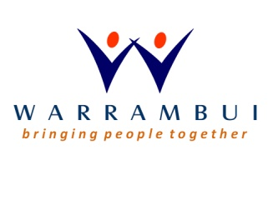
Cook
Warrambui Retreat and Conference Centre
Permanent, Full Time Position

Warrambui is a ministry of the Lutheran Church (NSW) with over 40 years experience in Christian hospitality, youth leadership training and camping ministry.
Applications are sought for the position of Cook for our retreat and school camp centre which accommodates up to 200 people.
The Cook is responsible for leading a small team in facilitating Warrambui’s catering operations including:
- Menu selection
- Preparation and cooking of meals for Warrambui’s Guests
- Overseeing and training of kitchen staff including kitchen hands and volunteer Interns
- Maintaining Warrambui’s Food Safety Plan, food standards and quality control
- Upholding the occupational health and safety standards
- Helping improve current systems, processes and procedures
We are seeking a person with experience and/or appropriate qualifications in cooking and food safety.
This position represents a wonderful opportunity to work in a Christian environment, amongst beautiful natural surroundings with the ability to input in a positive way to this invaluable ministry. As part of the Warrambui community, this position requires a flexible, open, team player, and someone with a servant heart who is willing to go the extra mile for clients and fellow Warrambui team members.
Onsite accommodation may be available to the successful candidate. Where applicable, casual/part time work as an administrator, cleaner or kitchen hand may be available to the spouse of the successful candidate.
For further information and to apply please visit the following link:
http://recruitshop.applynow.net.au/jobs/RS31690

