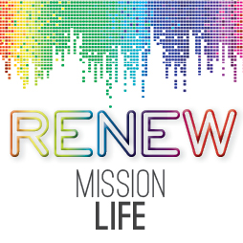

5 WEEK SERMON SERIES – SERMON 1

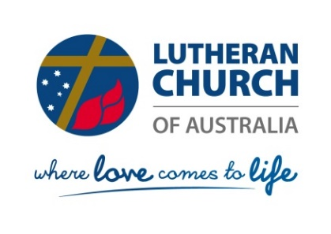

RENEW Mission Life: Where Love Comes to Life

Sermon One: WHERE LOVE COMES TO LIFE

Welcome to our first RENEW Mission Life season. This year the season theme is Where Love Comes to Life. After today’s sermon we commence the five weekly Bible Studies.
Reading: 1 John 4:7-21

Introduction
When people fall in love, it’s as if they come remarkably to life. Their eyes sparkle with special lights, their breath comes more urgently and they seem somehow to be straining forward to meet life. Love breathes life into the everyday ordinariness of our existence.
Actually, love changes people. The experience of being loved, at any stage of life, brings with it a kind of newness that brings out the best in us. We become more open to the gifts of life and the needs of others, and we live in a new way, a renewed way. Love brings life.
- God is Love
Of course, we can hardly think about love or life without thinking of God. 1 John 4:16b tells us that, God is love, and those who abide in love abide in God, and God abides in them.
In the very beginning God brought life to the world, reshaping the primeval chaos into a habitable planet (Genesis 1).
Then God breathed his own life into our human bodies and brought us to life (Genesis 2).
- God is Life
God even entered human life at a depth which no-one could have anticipated, becoming a human being and filling our humanity with his own life.
The Word became flesh and blood, and moved into the neighbourhood
(John 1.14 Message)
This flesh-taking (incarnation) was not an interesting experiment but God’s own project to rescue us from death and futility, and to renovate the whole world. In spite of our worst efforts, even when we killed him, God succeeded in bringing love back to life (John 1).
- God is on Mission
To continue his work on earth, God created the church, whose task now is to celebrate love and life, and to be the vehicle for God’s continued work of bringing love to life in the world. The church lives on the gifts of God – God’s forgiveness, God’s love, God’s own life.
In its worship the church experiences the love of God in words and actions of forgiveness and of empowerment. Infused with the real presence of Jesus Christ, love comes decisively to life every time the people of God gather.
Life in the church is really a preparation and empowerment for a life of love in the world.
Play video – MISSIONAL COMMUNITIES 1
As we hear the good news of Jesus Christ, as we receive his body and blood, we become new people, with new potential for good, with new energy for a life of love wherever God gives us the opportunity.
Through us our families, our communities and our workplaces might well experience something of God’s love as it comes to life again in us. That’s the plan. The life of a Christian is a life of faith active in love (Galatians 5), empowered by the love of Christ himself (1 Corinthians 13). Indeed, we have no other obligation, except to participate in this world transforming gift of God’s love (Romans 13).
The paradox of our time in history is that
we spend more, but have less;
we buy more, but enjoy it less.
We have bigger houses, and smaller families;
more conveniences, but less time;
more medicine, but less wellness.
We read too little, watch TV too much,
and pray too seldom.
We have multiplied our possessions,
but reduced our values.
These are the times of tall men, and short character;
These are the days of two incomes, but more divorce;
of fancier houses, but broken homes.
We’ve learned how to make a living, but not a life;
we’ve added years to life, not life to years;
we’ve worked at cleaning up the air, but polluted the soul.

Although many have solved the problem of how to make a living, we are left to wonder why we live.
The good news is …Jesus Christ spoke about the way we can move beyond superficial living…into a relationship with God and His people.
Discovering this kind of life is the reason why we are doing the RENEW Mission Life season.
Together we will see that real life begins when we experience Jesus as the heart and centre of our world, our work, our witness and all of our relationships.
Conclusion
A missional life participates in the shared life of Father, Son and Holy Spirit. As a consequence we are transformed to be a community where God’s love comes to life. The same love that transforms us is drawing our families, neighbours and friends into new life in Christ, thus we are urged by the Holy Spirit to include and invite all people to belong to Gods family. “For the love of Christ urges us on, because we are convinced that one has died for all; therefore all have died.” (2 Corinthians 5.14 NRSV)
So, how can we make the most of this season of being renewed in our mission life?
- Consider being here every week to join us in this sermon series.
- Starting this week consider utilizing the bible studies provided either in an existing small group or in one that you form for this season? If that is not possible for you then try doing the studies in your own time and finding someone to discuss your reflections with you, either online or in person once a week.
- Pray and ask God to shape your life through this season.

Adapted from Bob Moorehead - http://www.goodreads.com/quotes/22242-the-paradox-of-our-time-in-history-is-that-we

