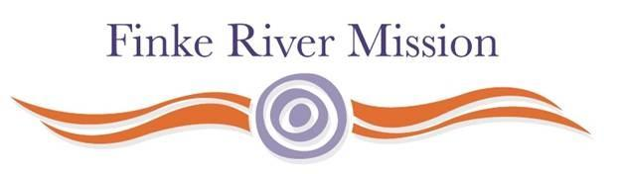
FRM Store Manager - Hermannsburg
Position Description
The position involves responsibility for the oversight of the non-pastoral operations of Finke River Mission in Hermannsburg. This includes direct responsibility for the operations of the Store and all accommodation and property management at Hermannsburg.
This is a leadership position answerable to the Finke River Mission Board through the Operations Manager of same.
The position also works closely with the Operations Manager to help ensure all Hermannsburg Historic Precinct operations are coordinated and align to the Precinct Business Plan.

Duty Statement
The following specific duties attach to the position:
- Ensure the recruitment of sufficient and appropriate staff for the efficient operations of the area. This will include making staff available to help meet peak and/or special requirements at the Store and / or the Precinct.
- In conjunction with other Lutheran agencies coordinate and oversee volunteer activities in the community.
- Within the context of available resources and budget priorities, ensure the repair and maintenance of FRM assets, both owned and leased.
- Ensure compliance with all workplace health and safety regulations and any other regulations that may apply to the workplace.
- Manage the operations of the Hermannsburg store.
- As far as practical develop and adopt common procedures and policies across the various operations.
- Ensure strong and effective working relationships with the Hermannsburg community, relevant government officials and business and community leaders.
- Ensure an effective working relationship with FRM Operations. General input and supervisory help is also available in building matters.
- Support and oversee any FRM capital developments in conjunction with the FRM Operations Manage.
- Submit a written report to the Operations Manager for regular Finke River Mission board meetings.
- Help ensure a collaborative workplace and community environment.
- Any other duties as may be directed by the Operations Manager and or the FRM Board from time to time.

