COVID19: Government easing restrictions …
Churches addressing some things … faithful to the Gospel.

ADVICE ON ROAD MAP THREE: Released June 30th 2020.
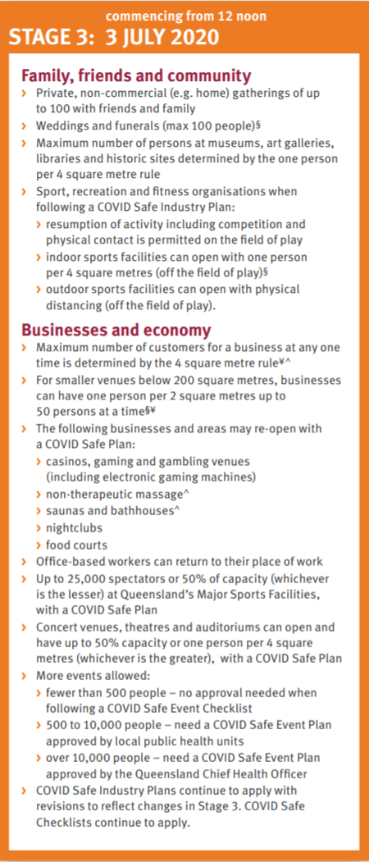
On Tuesday June 30th, our Queensland Premier's Office announced new guidelines for travel across our State borders, but also released a revision of the previous Road Map to Easing Queensland Restrictions.

The revised ROAD MAP THREE is attached at the end of this letter as "Appendix 1" with the key information shown in the orange box on the right. The changes commence from 12 noon on Friday July 3rd.

On the following pages are key matters to attend to, as you consider ROAD MAP THREE. This revised Road Map does not specifically mention "Places of Worship" as was the case in previous Road Maps.

The primary website for the Queensland Government COVID 19 material is: https://www.covid19.qld.gov.au/ This site includes this revised Road Map as well as other important documents.

Our Queensland Lutheran communities have worked diligently with Government requirements to protect the vulnerable and to suppress the rate of infections. Each pastor and congregation leader throughout the LCAQD has had a key role in this undertaking and I pray God's blessing on your Christian service in this time of pandemic.

May you encourage one another with words of the Gospel as you walk with the Lord through the "road maps" easing restrictions amongst us. In St Paul's letter to the Romans, he reminds us, "No, in all these things we are more than conquerors through him who loved us. For I am convinced that neither death, nor life, nor angels, nor rulers, nor things present, nor things to come, nor powers, nor height, nor depth, nor anything else in all creation, will be able to separate us from the love of God in Christ Jesus our Lord."

In Christ,
Paul
Bishop LCAQD

UPHOLDING THE PRIMARY HEALTH RULES:
> Physical distancing
> 4 square metres per person when indoors
> Hand hygiene
> Respiratory hygiene
> Frequent environmental cleaning and disinfection
> Stay at home if you are sick
ROAD MAP THREE START DATE:

ROAD MAP THREE applies from 12 Noon on Friday July 3rd.

RECORDING:

ROAD MAP THREE continues to require the recording of contact details for our Church gatherings and to keep these for 56 days.

NUMBERS:

a. Gatherings:
For smaller buildings under 200 square metres (with a distancing of one person per 2 square metres) - gatherings can have up to a maximum of 50 with a COVID Safe Checklist, when not complying with the COVID Safe Industry Plan - and provided contact details are kept for at least 56 days (this would apply to gathering for worship and gathering for other group activities run by a congregation).

b. Weddings and Funerals
Maximum of 100 people and provided contact details are kept for at least 56 days
CLEANING:

ROAD MAP THREE requires continued vigilance regarding cleaning. Directions for cleaning can be found on pages 11 and 12 of the Industry COVD Safe Plan for Places of Worship (this advice can be followed whether or not your congregation is adopting this Industry Plan - check link in next section).

INDUSTRY COVID SAFE PLAN FOR PLACES OF WORSHIP:

In Queensland, we have approved COVID safe plans, including one for places of worship. https://www.covid19.qld.gov.au/government-actions/approved-industry-covid-safe-plans. ROAD MAP THREE explains that "COVID Safe Industry Plans continue to apply with revisions to reflect changes in Stage 3. COVID Safe Checklists continue to apply."

There is NO requirement to adopt the "Industry COVID Safe Plan for Places of Worship" if your community chooses and your gathering space is below 200 square metres and you keep to 50 and under (note the previous comments on "NUMBERS").

The "Industry COVID Safe Plan for Places of Worship" stipulates if you plan to include singing, then you must not only complete the requirements of the Industry Safe Plan for Places of Worship but you must also ensure that each person is kept to a 7 sq meter spacing.

OLDER QUEENSLANDERS:

ROAD MAP THREE does not specifically address the situation of Older Queenslanders but the regulations for Aged Care communities changed on June 17th. There are specific requirements for FLU VACCINATION prior to visiting and Aged Care Facility. Care for older Queenslanders is a special priority in matters of the "Primary Health Rules".
https://www.qld.gov.au/health/conditions/health-alerts/coronavirus-covid-19/current-status/public-health-directions/aged-care

YOUR LOCAL CHURCH OFFICE:

ROAD MAP THREE advises that "Office-based workers can return to their place of work."

ADVICE REGARDING REMOTE LUTHERAN COMMUNITIES: Hopevale, Wujal Wujal and Coen:

ROAD MAP THREE directs us to the "Remote Communities Roadmap", which explains that any easing of restrictions in those areas will occur following an assessment of public health advice, response capability and community consultation. Each of the "Restricted Access" communities, including Hopevale, Wujal Wujal and Coen are addressed separately from the rest of Queensland's various communities by the Chief Health Officer.
https://www.health.qld.gov.au/system-governance/legislation/cho-public-health-directions-under-expanded-public-health-act-powers/restricted-access-to-remote-communities

FUTURE CHANGES:

ROAD MAP THREE points to potential changes in the future, based on "Ongoing review of state-based restrictions" contingent on levels of community transmission.
Possible future changes include:
a. Density requirements, including consideration of moving from 4 to 2 square metres per person for all venues
b. Remaining restrictions on high-risk businesses and activities (this could include the 7 sq metre ruling for "singing" in the Industry COVID Safe Plan for Places of Worship.)

ASYMPTOMATIC:

A good guiding question to discipline our Church work during this time of the "Road Maps" is to consider what would be best practise, if you happen to actually be a carrier of the virus in the "asymptomatic" category (ie: you are a carrier but don't have symptoms).

NOT 'REQUIRED' TO:

Congregations and parishes should NOT feel they are "required" to begin gatherings for public worship at Church straightaway. There may be local reasons for continuing with online worship. Pastors need to be ready, willing and able to take up duties that involve more social and physical contact. We must remember that some pastors are still "high risk" persons, as are some Church Workers and other volunteers and as are a number of the people who participate in the life of the Church.

CARE:

Our congregations have been outstanding in the work of care, ensuring that needs of vulnerable people are being addressed. This work of care remains a primary task as we travel the road map of reducing restrictions.

PANDEMIC STILL:

We yearn for an end to this pandemic. The rate of infection and death is very low across the states of Australia. However, we are travelling these "ROAD MAPS" because the COVID 19 Coronavirus pandemic continues to spread throughout the world. Our neighbouring countries are experiencing tragic escalations in infection and death. This global pandemic is far from "over".

PLANNING TO SERVE:

ROAD MAP THREE does not give directions for Christian service to the needy. That is not the job of the Government. In this time of pandemic, the people we serve in the name of Jesus, need us to continue to "do unto others as we would have them do unto us." Our Lutheran communities have opportunities to find new ways to support folk who are suffering on account of COVID19, such as those who are isolated, those who have lost income, students unable to get by financially, people caught up in domestic violence, those struggling with unexpected mental health issues, older people unable to connect with family members.

APPENDIX 1: QUEENSLAND ROAD MAP THREE - June 30
https://www.covid19.qld.gov.au/__data/assets/pdf_file/0016/127150/DPC7309-COVID-19-Restrictions-roadmap.pdf

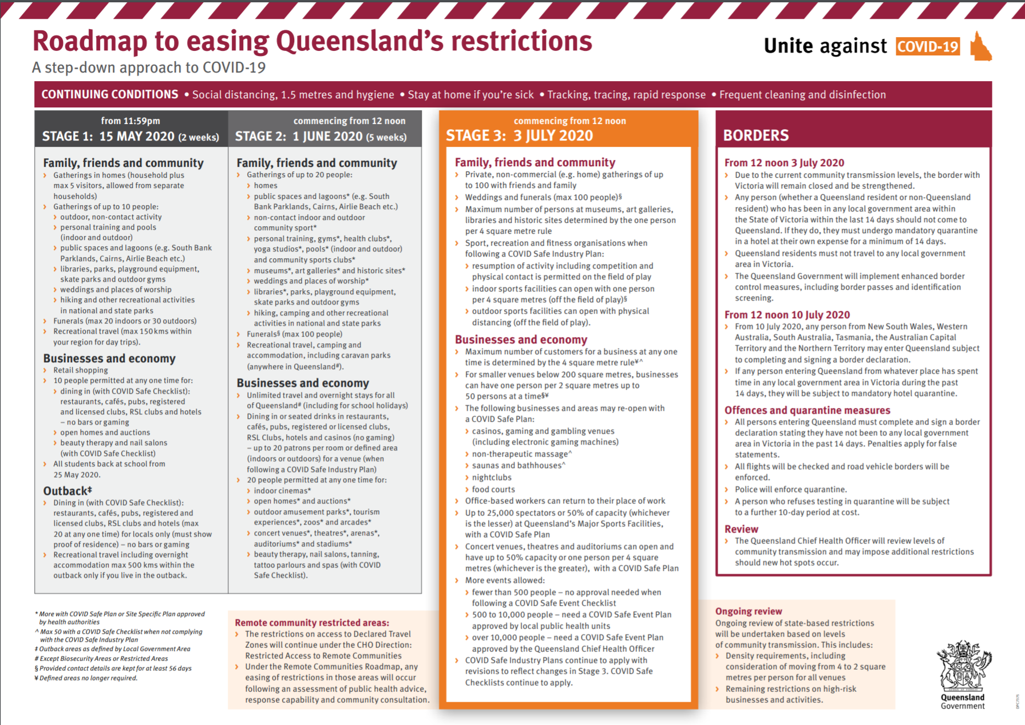

APPENDIX 2: THE FEDERAL ROAD MAP - MAY 8

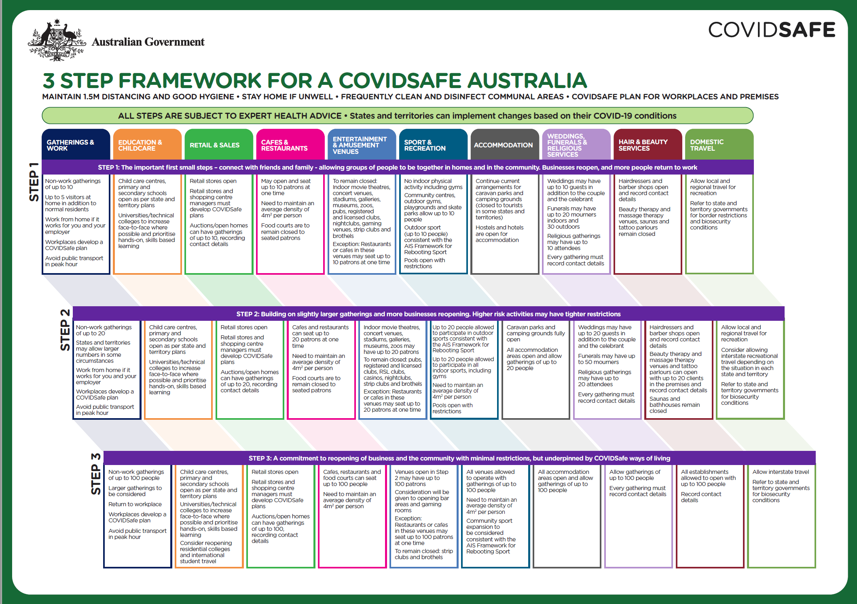
APPENDIX 3: THE SECOND WAVE WARNING:

The story of Philadelphia and St Louis
during the SPANISH FLU 100 years ago

This graph tells the story of "returning too soon".

The solid line of "Philadelphia" tells the story of a city that did not take quick action and the deaths escalated. The city eventually took on strict measures and controlled the spread of the virus.
The St Louis graph (the dotted line) tells another story. At first the city of St Louis "flattened the curve" with strict lock down and isolation procedures. Then at the end of November, they relaxed their restrictions "too early" and you can see the rate of deaths curve go back up again to an even higher rate than before. So in mid-December, the city of St Louis returned to their strict procedures and the curve flattened and cased went to zero.

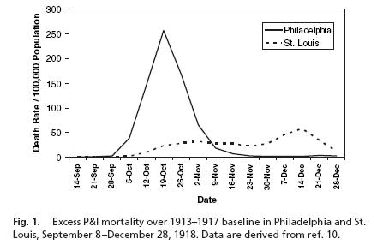

https://qz.com/1816060/a-chart-of-the-1918-spanish-flu-shows-why-social-distancing-works/

