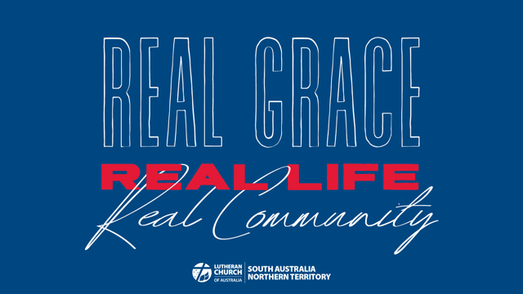

Bible Study Week 1
WHY CHURCH?
Why do we gather? Why do we celebrate the Word and Holy Communion? What is the purpose of the local church? What are we here for?

These are important questions for us to ask as we carry out the work of Jesus in the world. Let’s take the time to ask these big questions as we read the Bible together.

Are there some things that we need to repent of or return to? Sometimes the local church can become self-serving. Sometimes we are riddled with doubts and fears. What might it look like if we were to come back to Jesus and find our strength in him? What might happen if we devoted ourselves anew to reading God’s Word and to prayer? These are all questions that remind us of why we are here and motivate us to be the Church in the world.
OPENING
What is a part of church gatherings and worship times that you really appreciate?

What is it that has kept you coming back to the church where you belong?

In what ways are you encouraged by the people you worship next to?
STUDY
When Jesus died the disciples were confused and frightened. Even though Jesus had told them that he would die and on the third day he would rise again his disciples struggled to believe. But Jesus ministered to them in their unbelief. Then he sent the Holy Spirit to empower them. In John 20 Jesus broke through their fear, he brought his peace to them, and he send them out to take his peace to the world.

Read John 20:18-30

Why were the disciples fearful? What were they afraid would happen?

What do you think “Peace be with you” meant to the disciples?

What are some of the ways the Church is fearful today? What are we afraid of?

In what ways is Jesus’ peace with us today?

What does it look like when we bring Jesus’ forgiveness to someone?

In Matthew 28 Jesus gives his disciples a command to take on his ministry, he calls them to make disciples of all nations. A disciple is a follower, who learns from their teacher, devotes themself to their teaching and disciplines themself to do what their teacher does. Jesus tells his disciples that they are now to become the teacher helping others to know Jesus and live in his ways.

Read Matthew 28:16-20

Again, there are doubts among the disciples even as they worship the risen Lord Jesus. The disciples didn’t know everything at this point so how can they become teachers?

Alongside worship, we see a community here born to learn and live in Jesus. In what ways have you learnt to live in Jesus’ ways?

Discipleship means that we are always learning inside and outside of the “classroom”. In what ways have you experienced both in your faith journey?

What is the value in reading the Bible together rather, than just individually?

APPLICATION
What are some of the doubts and fears that you would like our churches to leave behind?
Who are the people in the community around you that need the peace of Jesus?

What might need to change for your church to prioritise discipleship more?

FEEDBACK
As you finish up your study please take a moment to send us a few notes at the District Office. We’d love to hear any stories or responses that you would like to share with us.

Send us an email at administration.sa-nt@lca.org.au or post your notes to 137 Archer Street North Adelaide SA 5006

We look forward to sharing in stories from all around South Australia and the Northern Territory.

PERSONAL REFLECTION TIME
Read Psalm 84
Have you ever desperately longed to worship in God’s presence?

Why do you think the psalm writer is so hungry to seek God?

Do church gatherings feel like home to you? Why?

This is a pilgrimage psalm. Why do you think God commanded the Jews to make three pilgrimages to the temple each year?

In what ways are we pilgrims here on earth?

How might you encourage those you worship with so that they are strengthened for their journey?

