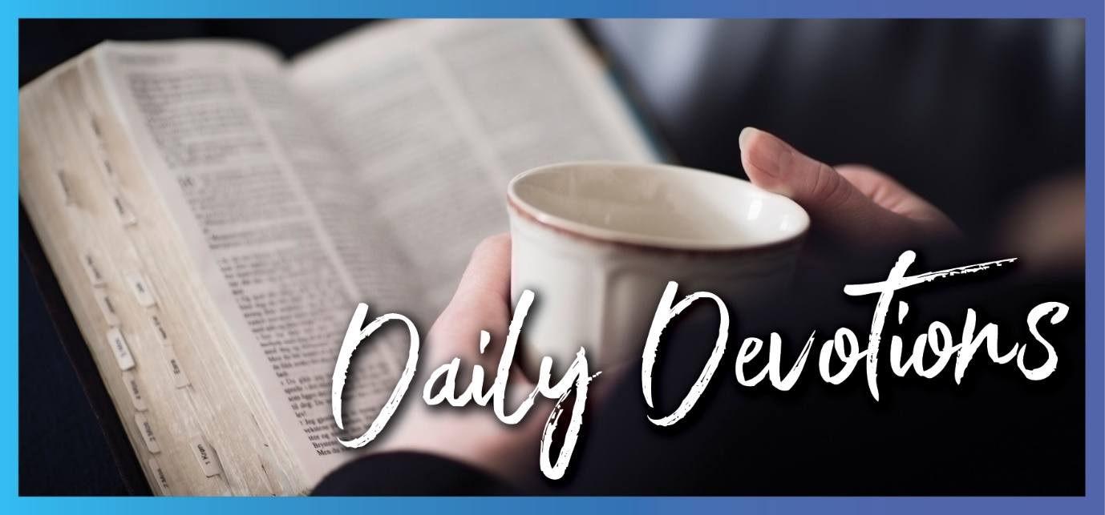

Sunday 4 July 2021 to Sunday 11 July 2021
Sunday 4 July 2021

Who has authority?
by Pastor Jim Strelan
He sent them out two by two and gave them authority over evil spirits (Mark 6:7).
Read Mark 6:1–13
How are you with authority? There are lots of people who have authority, and generally, we accept that. The government, the police, parents and those in schools have a hierarchy of authority going from the top and moving down to even the student body. Martin Luther taught that all those earthly authorities are extensions of God. Whether they recognise it or not, they work on behalf of God.
Jesus sends his disciples out, and he gives them authority. Their authority is not to do with their own abilities. It’s not to do with how much they have or how much they own – ‘take nothing for the journey except a staff’ (Mark 6:8). It doesn’t depend on their training or particular expertise. They go with the authority of Jesus, and in that authority, they drive out demons and heal the sick.
How are you with authority in your faith journey? Sometimes we can think that it’s only certain people who have this kind of authority. We can think that it’s only the pastor who has that authority, and we insist the pastor must be of a particular gender. But the authority is not the disciples’. Without the authority of Jesus, the disciples would have been timid and ineffective. It is the authority of Jesus, and it’s the highest authority there is. He gives it, and they go out in his name and do things they wouldn’t have thought conceivable.
We are to respect all authority that acts for the common good. The authority of Jesus is the highest of all, and he gives it to those who want to serve on his behalf – even you.
Jesus, I acknowledge that all authority is yours. Thank you for empowering all those who act in your name, even me. Amen.

Monday 5 July 2021

Who, me?
by Pastor Jim Strelan
‘Ah, Sovereign Lord,’ I said, ‘I do not know how to speak; I am only a child’ (Jeremiah 1:6).
Read Jeremiah 1:4–10
Is the Lord calling you? Is he calling you to reach out to that neighbour across the road who has just moved in? Is he calling you to speak to that person who seems to hang around after Sunday worship, but no-one seems to take much notice? Is he calling you to serve in your church in a particular ministry for which you have a gift? Or is the Lord calling you to be a good parent, a good friend, a faithful employee in your workplace?
Jeremiah was called. He was already marked out while in his mother’s womb. He was to be a prophet to the nations. But his response was much like ours can be: Who, me? I don’t have the gift of the gab. I’m just a child. Why would you call me to anything? Does that sound familiar? Not me. I’d like to, but I’m no prophet. I don’t have any title. I lack confidence. There must be someone else.
The thing is that this call comes from the Lord, and when he calls, he also equips. You don’t do things in your own strength. The authority is the Lord’s. To Jeremiah, he says, ‘Don’t be afraid ... I am with you’. That makes all the difference, doesn’t it? For Jeremiah, he put his words in the young boy’s mouth. Acting for the Lord, with the authority of the Lord, equipped by the Lord.
Who me? Sometimes we can use the argument that this ‘calling’ is a special thing: prophets, the disciples, today we might say pastors. And while they do have a specific call from the Lord, it doesn’t mean that this calling isn’t for anyone else. Each of us has a call from the Lord to serve him where we are, with those immediately around us. And the reassurance given to Jeremiah is also given to you: Don’t be afraid, I am with you.
Lord, if I listen carefully, I hear you calling me each day. But I’m not confident. Put your words into my mouth and give me your strength to respond. Amen.

Tuesday 6 July 2021

Stopping the praise of Jesus
by Pastor Jim Strelan
‘I tell you’, he replied, ‘if they keep quiet, the stones will cry out’ (Luke 19:40).
Read Luke 19:39–44
There’s a song being sung. It has been sung since the dawn of time, and it continues to this day. It’s the song of praise to God. Sometimes it’s loud and easy to hear. Sometimes it seems like only a quiet hum, and you have to strain your hearing to take it in. But nothing can stop it or ever will.
Are you singing that song? When life is good, and when everything is going your way, are you singing the song? When you are really struggling, when it seems like everything is falling apart, can you still sing the song? In this COVID-19 world, which creates so much uncertainty and apprehension, and our movement is restricted, can you hear the song?
Jesus had just entered Jerusalem, and a whole crowd of disciples (Luke 19:38) welcomed him with their song of praise. This implies not just the 12 disciples, the chosen ones, but a whole lot of others called as disciples. Men, women, maybe even children – disciples all singing the song. Some of the Pharisees asked Jesus to make them stop, and Jesus replied that even if they did, you can’t stop the song – even the stones will cry out.
Sometimes our desire to sing the song and our ability to sing is strangled by what is around us so that all that comes out is a choking sound. If you are ever in that place, be still and listen. Hear that humming sound in words from God you remember. Hear it as you reach out your hand to take the bread and the wine. Hear it as you see those around you living the song. Hear it in the rustle of the wind in the trees and the breaking of the waves on the shore. The eternal song remains, and soon you will sing it again.
Lord Jesus, loosen that which wants to strangle me so that I can sing the song of praise again. Amen.

Wednesday 7 July 2021

Standing shoeless
by Pastor Jim Strelan
Then the Lord said to him, ‘Take off your sandals; the place where you are standing is holy ground’ (Acts 7:33).
Read Acts 7:30–39
If you were to go to a Muslim mosque, or if you’ve seen photos, there’s something you will notice at the entry to the mosque. You will see rows and rows of sandals and shoes. Before entering the mosque to pray, worshippers take off their shoes and leave them at the entrance. God appears to Moses, and before he gives Moses instructions, he asks him to take off his sandals. Why? Because the place where he is (you are) standing is holy ground. The place where the Lord is present, in this case, is the flames of the burning bush in the desert.
When we gather for worship, one of the first things we do is to have a time of confession. Now there may well be several reasons for that, but one is that we are in the presence of the Almighty God, and it’s right for us to ‘take off our shoes’ in his presence. The shoes that have been to who knows where; the shoes that have picked up dust and dirt; the shoes that we seem to think give us some dignity – we shed them and stand humbly before God.
God is about to recommission Moses for a task and send him out in his authority, and this is the first thing he asks. When God wants to work with us and in us, he asks the same thing of us: let go of everything that might make you think you have all the skills and know-how, the gift of the gab. Let go of that, and stand shoeless before your God. Then he will do what he wants to do, in and through you.
It might be a good thing if we actually did that one Sunday – stood shoeless – just to remind us.
God of us all, I take off my shoes before you and wait on you. Direct me your way. Amen.

Thursday 8 July 2021

Opposition
by Pastor Jim Strelan
They stirred up persecution against Paul and Barnabas and expelled them from their region (Acts 13:50b).
Read Acts 13:38–50
Do you ever get given a hard time because you are a Christian? You may not come across like a Bible-basher, but it is known that you are Christian, and so you become the butt of jokes and snide and sarcastic comments. This can happen in the workplace, in a sporting team, in the school community or in your extended family. It’s hard. You try to be non-judgemental, you are loving and understanding towards others, and if they want to debate, then you are willing to state your view, but opposition is strong and persistent, and it wears you down. You can even be tempted to try and cover your faith up – no-one can take constant ridicule for too long.
Paul and Barnabas experienced constant opposition as they spoke the word about Jesus. But they also attracted a lot of curious crowds and had the opportunity to share the grace of God with many people. Despite the opposition, they persisted. They were bold and unwavering. Did they have something you and I don’t have? Maybe they had a particular charisma that set them apart. Maybe they had particular gifts, more than the average person has. Maybe they didn’t. What they did have is a word from God. A word about Jesus, about forgiveness, about grace, about inclusivity in contrast to a holding onto an exclusivity. ‘When the Gentiles heard this, they were glad and honoured the word of the Lord’ (Acts 13:48).
When it is known that you are a Christian, there will always be opposition. Your task is to be genuine in who you are in every way. To genuinely care, to genuinely give support, to match what you speak about with the way you act, to know that the word of the Lord is a powerful and life-changing thing. In the end, the power for change lies with God.
Lord God, it’s hard to stand up for you when it means I stand out. Please help me to be true and to trust the power of your word. Amen.

Friday 9 July 2021

Influences in your life
by Pastor Jim Strelan
I have been reminded of your sure faith which first lived in your grandmother Lois and in your mother Eunice and I am persuaded now lives in you also (1 Timothy 1:5).
Read 2 Timothy 1:3–14
Think for a moment about the person who has had the most influence in your life in terms of your walk with Jesus. It could be a parent, a teacher, a pastor or a friend. It’s interesting that in many cases, the one who most influenced us is a woman. Maybe it’s their tendency to be the nurturer, and they see the nurturing of you includes a fostering of your faith. Maybe you had a mother as I did who taught me to pray, sang songs and verses of hymns to me, and who I know prayed for me all the way through to adulthood. Whoever that main influence might be, thank God for them.
Pauls reminds Timothy that the first flame of faith was kindled by his grandmother and mother and still resides in him. It seems that Timothy lacked a little in terms of confidence. So Paul reminds Timothy of the strong ones in his life. Then Paul reminds Timothy that he laid hands on him, so he has the Spirit of God with him. And he reminds him that the heart of the gospel message is Jesus through whom we know the grace of God. So, Paul says, don’t be timid and don’t be ashamed.
If you are blessed to stand in a line of believers going back generations, then thank God for it. And be determined to continue that influence with the young ones in your life. If you don’t have that long connection with faithful believers, then you make a start. Pass on what you have – be a Lois and a Eunice, regardless of which gender you are. The faith you have and want to pass on is a faith in a God who has the power and authority and pours his Spirit into you.
Thank you, God, for those who have had the most influence in my life by showing me Jesus. Empower me to do the same in the power of Jesus. Amen.

Saturday 10 July 2021

Blessings from God
by Pastor Jim Strelan
The Lord will indeed give what is good, and our land will yield its harvest (Psalm 85:12).
Read Psalm 85:8–13
There are different ways of understanding the way God works in our lives. Some believe that God is active in every part of their lives so that there are few choices they make without God directing them. For example, ‘God, please help me find a parking space’. Others have the view that there is very little that God does in terms of our day-to-day living, almost as though he set the world in motion and has basically been sleeping ever since. Except for when your boat has overturned, and you are thrashing about in the open sea – then you cry out to this inactive God!
So how does it work? Look again at verse 12 from the psalm, ‘The Lord will indeed give what is good, and our land will yield its harvest’. Read the whole psalm. It suggests that there was a time when things weren’t going so well. But God restored their fortunes, he forgave their sins, and he set aside his anger (verses 1–3). Why did God do that? Was it because the people asked him to? Maybe. Was it because he saw how faithful they were, and so he rewarded them? Or was it because that is God’s nature? He would much rather bless us than curse us. In God, ‘love and faithfulness meet together, righteousness and peace kiss each other’ (verse 10).
The point is this: when we see God blessing us, when the land yields its harvest, when we acknowledge that we have a new start because our God is gracious and merciful, then we are left with nothing but gratitude. We thank God for blessing us, even though we know we are deserving of much less. We thank God for being true to his nature and not acting according to our nature. When life is a struggle, we look expectantly to the time when our sovereign God will once again bless us.
Thank you, Sovereign God, for all your blessings on us. When the going is tough, please help us to wait on you. Amen.
Sunday 11 July 2021

The gift of a clear conscience
by Kimberley Pfeiffer
But when Herod heard of it, he said, ‘John, whom I beheaded, has been raised’ (Mark 6:16).
Read Mark 6:14–29
I doubt that a modern person would jump quite as quickly to ‘he’s been raised from the dead’ as an explanation for something unexplainable as Herod does in today’s reading. This is especially so when we remember that John died by beheading. We can be quite certain that people do not come back from that kind of death. So why does this thought get at Herod and become so convincing in his mind?
Herod clearly has a disturbed conscience about killing John the Baptist and all the events that led to it. The reading tells us that Herod liked to listen to John, although he was perplexed by what John had to say. John’s integrity as a ‘righteous and holy man’ was well known. His words were good and true. It was the very truth of his words that stirred up John’s conscience as he pointed out Herod’s unlawful relationship with his brother’s wife, Herodias. Herod knew that the murder of John was unjustified.
The conscience is the place in the human soul where we can fully realise the grip of sin. Through a complex interplay that involves reflection on action, imagination, conscious and unconscious thought, we consider our past actions and intentions for the future, our triumphs and mistakes, and the role we play in life and before God.
A good or clear conscience is something we all long for. None of us is entitled to a clear conscience; we live in a broken world that is tarnished by sin. Yet, we know what a clear conscience is by what it is not. It doesn’t haunt us at night, it doesn’t replay our regrets, and it doesn’t hold us back from taking healthy risks in life with confidence and hope.
Through the shed blood of Christ, our peace has been restored with God, and our conscience is cleansed. As we receive that underserved gospel gift of Christ’s power over death, the devil and all his works, in our baptism and again and again through the word and sacrament, Christ calms the furies of our conscience. That same power by the Holy Spirit enables us to look at our earthly reality. We may have to face the consequences from the past, but in so doing, we have hope because the eternal consequences are no longer. This frees us to live in hope, joining in his Spirit as we face, embrace and find joy in our earthly vocations.
Dear Heavenly Father, thank you for sending Christ to be the sacrifice that cleanses us from sin. Renew us as we daily receive your gospel gift that sets us free from sin’s power. Give us hope in your Spirit that sustains us as we face the messiness of life and the peace that surpasses all understanding, keeping our hearts and minds safe in Christ Jesus. Amen.

