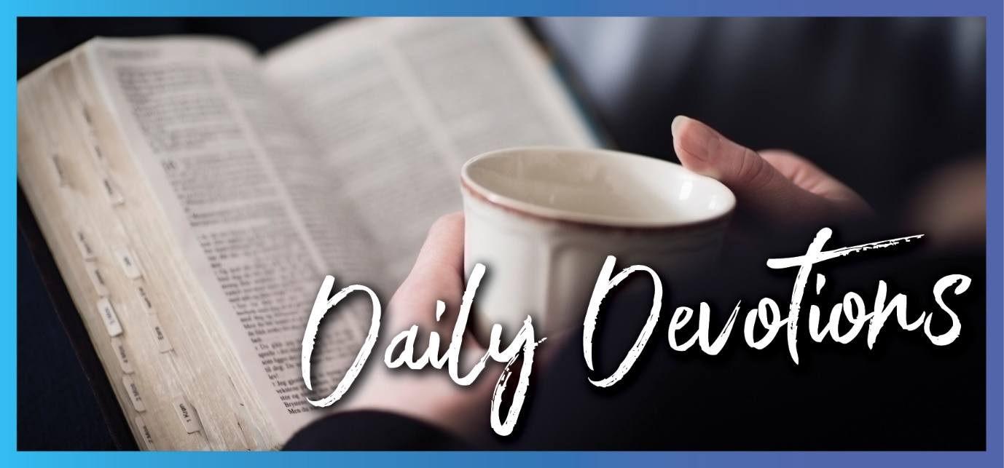

Sunday 10 July 2022 to Sunday 17 July 2022
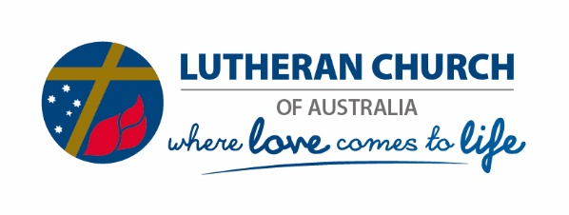
Sunday 10 July 2022

Just another day on the road. Why?
by Darren Pope
Love the Lord your God with all your heart and with all your soul and with all your strength and with all your mind; and, love your neighbour as yourself (Luke 10:27).
Read Luke 10:25–37
Windows up, air conditioner on and car karaoke tunes pumping to make the repetitious commute as painless as possible. Kaboom! At the lights up ahead, the sound of screeching brakes, smashing glass and ripping metal is horrific and offensive to every ear. Shocked silence. Stillness. Now what?
The moments after a road crash magnify the best and worst of human nature. Strangers put their commute on pause and pull over, and a heightened sense of purpose prevails. Checks of drivers and passengers happen quickly, emergency services are called, and so often, professionals with the capacity to care move quietly into action as responsibility for traffic management is taken care of by random tradies. Annoyed by the inconvenience, others slowly pass by, shake their heads, stickybeak, or get on the socials to stream and comment. Help arrives, care is given, wrecks are cleared, and the daily rhythm returns. Just another day on the road!
The Samaritan took a huge risk to stop, help and be generous! Through the lens of ancient cultural bias, other travellers were highly likely to assume that the Samaritan was the bad guy and stopped only long enough to steal from the stranger on the road. He risked judgement and punishment to render selfless help. So, why risk it? Extreme emergencies crystalise character, yet, gentle and humble acts of loving and serving latently permeate our daily lives, going unseen, unsaid and unknown. What motivates small or significant selfless acts? What’s our collective, ‘Why’?
Empathy and vocation are strong advocates for action. Deeply understanding needs allows sensitivity in our response. Wisdom is what guides decision-making as people serve their neighbours and the community. A crucial element is our capacity to listen, to ensure that we understand the specific needs of a particular neighbour at any given moment. As we listen, we stand beside our neighbour rather than assuming a position of superiority, thinking we know what the neighbour needs in advance. By asking, we serve through ‘doing with’ rather than ‘doing for’.
Grace sets us free to listen and ‘do with’ because of what our loving Lord has already ‘done for’ us on the cross and because he first loved us. God made us to be social, to be thoughtful, to notice, to ask, to listen in empathy. God designed us to actively live in community and share the road with family, friends and strangers every day. It’s not just another day on the road. God’s unconditional gift of love to us and a deep calling of the heart lead our response. That’s our vocation. That’s our ‘why’!
Lord of love, thank you for knowing me deeply and coming to me again in unconditional love today. You know the speed bumps in my day ahead. Guide my interactions, my listening and my words. Thank you for being on the road and doing life with me. Amen.

As a life-long learner, Darren has a heart to share the gospel through Lutheran education. He treasures time with family, is a mad VW Kombi fan, and loves to swim.

Monday 11 July 2022

Return to sender
by Darren Pope
But God sent me ahead of you to preserve for you a remnant on earth and to save your lives by a great deliverance (Genesis 45:7).
Read Genesis 45:1–15
Ding-dong, ding-dong. Greeted with a smile, scan and signature, another package is delivered to our door. E-commerce is a burgeoning business fuelled by our desire for deliveries. Australians ordered and received well in excess of 1.5 billion items in the last 12 months, delivered to doorsteps at a rate of 40 parcels per second for the entire year.
It’s simple, right? Robots sort, courier vans scurry, scanners chirp, and clients collect. Well, simple most of the time. Eighties fluoro-pink leg warmers addressed to a stranger and delivered mid-summer just doesn’t make much sense! Only one course of action now; I need to return the item to the sender.
The love of a family can be a beautiful and complex thing. It was for Joseph. When he greeted his brothers after so long apart, injustice may have led to wielding great power as a weapon. Instead, he wrapped his arms around his brothers in gracious love. Joseph tells his family three times that God sent him ahead of them to help prepare a way. Again, Joseph deflects all purpose away from earthly kingdoms and points to God’s glory. His gentleness and authenticity in love point his brothers back to our loving Lord. He turns their eyes and encourages them to ‘return to the sender’. Is this just a story of a man and his brothers? Who is preparing the way and why? Even way back in Genesis, we look forward to the coming of Christ, the king, to prepare a way for us.
It’s always God’s work – for us, to us, and through us. God sends each of us a personalised delivery of unconditional love through Christ each day. His grace, love and forgiveness arrive on our doorstep, fuelled by his desire to be in a relationship with us. This comes no matter what is happening in our lives or what we have or haven’t done. His love doesn’t have rules or conditions for delivery. It’s free and always reliable. In response, with my whole being, I return to the sender.
My Lord and King, I got your delivery today. Personally addressed to me, it was packed full of your love, grace, mercy and forgiveness. I return again to you and live in your deep love. Thank you. Amen.

Tuesday 12 July 2022

Free
by Darren Pope
Remember that you were slaves in Egypt and the Lord your God redeemed you from there (Deuteronomy 24:18).
Read Deuteronomy 24:17–22
Lazy summer breeze, sand tickling toes, wispy clouds mirror dancing waves. Drifting back, memories are free. It’s amazing how a random sound, sight or smell can transport us back to a past place. Our brains are wired to remember. In our brain, the hippocampus helps with memories of experiences and knowing people’s faces. The cerebellum makes sure we can recall how to do things, like driving a car or playing the piano. The prefrontal cortex is active in remembering little details and solving complex problems. God, our designer, created us to recall and remember, yet, we forget!
It can be annoying when we forget our car keys, passwords, pin codes or names. It can be a safety risk if we cannot remember whether we closed the garage door or switched off the oven! So, we find ways to remember. We stick a note on the fridge, write on our hands, create a phone reminder, set an alarm or ask for help – whatever it takes to just get this stuff done. It’s important to remember.
It’s important to remember where you work and live, how to get places and how to get back. Remembering birthdays, anniversaries, and special moments herald valuable celebrations. Remembering that we are created in God’s image, along with every other human on earth, reminds us that every person we encounter in our day is inherently valuable, special, loved, forgiven and important.
Remembering that Christ, fully human and fully God, bore our sin, suffered, died and rose to eternal life brings daily and eternal hope through his unconditional gift of grace. How do we respond? What are we called to do? Our response is to act justly, love mercy and walk humbly with God. By grace, we are free. Free to remember. Free to serve.
Lord of all ages, Lord of my heart, thank you for loving me fully today. Help me to remember that I am free. Give me the heart to notice and value others. Bless my head, heart and hands as I serve today. Amen.

Wednesday 13 July 2022

Head, hands, heart
by Darren Pope
Loose the chains of injustice. Set the oppressed free. Share your food with the hungry and to provide the poor wanderer with shelter (Isaiah 58:6,7).
Read Isaiah 58:6–9a
Unannounced, the little yellow van rolls quietly into the driveway. Peeking out, people emerge and gather. Cornflakes, toilet paper, vegemite and cream biscuits disappear from the trestle table as swiftly as they are laid out. Patiently waiting, lowered eyes and smiles alike offer deep gratitude. Steaming cuppas invite familiar faces to blend with new. Warming, the chirp of laughter infectiously erupts. Heads rise as safety emerges. A brief encounter, gently sowing seeds of hope.
God comes to us and serves his world through us. Prayerfully and practically, in response to God’s free gift of unconditional love, we are free to serve, give, welcome and share as love comes to life. Homelessness, suffering or need can remain ‘head knowledge’ as we hear or see. In our broken humanity, we can choose to ‘not see’; however, we are also free to serve and ‘do love’ with others. Advocacy in action arises through active hands and feet as we meet needs where they are to share time and talents.
Once we know and do, there is a real change that takes place. Authenticity, vulnerability and empathy focus the lens of reality. When we invest through relationship, ‘doing with’ rather than ‘doing for’, the recipient of our loving care and support is a beneficiary, but the real change of love happens deep in our own hearts. Head knowledge becomes experiential, and we are changed, different and moved. We are transformed. A fresh understanding of whose, how and who we are germinates, propagating a deep transformation of our hearts.
Are you being called to serve with your head, hands and heart? This is where love comes to life.
Lord of deep and generous love, thank you for knowing all of me and loving me fully. You love and serve your world through me. Inform my mind, nurture my talents. Stir me deep within. Transform my heart. Amen.
Thursday 14 July 2022

You’re welcome!
by Darren Pope
Anyone who welcomes you welcomes me, and anyone who welcomes me welcomes the one who sent me (Matthew 10:40).
Read Matthew 10:40–42
‘Get out and don’t come back!’
Okay, so that’s not a very encouraging start, is it? People and relationships are dynamic and complex. Friendships flourish, and friendships fall. Love wows, and love wanes. That’s real life. Hmm, still not very encouraging!
‘You’re welcome!’
Feeling included, encouraged and valued are needs that are etched deep within our human psyche. Simple words offered with a smile are a gift of grace. Rich and generous grace lives through us as we give or receive an authentic sense of welcome. That sounds a bit better, doesn’t it?
Where does welcome come from? Why do we share it with others, and how do we know it’s real?
Welcome comes from our loving Lord, through Christ. God sends Christ as his gift of grace to welcome everyone into relationship with him. We are welcome in Christ. Living in Christ is not something we need to pursue, earn or choose. He died for us. Everyone. No exceptions. All people are of immeasurable, inherent value to God as one of his created children. The sacraments don’t just remind us of this; they welcome us into Christ. Baptism, God’s gift of grace, is, in itself, an effective action of God. Human faith does not create the sacrament and does not make it effective. We are baptised ‘into Christ’. Human faith merely receives the gift of divine grace. In the words of institution, we hear that the bread and wine are ‘given, for you’. Through the sacraments, we are immersed in the saving acts of Christ, that is, in his sacrificial death, resurrection and ascension to sit at God’s right hand.
Our loving Lord comes again today through Christ in water, word, bread and wine. It’s personal. You’re welcome!
Living Lord, thank you for your gifts of grace today. Thank you for making me truly welcome, so I can fully live in you. Amen.
Friday 15 July 2022

Oops, my bad!
by Darren Pope
Love the Lord your God with all your heart … and with all your strength. Love your neighbour as yourself. There is no commandment greater than these (Mark 12:30,31).
Read Mark 12:14–44
Oh, c’mon! You can’t be serious!
Ever raised your arms at the footy umpire’s decision and let them know what really happened? Perhaps, you’ve been the designated driver for friends or family? Maybe, you’ve had a police officer step from the shade of a tree and flag you down to stop? Cameras that monitor speed, seat belts, mobile phones, registration, load security and toll payment are just part of the fabric of society. The law is everywhere.
The law can equally be our protector and our frustration. It can help create safe behaviours in others that help keep us safe, but it can also feel restrictive or illogical. Nonetheless, it is the law. Bills are passed into law and serve three purposes for the greater good. Laws can be thought of as:
- A boundary line or fence – our cars may be capable of excessive speeds, but clear and safe limits on the road provide protection for all users.
- A signpost – knowing that a few drinks can make us unsafe drivers guides our choice to get others home safely.
- A mirror – seeing a police car on the highway causes us to check our speed and reminds us of the right choices.
Is there a law that you really appreciate or really don’t? Do you understand the intent and application of every law? So many people tried to trap Jesus by using the law. It was clear from their questions and tricky scenarios that they had a very linear and simplistic view of the law, with actions being right or wrong. Sadly, this was used to make them look puffed up and pompous and make everyone else look bad. Jesus was savvy to their thinking and flipped the narrative from condemnation by the law to one of freedom through grace and love. We believe that we are saved 'by grace, for Christ's sake, through faith'. In other words, there is nothing we can do to earn God's favour or gain eternal life. Christ won all this and more for us through his death and resurrection. Does this mean we don’t need to do the right thing or follow any laws? Absolutely not! We are set free from the law and are justified by grace through faith, not works. In response, we uphold the law of our Lord and land as a matter of principle and praise.
God’s unconditional love comes to us each day. It shows the boundaries, points to the right way and helps us reflect and respond. Will we get it wrong and stuff things up? Absolutely – yet he loves us!
In his love, we are free.
Risen Lord, you love me. You set me free. I lean into your love. That’s all I need for today. Amen.

Saturday 16 July 2022

What do I have to do?
by Darren Pope
Lord, who may dwell in your sacred tent? Who may live on your holy mountain? (Psalm 15:1).
Read Psalm 15
Alarm switched off, out-of-office reply set – hooray for holidays! Woohoo, it’s time to do nothing! As I ponder breakfast choices, the list of jobs attached to the fridge door catches my eye. Okay, that’s for later. Back in the bathroom, the squeaky door bugs me again. That’s for later, too. A check of the mailbox reminds me of the tall grass that needs taming out front. Can that wait for later, also? Hmm, I just started holidays, and I feel loaded with all the stuff I have to get done. There’s a long and impossible list of tasks. Maybe it is relaxing that will need to wait until later!
As the psalmist, David often shares beautiful imagery, lyrics or poetic prose. In Psalm 15, we read questions from David seeking clarity about needing to be blameless, righteous, truthful, do no wrong, not change his mind, give away his money and keep all his promises to be in relationship with God. So, what’s with the long list of impossible tasks? If this all relies on me, it is not going to happen. There is no way I can make and keep a promise to do all of that, all of the time. If I need to do all those things to earn God’s love, I’m stuffed!
Here's the great news. David didn’t know God’s plan yet. It’s actually Jesus that does all those things on the long and impossible list – and more. He does them for us. He lived fully human and fully God, so he understands how hard it is every day. More than this, he died and rose for us. It’s always God’s work, not ours, that matters. His love is free, unconditional and never-ending. So, what do I have to do? Act justly, love mercy and walk humbly with God.
We are saved by his grace through faith.
Lord of love, thank you for walking with me today. The list feels long, but I know you’ve got this. I live in your grace and love. Amen.

Sunday 17 July 2022

At home with Martha and Mary
by Ruth Olsen
Mary has chosen what is better, and it will not be taken from her (Luke 10:42).
Read Luke 10:38–42
Imagine being at home with Martha and Mary. Luke tells us that it was Martha who opened her home to Jesus, and she had a sister Mary, who sat at the Lord’s feet listening to what he said. In John 12:1–3, we read that the village is Bethany, and Lazarus lived with them also. In both settings, Martha is serving, probably exercising a gift of hospitality. Jesus was obviously at home with them, more than welcome to be there.
Luke says that Martha was distracted by all the preparations that had to be made. She was probably feeling under pressure and increasingly frustrated doing what needed to be done. Many of us, and predominantly women, most likely, can identify with her, whether we have the gift of hospitality or not. And if we are not responsible for preparing the food, we probably don’t even give it a thought.
From observation, Mary’s focus and priority were not on preparing food for the guests, and we can imagine there were other people in the home listening to Jesus also. Where would you be – in Martha’s shoes or Mary’s? Hospitality and food preparation are necessary parts of life. In any culture where it is expected that women do the food preparation and serving, people would agree with Martha’s frustrated plea to Jesus for him to tell Mary to help her. Do you sense the moment? Jesus heard Martha’s request, knew her heart in her frustration, but said, ‘Martha, Martha … only one thing is needed. Mary has chosen what is better, and it will not be taken away from her’. Do you sense a shift in priorities? And that sitting at the feet of Jesus is open to women also?
What catches your attention in this Scripture passage? Are you willing for Jesus to be at home with you?
Lord Jesus, we welcome you to be at home with us also. Enable us to hear what you are saying to us, and by the power of your Spirit, enable us to change focus to pursue listening to you. Thank you!

Ruth has been the other half of her husband Steen for 48-plus years. She has lived in Victoria, Queensland, New South Wales, ACT, New Zealand, and now again in Adelaide, South Australia. Together with their children and grandchildren, they number 11, so Ruth says it was rather sad when lockdown caps were 10 per household! Among many other activities, she is often reading or learning French. She is grateful for open borders now, with more caravan trips beckoning.

