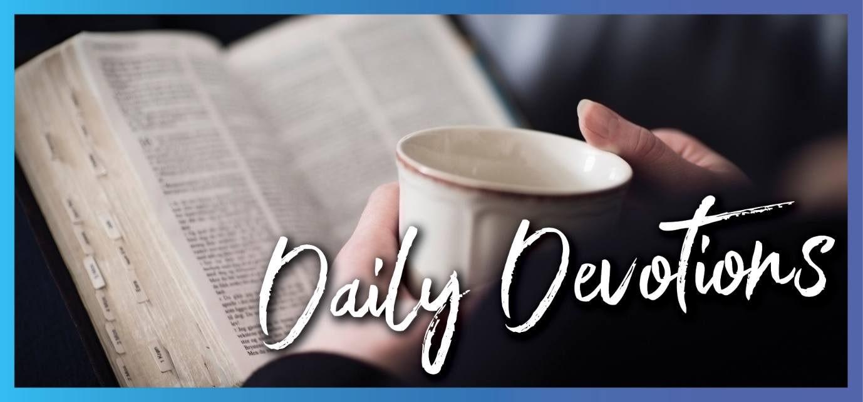

Sunday 26 December 2021 to Sunday 2 January 2022
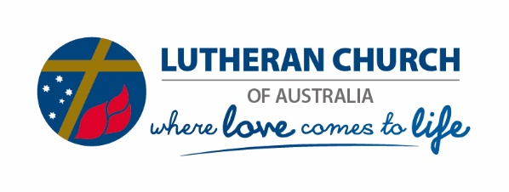
Sunday 26 December 2021

Growing in mind, body, spirit and relationships
by Pastor Nathan Hedt
And Jesus grew in wisdom and stature, and in favour with God and all the people (Luke 2:52).
Read Luke 2:41–52
Unlike modern biographies, we have very little record in the gospels of Jesus’ growing up years. The events between his birth and the beginning of his public ministry in his baptism all fit into less than two chapters (Luke 2 and Matthew 2). But there is this wonderful summary in Luke 2:52, after Jesus’ trip to the temple at 12 years old: ‘And Jesus grew in wisdom and stature, and in favour with God and all the people.’
This verse talks about the boy Jesus growing in body, mind, spirit and relationships. These are four essential elements that make us human and, to a large extent, comprise the ‘image of God’.
Body: Jesus was a real human being who went through all of the normal things that a young human does as they grow up. He ‘became flesh and dwelt amongst us’ as John 1 says.
Mind: The Son of God had to learn, to grow in wisdom. It’s an astounding thought that God had never experienced being human from the inside before! God’s very being was changed by taking the risk of the incarnation.
Spirit: Jesus grew in favour with God. It’s not that he didn’t have God the Father’s favour from all eternity. But he learned to actively carry out his Father’s will throughout his life.
Relationships: Jesus grew in favour with all the people. We see from the rest of the gospels that he really cared for people; he looked past their social status, illness, sin and weakness, and he loved them fully as he loved himself.
In this coming year, how beautiful would it be if each of us could, like Jesus, ‘grow in wisdom and stature, in favour with God and with all the people’! Could there be a better prayer or New Year’s resolution? If we could care for our bodies, the temples of the Holy Spirit. If we could grow more and more in wisdom, a God-given skill for living in the complexities of everyday life. If we could grow in Spirit in favour with God as we grow deeper in our understanding of his favour for us always through Jesus. If we could grow in relationships in favour with all the people, not just to please people but to introduce them more closely to Jesus.
Lord Jesus, thank you for the profound reality of your incarnation. This coming year, would you help me grow more fully human? Would you restore me in the image of God, so I may grow in wisdom and stature, in favour with God and with all the people? In your name, I pray. Amen.

Monday 27 December 2021

Drawn out of the water
by Pastor Nathan Hedt
Pharaoh’s daughter named the child Moses, saying, ‘I drew him out of the water’ (Exodus 2:10).
Read Exodus 2:1–10
Sometimes in life, it feels like we are in deep water. There seems to be no way out. But God’s plans are not only bigger than our own troubles; they are prepared over a longer timespan than we could conceive. God’s plans take in the sweep of a whole lifetime. Moses’ mother saw little hope, perhaps, when she was forced to place him in a basket on the Nile River. But God had other ideas.
God delights in working all things for good for those who love him! Ironically, it was Pharaoh’s order that Hebrew babies be thrown into the Nile that led his own daughter to adopt the child who would become God’s deliverer for the Hebrew people. Not only did Moses’ mother get to care for him, but she was also paid for the privilege! Later, God used Moses to deliver God’s people through the water of the Sea of Reeds in the great redemptive act of the Old Testament.
Like Moses, we too are people who are ‘drawn out of the water’. In the water of our own baptism, we get immersed in God’s redemptive plans and purposes for us. No matter how deep the waters we pass through, the water of baptism means we are deep within God’s plans for us. Our lives are plunged under the life of Jesus. Even our death is plunged into the death and resurrection of Jesus. Isaiah 43 expresses God’s promise for all he loves, all the people he draws out of the water:
Fear not, for I have redeemed you; I have summoned you by name; you are mine. When you pass through the waters, I will be with you; and when you pass through the rivers, they will not sweep over you … For I am the Lord your God, the Holy One of Israel, your Saviour… do not be afraid, for I am with you.
Dear God, sometimes it seems like I’m in really deep water and can see no way out. Thank you that you are working my troubles for my ultimate good and that in the water of baptism, you have promised to redeem and rescue me. Amen.
Tuesday 28 December 2021

Pursue righteousness
by Pastor Nathan Hedt
Listen to me, you who pursue righteousness, and who seek the Lord … My righteousness draws near speedily, my salvation is on the way (Isaiah 51:1a,5a).
Read Isaiah 51:1–5
‘Righteousness’ is a fairly unfamiliar word to us outside of our church experience. In many ways, it has taken on a somewhat negative tint. The term ‘self-righteous’ especially has connotations of being judgemental and hypocritical. What does it mean, then, to pursue righteousness?
New York pastor Tim Keller says that righteousness has two main elements. The first is to be right in relationship with God (not perfect or sinless, and certainly not judgemental, but having a heart tuned in to God’s heart). Abraham was ‘righteous’ because he believed and trusted God’s promises, and Isaiah 51:1 picks up on this connection by pointing to Abraham.
The second element of righteousness is that righteous people seek the good, the benefit and the blessing of the whole community. They invest their time, wealth and resources not for themselves but for the good of society. This is almost the polar opposite of a ‘self-righteous’ person who judges and condemns others.
Jesus says, ‘Blessed are those who hunger and thirst for righteousness, for they will be filled’ (Matthew 5:6). To long for a right and trusting relationship with God is a good longing. To hunger for justice and restoration to come to those who are hurting is a hunger God himself will fill. Righteousness in this sense is something that it is good to pursue, to pour effort into, for in doing so, we are aligning ourselves with God’s own mission of justice, salvation and restoration.
Let us pursue righteousness, for in doing so, we will be met and filled by God, himself!
Lord, you are the God who brings righteousness, justice and salvation. May my longings be aligned to your heart. Help me pursue righteousness and hunger and thirst for it. Thank you that you will fill this longing. In the name of the Righteous One, Jesus, I pray. Amen.

Wednesday 29 December 2021

A Father’s heart
by Pastor Nathan Hedt
But the more I called Israel, the further they went from me … all my compassion is aroused (Hosea 11:2,8b).
Read Hosea 11:1–4,8,9
Bette Midler sang, ‘God is watching us … from a distance’. Nothing could be further from the truth of God’s character found in the Bible! Far from a remote God watching us from a distance as Bette Midler sings. God is heartbroken, emotional, compassionate and deeply involved in the lives of his people.
The Book of Hosea is a poignant love story of God, who loved his people Israel although they continually rebelled against his love. Their rebellion placed them in great danger. Nothing breaks a parent’s heart more than these things: seeing a beloved child rebel and walk away or seeing a beloved child in great pain or danger. As a father, I’ve experienced the second but not the first to any great degree. God’s heart broke for both the rebellion and the danger.
Like the waiting father in Luke 15, the God revealed in the Book of Hosea longed for his people to return to him. He longs to shower his people with love and compassion, tend their wounds, save them from their often self-inflicted danger, and hold them close and whisper his love for them.
Have you wandered away from God? Have you actively rebelled? Have your decisions led to pain and hurt in your life? If you are carrying a sense of shame and distance from God, thinking to yourself that he wouldn’t go so far as to love or forgive you, remember the Father’s heart. He loves you. He longs for you. He will show forgiveness and compassion to you. The Father’s arms are open wide.
Compassionate and loving Father, thank you for your deep involvement, love and compassion in my life. When I turn away, help me turn back and come to your waiting arms. Thank you that your love for me never fades or changes, no matter what I do. Help me believe and receive your love and compassion. Amen.
Thursday 30 December 2021

All things
by Pastor Nathan Hedt
All things were created by him and for him. He is before all things, and in him all things hold together (Colossians 1:16,17).
Read Colossians 1:15–20
I have been awestruck – held absolutely speechless with wonder – when looking at an animation that conveys the scale and size of things in the universe. It’s simply impossible for the human mind to comprehend the size of stars, galaxies or the minuteness of atoms, neutrons, electrons and quarks. From the minuscule to the massive, the universe is beyond our conception.
In Colossians 1:15–20, St Paul conveys the cosmic scale and scope of the work of Christ. He uses the words ‘All creation,’ ‘all things’, and ‘everything’ seven times in six verses. Christ created all things. All things were created for him. All things hold together in him. He is before all things. In everything, he is supreme. God reconciles all things to himself in and through the cross of Christ. This just can’t fit in a human mind! But it is well worth contemplating, meditating on and letting ourselves be filled with wonder over. It is not just human beings but the whole cosmos that is brought into being and held together and redeemed by the work of Christ. The universe itself finds its purpose, origin, destiny and reconciliation in Christ.
Have you let the work of Christ become too small? Have you lost your sense of wonder of the scope and scale of Jesus’ love? Spend some time dwelling on Colossians 1:15–20. Let the Spirit work in you again a sense of awe and love for Jesus Christ, the fullness of God, and his work not just for you but for all things.
Lord Jesus Christ, as I contemplate the scope of your creation, your cross, your work and your love for all things, let me once again be ‘lost in wonder, love and praise’. Amen.

Friday 31 December 2021

From the beginning!
by Pastor Nathan Hedt
That which was from the beginning, which we have heard … seen with our eyes … looked [and] … touched – this we proclaim concerning the word of life (1 John 1:1).
Read 1 John 1:1–7
It’s New Year’s Eve. It’s the end of 2021, a year that has been one of ‘uninterrupted disruptions’, as I recently wrote in my journal. A year that when it began, I was hoping would turn out quite different from 2020. However, for us citizens of Melbourne, the year just past turned out to be more of the same: time-warping and somewhat traumatic COVID lockdowns.
It has sometimes been hard to hold on to hope this year. It has been difficult to remember that God is the Lord of all history, and he is working all things together for the good of those who love him and are called according to his purpose.
The apostle John powerfully reminds us that the Word of Life, Jesus, was ‘from the beginning’. The words of 1 John 1, Genesis 1 and John 1 say, ‘In the beginning God created the heavens and the earth’, ‘In the beginning was the Word’, and ‘That which was from the beginning’. This reminds us of the truth that the Word of God spoke the world into being. Whatever may be happening, Jesus – the incarnate, crucified, resurrected, ascended and exalted Word – is the one who gets the first and final word on how history turns out. Jesus speaks life where there is no life. He gives hope to the hopeless, forgiveness to the sinner, and healing to the broken.
Whatever you have been through in this last year, whatever you may be going through now, whatever situations may arise in 2022, Jesus is the Word of Life, who is, was and is to come. He holds the future, shapes the present and heals the past. On this New Year’s Eve and into the new year, you can trust in him, the Word of Life, from beginning to end.
Dear Jesus, you are the Word of Life who was from the beginning. You are the Alpha and the Omega, the first and the last, the beginning and the end. I commit to you this year that has been and the year that will come. Speak your word and bring life and light into my past, present and future. In your mighty and eternal name, I pray. Amen.

Saturday 1 January 2022

The name of Jesus
by Pastor Nathan Hedt
On the eighth day, when it was time to circumcise him, he was named Jesus, the name the angel had given him before he was conceived (Luke 2:21).
Read Luke 2:15–21
In the church calendar, New Year’s Day is known as the festival of the ‘Name of Jesus’. It’s the eighth day after the celebration of Jesus’ birth (counting Christmas Day as day 1!). The eighth day was the day Jesus was circumcised and given his human name.
I think this is a beautiful tradition. As people who have been marked with the name of the Son in our baptism, we carry the his name in each of our interactions in this new year. Not only our bodies but our time also bears the name of Jesus.
There are many names given to the incarnate Son of God. Saviour, Holy One, Lamb of God, Light of the World, Christ, Messiah, Anointed One, Lion of Judah, Alpha and Omega. Each of them brings a different shade of meaning and conveys a different facet of the person, work and character of this person, who is Emmanuel, God with us. We could fruitfully meditate each day on a different name given to Jesus and what that name means for his work with us.
Today, this New Year’s Day, let us spend some time contemplating the name the angel gave him on God’s behalf: ‘You are to give him the name Jesus’ (Luke 1:31). Matthew 1:21 tells us that he will be named Jesus ‘because he will save his people from their sins’. Jesus is the Greek version of Joshua, the Hebrew name Yeshua, which means ‘The Lord saves’. New Year’s Day and the name of Jesus means we go into this new year as forgiven people, beloved, washed clean, holy in God’s sight, spotless and radiant before God. What a wonderful way to start this year!
Jesus, your name is beautiful. Thank you that you have placed your name on us and that you have come to save us from our sins and forgive us. Please grant us the grace to bear your name in this new year. May your blessing be on all the days of 2022. In your beautiful, powerful and precious name, we pray. Amen.

Sunday 2 January 2022

Born of God
by Ruth Olsen
They are reborn – not with a physical birth … but a birth that comes from God (John 1:13).
Read John 1:[1-9],10–18
As John wrote, the Word of God already existed with God before time began; he gave life to everything that was created, and his life brought light to everyone. A light that the darkness can never extinguish (John 1:1–5)! But the world does not recognise him. Of ourselves, we do not recognise him! Human self-determination has separated us from God so that we are blinded and cannot recognise Jesus (see 2 Corinthians 4:4). Yet to any who receive him and believe in his name, he gave the right to become children of God. Reborn by the Spirit from above. Given new life that comes from God and has his DNA flowing through it! Amazing!
Anyone who receives and believes Jesus no longer belongs only to their earthly family but also to God’s family. Because Jesus, the Living Word of God who is ‘full of grace and truth’ (John 1:14 NIV) has come to us and dwells among us. He makes his grace and truth fully available for us to live in, walk in, soak in and share with others. He reveals God to us as the Father who is for us. His family spans around the world and stretches across time. Does that make a difference to how you see yourself and others around you?
The gift of unconditional love for a newborn is amazing, but often, we don’t recognise it. An unconditional love that comes from God, given anew to every person born from above, empowers us to love others.
Every day as we receive Jesus and believe in his name, we are drawn into his grace and truth, to what he is like. His DNA in us by his Spirit makes us new; his light inside us overcomes the darkness no matter what the world might shout or what our spiritual enemy whispers. Reborn with new life from God, in renewed relationship with him.
Lord God, draw us deeper into your grace and truth that sets us free to live as loved children, in and through Jesus, your light into the world. Amen.

