agenda 14.1

Finance, Audit and Risk Committee

MEMBERS
Mel Zerner (SA/NT District), Stephen Podlich (Qld District), Peter Schirmer (Executive Officer of the Church), Debbie Venz (LCA Business Manager)

BACKGROUND
The Finance, Audit and Risk Committee was established by the General Church Council in 2014.
The primary objective of the committee is to assist the GCC in fulfilling its finance-related responsibilities prescribed in the LCA’s By Laws (Section 8.4), monitor risk and ensure compliance with relevant legislation. Its role is to provide independent comment, advice and counsel to GCC on matters within the FAR’s Terms of Reference and respond to issues that may be referred to it by GCC from time to time.
This report provides an overview of its activities during this synodical term.

Cooperation with other areas of the Church
The committee engages with other areas of the church to discuss issues of mutual concern and interest. During the 18th synodical period, the committee has met with Allen Kupke (to address issues concerning the LLL particularly its transition to an Authorised Deposit-taking Institution and discuss the work of the Commission on Salaries); Graham Tscharke (to review the church’s insurance cover through LCA Insurance), Mark Le Cornu (LCA Auditor), and Stephen Kroker (Lutheran Education Australia). It has also received and reviewed reports from the Loan Management Committee in regard to the approval and monitoring of loans.

RiskS
A major component of the work of the committee is to look at risks to the church. These include financial, operational, reputation and legal risks. This is being approached by way of:
- development of a risk matrix and register
- reviews of the loans that are covered by the Guarantees and indemnities (primary the LLL and Westpac).
- policies are being developed to cover the operational and financial aspects So far delegations and fixed asset policies have been approved. The other policies being developed are general accounting principles, disbursement and payables, income recognition, audit, investment, treatment of reserves, Data Protection, Cyber and IT security, enhanced Work Health and Safety.
- reviews of LCA entities has been through its testing stage and, after the completion of Convention 2018 activities, will be launched with all the LCA separately incorporated entities. The review has some 30 items to check against.
- Legal and reputation risks are being assessed on an ongoing basis.

Systems Improvement
The committee has focused on improving the LCA’s financial systems, policies, processing and reporting in order to enhance transparency and meet standards of good practice. In this regard it works closely with the LCA’s auditors, MRL Group, to address matters raised in the annual audit report and related management letter.
Based on the recommendations of the LCA auditor, the FAR Committee has either finalised or is in the process of preparing financial policies in areas such as:
- General internal control environment policy
- Disbursements and payments policy
- General accounting policy
- Reserves and specific funds policy
- Accounting Policy
- Audit policy
- Investment policy
- Risk management policy
- Loans policy
- Asset recognition policy
- Delegations policy

Finance and Administration Department
The various financial and administration functions carried out in the Churchwide office were consolidated by the formalisation of a Finance and Administration department, which became operational on 1 January 2018.

A key reason for the change was the decision, mutually agreed by the LLL and LCA, for the LCA to resume responsibility for its own finance and accounting functions in order to meet its needs at operational, management and governance levels.

This decision was also consistent with the LCA auditor’s opinion that the LCA will be better served by the adoption of a new accounting platform. In this regard, a new accounting package, using MYOB and the Prophix reporting system, has been introduced and became fully operational in June 2018.

The formalisation of the Finance and Administration Department will enable better support to the LCA’s departments and other ministries in the areas of finance, IT, building management, and general operations. The aim is to achieve greater efficiencies in these areas and allow the departments and ministries to focus on their specific ministry programmes.

The FAR Committee takes this opportunity to thank the LLL for providing Central Treasury Services to the church over the past 18 years.

Financial reports for the synodical period
The financial reporting over this synodical period has been subject to continuous improvement following on from the enhancements made in the previous synodical period. Delegates will notice these changes when comparing the reports presented at this General Convention to those provided in 2015.
It is pointed out that, while the LCA has moved to a consolidated reporting structure, the departments still provide their individual financial reports as part of their synodical reports.

Explanatory notes on financial performance
The financial results over the past three years are included in the Book of Reports (see 14.2). This report provides information about the reasons for significant variations from year to year in a number of income and expenditure areas.

Income
The financial statements shows small changes in income over 2015 to 2017. This primarily reflects decreases in funds from the districts and the cyclical nature of income related to the triennial General Conventions of Synod.

Appeals donations and requests
The main reason for an increase in this income category between 2014 and 2017 is that the LCA received a significant bequest and there was an appeal for the Disaster and Welfare Fund (for the South Australia and Western Australia fires of late 2015). There were also additional donations for LCA International Mission over this period.

Investment income
This category primarily consists of interest received from funds held on deposit at the LLL, in line with the current investment policy. The LCA income from this source is lower than previous synodical periods because of a reduction in the interest rate on LLL deposit accounts.

LCA Group income
This area of income increased significantly in 2017 compared to 2012 and 2013. The primary reason for this variation is the increase in recorded income from the LLL. In 2014 the LLL income is exaggerated because income received from the LLL in this year included income received for planned expenditure both in the 2014 and 2015 years. This has resulted in a corresponding reduction in LLL income in 2015.

District income is also included in this category. The amount transferred from the Districts to the Churchwide office has declined over the past three years, after deducting the additional, one-off income amounts received from the LCA NSW District (approximately $330,000 in 2017 and $655,000 in 2016), which came as a tithe on the proceeds of the sale of two District properties. These additional funds have been allocated to specific projects and not for general income. We are very grateful to the LCA NSW District for these special contributions to support the work of the wider church.

Changes to the management of the LCA Pastor Transfer and Support Fund now have the costs being directly paid from the LCA rather than through the Districts as has been the case previously. This has contributed to the increase in recorded income in this category. The Districts are now also forwarding the income to the LCA in the quarter following its receipt in accordance with the rules of the Fund, a process which hasn’t always been strictly followed in the past.

Reimbursements
This income item fluctuates from year to year depending on the level of expenditure incurred by the LCA and then subsequently reimbursed to it, as well as the reporting periods in which the transactions occur.
Trading income
This records the income for services supplied by LCA entities (eg for training and conferences) to other bodies, such as congregations and parishes and individual members.

Expenditure
LCA expenditure has increased by approximately $1,430,000, or 19% over the three year period.

Fixed Assets and Depreciation
In the 2015 financial year a review and revaluation of all fixed assets held by the LCA was undertaken. This took place as part of the introduction of the LCA Fixed Asset and Depreciation Policy. The result of these actions was a net change to the balance sheet of $405,000 and a depreciation expense in the 2016 and 2017 of $65,000 per year.

Ministry expenses
The main expenditures under this category included support for the work of Finke River Mission, pastors and teachers transfer and support costs (through the LCA Transfer and Support Fund) and the operations of The Lutheran.

Project Costs
This category has included the costs of the North Adelaide redevelopment project, Governance and Administration review, the Royal Commission into Institutional Responses to Child Sexual Abuse, LCA Aged Care and Community Services Dialogue, the implementation of Synod resolutions (such as the draft doctrinal statement on the ordination of women and men; prevention of domestic and family violence campaign; and the review of the call system), various ICT projects, the 50.500-related projects and grants, as well as costs associated with General Convention of Synod and General Pastors Conference.

Overall results
The overall results shows deficits in each year, largely due to draw downs of departments funds through approved spending and because income recognised in one year wasn’t necessarily spent in that year. As outlined in the segment reporting, the LCA National Office reported modest losses in each year, largely due to additional depreciation and lower income for the reasons outlined above. The availability of uncommitted cash reserves improved over the three year period, which has increased the LCA’s capacity to meet its obligations and any unexpected adverse events.

Balance Sheet
Reserves
Where income has been recognised in line with the income policy, but has not been fully expended within the reporting period, the balance of the funds is transferred to the appropriate reserve account or into accumulated funds.
This funding is then available to the department for use in future years in accordance with the purposes for which the income was given and thereby ensures that the wishes of the donor is honoured.
A comprehensive review of the reserve accounts has been undertaken in this synodical term and it is expected this task will be completed early in the next synodical term.
The FAR also reviewed the all of the LCA’s bank accounts and a number were identified as no longer serving a purpose and were closed. The balance of the funds in these accounts were transferred to the appropriate department to be used according to their intended purpose.

LCA Property companies
In 2004 three companies limited by guarantee were established to hold the land and buildings owned by LCA. The LCA auditor advised the FAR Committee that these companies were not set up as charities and therefore were subject to taxation, stamp duty and other costs. A review found that none of the companies had accrued any liabilities since inception. They were all subsequently registered as charities in 2015 and are now operating as intended.

The rental income and operational costs of each company are received and paid for by the company.

Summary of allocation of income from Districts
The income from the congregations and parishes is derived from two main sources, as follows:
2017 2016 2015
Income via Districts (removing non budget amounts) 1625,554 1,627,682 1,679,732
LCA Funds Levy 321,200 318,000 309,000
Total contribution to LCA 1,946,554 1,945,682 1,988,732

This income is allocated to the LCA budget. The top four ministries by amount received from the LCA budget (and therefore where congregation/parish income received through the districts are allocated) are as follows:
- Australian Lutheran College ($1,425,000 in 2017)
- International Mission ($500,000 in 2017)
- Lutheran Archives ($163,000 in 2017)
- Finke River Mission ($180,000 in 2017)
The LCA budget must also meet the following expenditure areas:
- National Office direct costs (including reception and building)
- Office of the Bishop
- Office of the Secretary
As this indicates, and the graphs below illustrate, the District income primarily supports but is not enough to fully meet, the expenditure for these four ministry areas. The shortfall is therefore met by way of ‘other income’ derived from a number of sources, most of which are described above.
A key ongoing task for the FAR Committee is to explore options for a sustainable funding model, in cooperation with the ministries supported by the LCA, and all those bodies that support the work of the church.
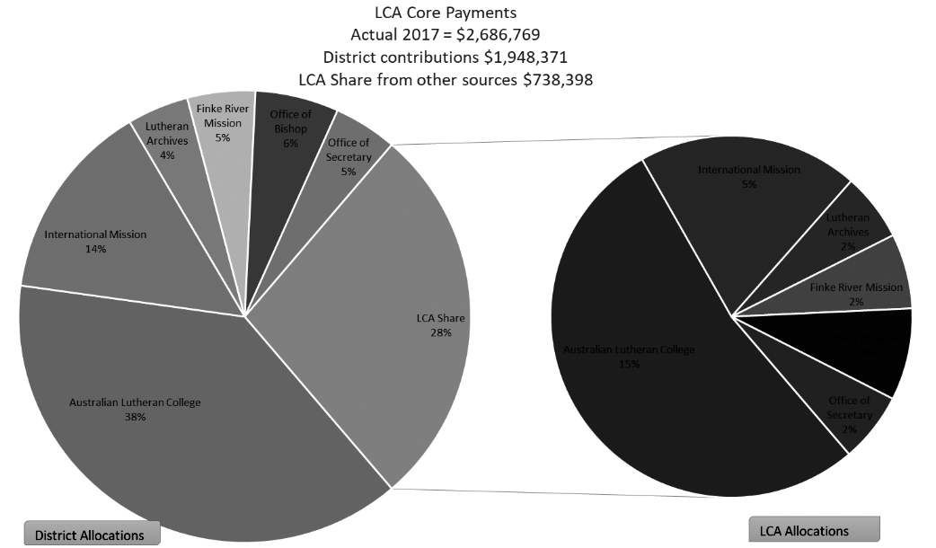

LLL Funding
2017 2016 2015
(Year of allocation; funds are spent the years following)
LLL grant funding: 1,716,000 1,670,000 1,475,000
LCA Department allocations:
Child Youth and Family Ministries 256,000 240,000 226,000
Assistant to the Bishop - Reconciliation Ministries 135,000 133,000 138,000
Assistant to the Bishop – Public Theology 60,000 152,000 0
Cross Cultural Ministry (Formerly Asian Ministry) 125,000 152,000 150,000
Church Worker Support Department 219,000 215,000 272,196
Communications Department 100,000 95,000 90,000
Interim Pastors 50,000 100,000 50,000
LCA Projects allocations:
Governance review: - implementation 170,000 80,000 100,000
ALC business review and Luther Conference 0 0 168,250
Local Mission – National Church Life Survey 0 0 85,000
ALWS – Community Education 110,000 107,000 75,000
Lutheran Bible Translators 20,000 20,000 20,000
The Lutheran 20,000 20,000 0
Convention of Synod 90,000 0 70,000
Implementation of Synod proposals: 95,000 155,000 110,604
Accounting project 186,000 150,000 0
Digitisation of pastor records 30,000 0 0
North Adelaide Redevelopment 50.000 50,000 0

LLL Permanent fund disbursements 1,673,000 1,599,000 1,852,000
LLL special gifts 885,000 325,000 325,000

