Week 1 Sunday School Activity Suggestions: Why Church?
Resources adapted from ministry-to-children.com

Memory verse
Again Jesus said, “Peace be with you! As the Father has sent me, I am sending you.” (John 20:21 NIV)

Songs
I’m Not Afraid https://crossroadskidsclub.net/song/im-not-afraid/
I’m Not Alone https://crossroadskidsclub.net/motion-video-im-not-alone/
Come With Me https://crossroadskidsclub.net/motion-video-come-with-me/

Craft activities
Peace Mosaic Art Project
Shred up a magazine picture or newspaper photograph and tell the students that this world is a broken place, just like this ripped paper. It is a mess! But there is good news! Jesus was born to bring peace to our world! He brings peace to us through the cross of His Son Jesus. And when God brings peace, there is great joy! Today we’re going to make something beautiful out of all of our ripped pieces.
- Distribute the coloured construction paper (red looks best) with the cross outline, glue, scissors, and newspaper and magazine pages.
- Have the students rip up the newspaper and magazine articles into small pieces and glue them into the cross outline.
- For an additional challenge, have students look for letters to spell “PEACE” and glue them somewhere on their page as well.
- Have them write out a simplified form of John 20:21 on the bottom of their papers. Younger students may need help with writing the words. “Peace be with you! As the Father has sent me, I am sending you.”

Good News Bookmarks
Have students create the bookmarks; help them cut and hole punch (glue to cardstock if necessary) and attach string. Then provide paper and note caption. Have students create encouraging Good News cards to pass along to friends, reminding them that Christ is their “life saver”! Attach a lolly (and maybe eat one, as well…).

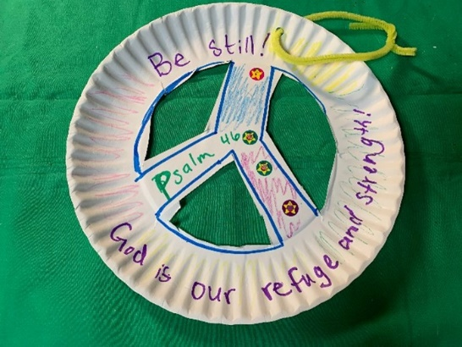
Be Still Door Hanger
Supplies
- Construction Paper or cardstock
- Scissors
- Glue or tape
- Decorative elements as desired
- Markers or crayons
- Paper plate
- Pipe cleaner or string

1. Trace a peace sign in the paper plate.
2. Carefully cut the triangular elements out of the plate so that the peace sign stands out.
3. Decorate the plate with memory verse (Peace be with you!), captions, etc
4. Add extra stickers and decorations as desired.
5. Attach a string, pipe cleaner, or magnet. Use the peace plate as a door hanger or refrigerator magnet to recall the importance of being at peace and still in the Lord.

