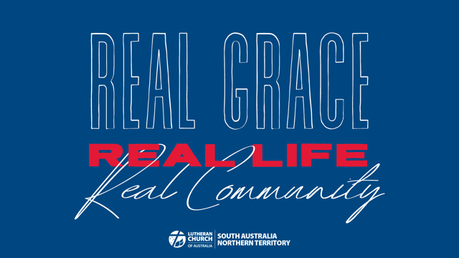

Bible Study Week 3
REAL LIFE
Real Life is where God’s love changes the way we live. In Real life we Grow as God’s people.

Real Life was taught by Dietrich Bonhoeffer, who challenged us to live in selfless community together.

We are not afraid to embrace Real Life. When things don’t look perfect, we know that God’s grace and love will see us through. Real Life is acknowledging our mistakes and learning from our struggles. Real Life is trusting in God in the midst of those struggles.

OPENING
What does it look like when God softens a heart of stone?

In what ways has God been patient with you? What is so powerful about God’s patience?

What does it take to make lasting change in a person’s life?

STUDY
When Jesus called his 12 disciples to come and follow him what do you think began to change in them?

When they lived with Jesus what do you think the disciples may have found hard to adapt to?

Read Romans 6:1-18

Since we are no longer under the law what is wrong with indulging our sinful nature once in a while?

The idea of death is mentioned 15 times in this passage of Scripture. How does Jesus’ death and resurrection connect with our relationship with sin?

In his Small Catechism, Martin Luther encourages us to drown the old sinful nature we were born with and to let the new nature we have in baptism to come alive day after day. What parts of the old sinful nature nag at you? And what is the new life way of responding?

How does the Holy Spirit help us as we let this new nature come to life?

Read Galatians 5:13-26

What does Paul mean when he encourages us to keep in step with the Spirit?
The acts of the sinful nature listed by Paul in verses 19-21 sound pretty nasty. Why would we want to do those things?

What part of your sinful nature would you like to be crucified and buried?

What fruit of the Spirit (v22-23) would you most like to see the Holy Spirit grow in you?

What are the things that most help you to leave the old life of sin behind?

APPLICATION
When new people come to our church how can we support them in their struggle with sin?

People’s personal battles make life messy in the Church. Why is it important for them to feel safe and to know that they belong at these times?

How do we see the work of the Spirit in the people who are struggling in our church community?

FEEDBACK
As you finish up your study please take a moment to send us a few notes at the District Office. We’d love to hear any stories or responses that you would like to share with us.

Send us an email at administration.sa-nt@lca.org.au or post your notes to 137 Archer Street North Adelaide SA 5006

We look forward to sharing in stories from all around South Australia and the Northern Territory.

PERSONAL REFLECTION TIME
Read Psalm 103

What part of this psalm encourages you today?

List some of the wonderful things the Lord has done in your life.

In what way does the psalm writer talk to himself and what is he saying?

What could this psalm teach you about your own self talk?

