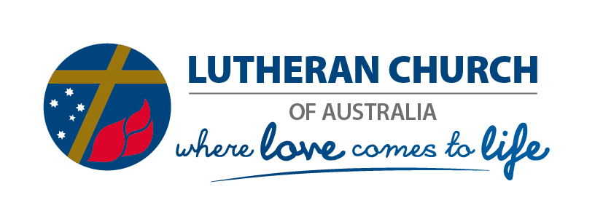

30 March 2020
Government Stimulus Package – Charities and Not-for-Profits

Background
The following provides a summary of the government’s stimulus package that may be available to your congregation. Please contact your District Administrator if you have any questions.
Further information is also available here: https://www.business.gov.au/Risk-management/Emergency-management/Coronavirus-information-and-support-for-business/Boosting-cash-flow-for-employers
Summary
The cash flow boost offered by the government is linked to the amount of PAYG withholding reported for the January to June 2020 period.
The basic eligibility requirements for Not for Profits - NFPs (including charities) are as follows:
- The entity must be a small or medium business entity (NFP bodies that would ordinarily be eligible for GST concessions are deemed to satisfy this).
- The entity must pay a wage or salary for the relevant period which would ordinarily be reported on an activity statement (irrespective of whether an amount of PAYG is actually withheld).
- The entity must be ACNC-registered during the period.
It is important to note that Point 2 is vital – only entities that pay employees – for taxation purposes this includes pastors - (and would therefore be registered for wage reporting to the ATO) are eligible.
There are two payments as follows (assuming quarterly activity statement lodgement cycle):
First payment
- Will be equal to:
  - 100% of the amount of PAYG withheld on the March and June BAS’s, up to a maximum of $50,000; OR
  - If PAYGW is less than $10,000 per quarter – the payment will be $10,000 on the March BAS
- This will be applied as a credit direct to the entity’s ATO account upon lodgement of the March and June BAS’s. If there is an amount refundable on the BAS as a result, the entity will receive a refund directly to its bank account.
Second payment
- Will be equal to the first payment, paid in equal instalments upon lodgement of the June and September BAS’s.
- Will be applied as credit direct to the entity’s ATO account upon lodgement of the June and September BAS’s
- If there is an amount refundable as a result, the entity will receive a refund directly to its bank account.
Therefore the minimum amount an employer will receive is $20,000. The maximum amount will be two times the combined PAYGW on the March and June BAS’s, up to a maximum of $100,000.
There is no need to specifically apply for the relief. It will automatically be applied when the March, June and September activity statements are lodged by employers (assuming quarterly lodgement cycle).

Peter Schirmer
Executive Officer of the Church

