13 December 2019

Communiqué 1: Review of the LCA Constitution – Phase 1

A message to all members, bodies and agencies of the Lutheran Church of Australia and New Zealand.
We are preparing ourselves to update our church-wide Constitution.
Our church has commenced a half-century review of its Constitution - our legal basis for being. We are excited at the prospect of being able, at a future General Convention, to update our constitution which has served us well, to enable us to better witness and thrive in the 21st Century.
Do you think the name of our church should change?
How could the Constitution, in a changing context, be framed to better reflect and thereby support the mission and ministry of our congregations, our communities of witness and service, our local early childhood, youth, schools, aged care and other community services?
How could a new Constitution help ensure good and timely decisions within our church?
What authorities, By-Laws, policies, processes etc need to be better expressed, clarified or changed in an updated Constitution?
These are just some of the many questions and opinions that may arise amongst church members during this Review.
The Church is currently commencing Phase 1 of the Review. In this phase, we will discern Key Principles for updating our Constitution. In 2021, General Church Board will be responsible to decide if, when and how we will move into Phase 2, planning for the actual updating of our Constitution.
Further Information about the Phase 1 Review and how it will be conducted is available here: LCA-NZ Constitution Review.docx
I encourage all Congregations, Districts, Boards, Councils, other bodies and agencies of our church to make this an agenda topic during at least one of your meetings - and then provide your combined wisdom to the people who are helping to facilitate this most important project.
In my next Review Communiqué I will share with you how you can all participate in the Review by completing a Survey or by making a submission.
We are also in the process of setting up a webpage for this Review as part of the LCA website. Shortly you will be able to find out more about this important Review by going to the LCA website (www.lca.org.au) and clicking on the “LCA/NZ Constitution Review” tab. I’ll let you know when the Review webpage is up and running.
In the meantime, if you have any enquiries about this Phase 1 Review you may contact Peter Schirmer, Executive Officer of the Church at peter.schirmer@lca.org.au.
Yours in Christ,
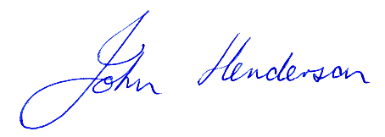
Pastor John Henderson,
Bishop
Lutheran Church of Australia.

