(NAME OF CHURCH)

Return to Worship during Stage 3 of COVID
Industry Plan

(LOCATION)

Ensure the Checklists and Statement of Compliance (Appendices 1, 2 and 3) are completed, printed, signed and prominently displayed

Key Points
(modified from 30 June Communique. This document was distributed to congregational leaders on 22 July 2020)
UPHOLDING THE PRIMARY HEALTH RULES:
> Physical distancing
> 4 square metres per person when indoors
> Hand hygiene
> Respiratory hygiene
> Frequent environmental cleaning and disinfection
> Stay at home if you are sick

RECORDING:
ROAD MAP THREE continues to require the recording of contact details for our Church gatherings and to keep these for 56 days.
NOTIFY LCAQD District Office of your intent:
NUMBERS:
a. Gatherings:
For smaller venues under 200 square metres the ratio is still one person per 4m². However, for these smaller venues the Government does permit a distancing of one person per 2m² if a COVID Safe Checklist is used. This Checklist is part of the COVID Safe Industry Plan, so it is recommended that to opt for the one person per 2m² density, it is best to err on the side of caution and complete the plan. The COVID Safe Checklist includes reference to a Risk Assessment and a template of an assessment is attached.
b. Weddings and Funerals
Maximum of 100 people and provided contact details are kept for at least 56 days
CLEANING:
ROAD MAP THREE requires continued vigilance regarding cleaning. Directions for cleaning can be found on pages 11 and 12 of the Industry COVD Safe Plan for Places of Worship (this advice can be followed whether or not your congregation is adopting this Industry Plan - check link in next section).
INDUSTRY COVID SAFE PLAN FOR PLACES OF WORSHIP:
In Queensland, we have approved COVID safe plans, including one for places of worship. https://www.covid19.qld.gov.au/government-actions/approved-industry-covid-safe-plans. ROAD MAP THREE explains that "COVID Safe Industry Plans continue to apply with revisions to reflect changes in Stage 3. COVID Safe Checklists continue to apply."
There is NO requirement to adopt the "Industry COVID Safe Plan for Places of Worship" if your community chooses and your gathering space is below 200 square metres and you keep to 50 and under (note the previous comments on "NUMBERS").
The "Industry COVID Safe Plan for Places of Worship" stipulates singing is permissible, as long as you comply with the appropriate density arrangements (eg 1 person per 4m²).
FACE MASKS:
The revised plan instructs that a face mask needs to be provided to an attendee, should that person display symptoms of COVID-19, and that the procedure for dealing with such an incident recorded in the Risk Assessment. It is essential that should an incident occur, the LCAQD be notified as required.
OLDER QUEENSLANDERS:
ROAD MAP THREE does not specifically address the situation of Older Queenslanders but the regulations for Aged Care communities changed on June 17th. There are specific requirements for FLU VACCINATION prior to visiting and Aged Care Facility. Care for older Queenslanders is a special priority in matters of the "Primary Health Rules".
https://www.qld.gov.au/health/conditions/health-alerts/coronavirus-covid-19/current-status/public-health-directions/aged-care
YOUR LOCAL CHURCH OFFICE:
ROAD MAP THREE advises that "Office-based workers can return to their place of work."
ADVICE REGARDING REMOTE LUTHERAN COMMUNITIES: Hopevale, Wujal Wujal and Coen:
ROAD MAP THREE directs us to the "Remote Communities Roadmap", which explains that any easing of restrictions in those areas will occur following an assessment of public health advice, response capability and community consultation. Each of the "Restricted Access" communities, including Hopevale, Wujal Wujal and Coen are addressed separately from the rest of Queensland's various communities by the Chief Health Officer.
https://www.health.qld.gov.au/system-governance/legislation/cho-public-health-directions-under-expanded-public-health-act-powers/restricted-access-to-remote-communities
FUTURE CHANGES:
ROAD MAP THREE points to potential changes in the future, based on "Ongoing review of state-based restrictions" contingent on levels of community transmission.
ASYMPTOMATIC:
A good guiding question to discipline our Church work during this time of the "Road Maps" is to consider what would be best practise, if you happen to actually be a carrier of the virus in the "asymptomatic" category (ie: you are a carrier but don't have symptoms).
NOT 'REQUIRED' TO:
Congregations and parishes should NOT feel they are "required" to begin gatherings for public worship at Church straightaway. There may be local reasons for continuing with online worship. Pastors need to be ready, willing and able to take up duties that involve more social and physical contact. We must remember that some pastors are still "high risk" persons, as are some Church Workers and other volunteers and as are a number of the people who participate in the life of the Church.

CARE:
Our congregations have been outstanding in the work of care, ensuring that needs of vulnerable people are being addressed. This work of care remains a primary task as we travel the road map of reducing restrictions.
PANDEMIC STILL:
We yearn for an end to this pandemic. The rate of infection and death is very low across the states of Australia. However, we are travelling these "ROAD MAPS" because the COVID 19 Coronavirus pandemic continues to spread throughout the world. Our neighbouring countries are experiencing tragic escalations in infection and death. This global pandemic is far from "over".
PLANNING TO SERVE:
ROAD MAP THREE does not give directions for Christian service to the needy. That is not the job of the Government. In this time of pandemic, the people we serve in the name of Jesus, need us to continue to "do unto others as we would have them do unto us." Our Lutheran communities have opportunities to find new ways to support folk who are suffering on account of COVID19, such as those who are isolated, those who have lost income, students unable to get by financially, people caught up in domestic violence, those struggling with unexpected mental health issues, older people unable to connect with family members.

Important Links to Information

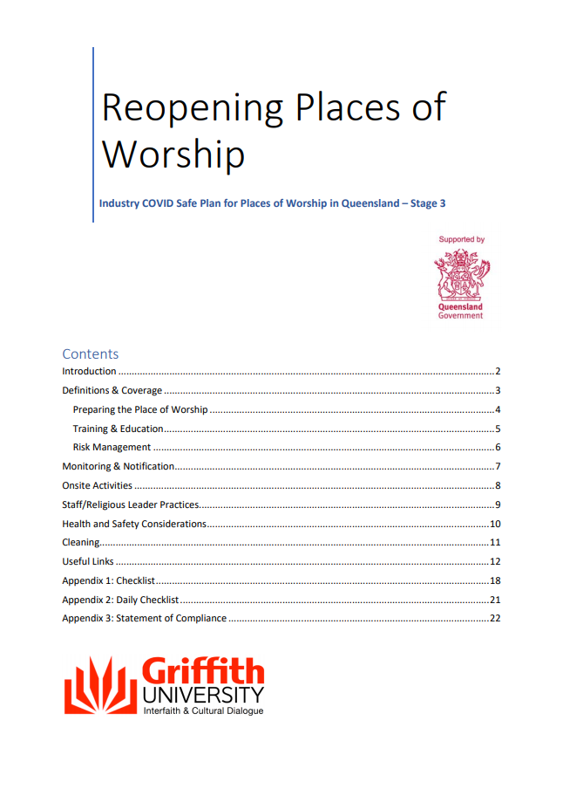  COVID Safe Industry Plan  COVID Safe Industry Plan | 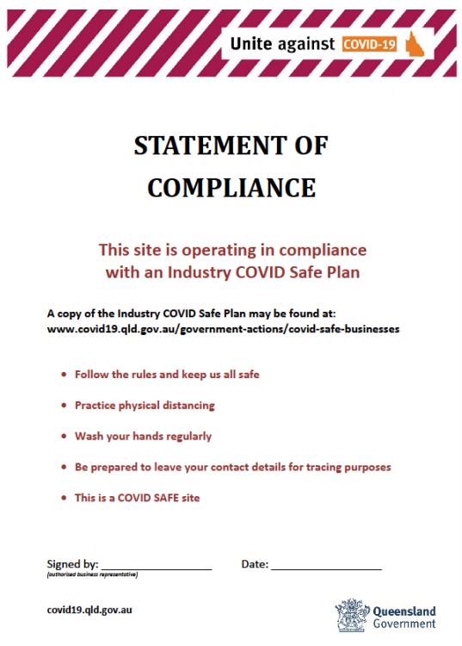  COVID Safe Compliance Statement  (See page 22 of Industry Safe Plan)  This needs to be displayed in the place of worship. | 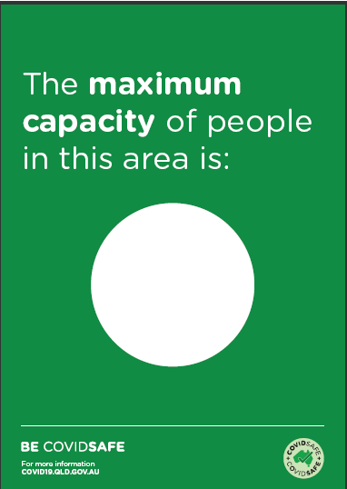  COVID Poster – Blank Circle  See Poster
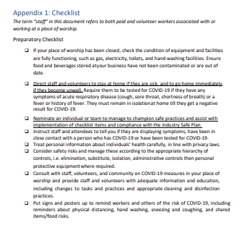  COVID Safe Checklists  (See page 18-20 of Industry Safe Plan) This needs to be displayed in the place of worship. | 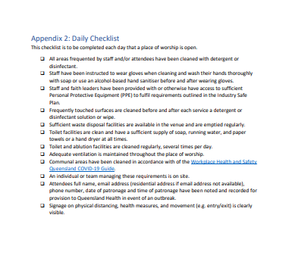  COVID Safe Daily Checklist  (See page 21 of Industry Safe Plan) | 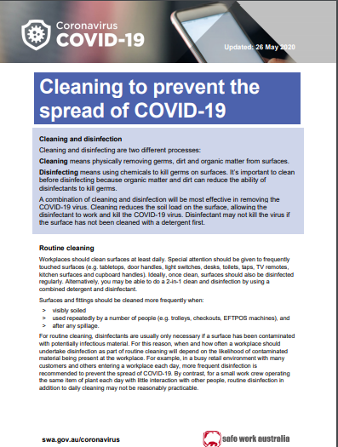  Cleaning to prevent COVID-19  Cleaning to prevent COVID-19
Contact Tracing Register  Draft attached to this document | National COVID-19 Safe Workplace Principles  National COVID-19 safe workspace principles

Printable Posters
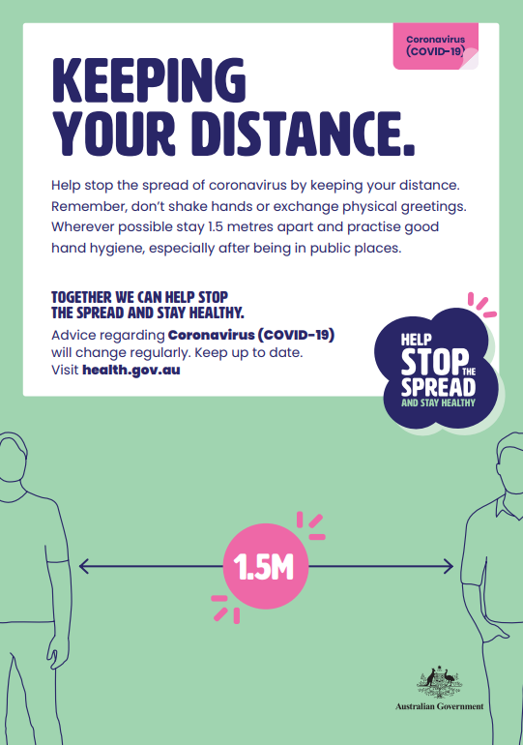  Keeping your distance | 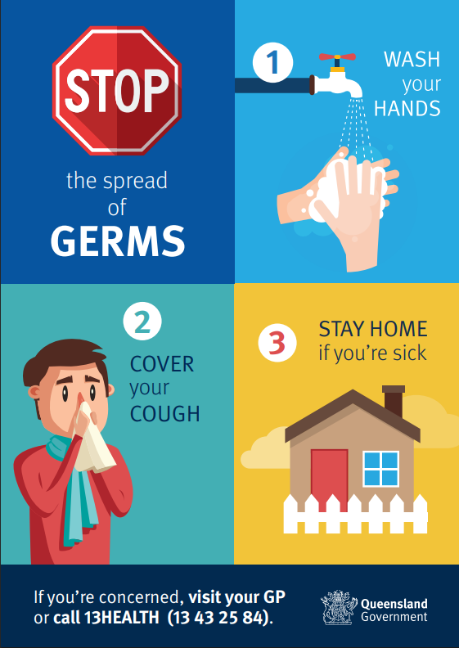  Stop Spread of Germs | 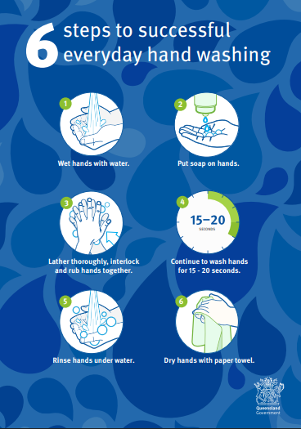  6 Steps to wash hands
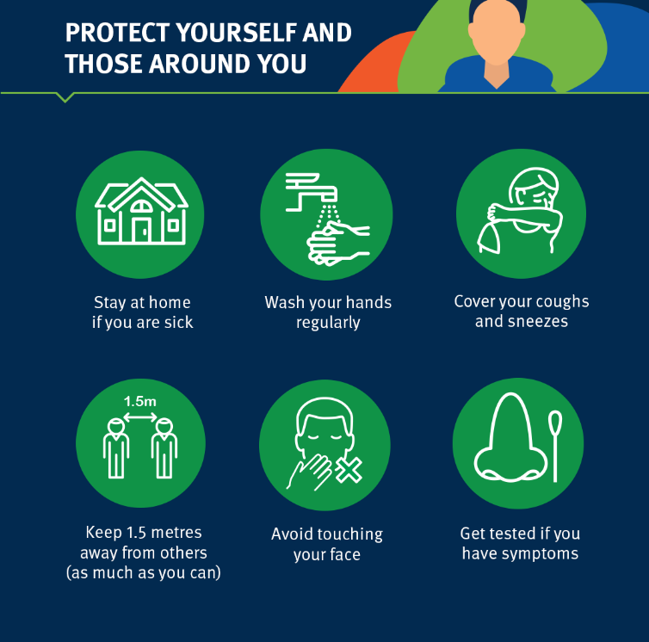  Protect those around you | 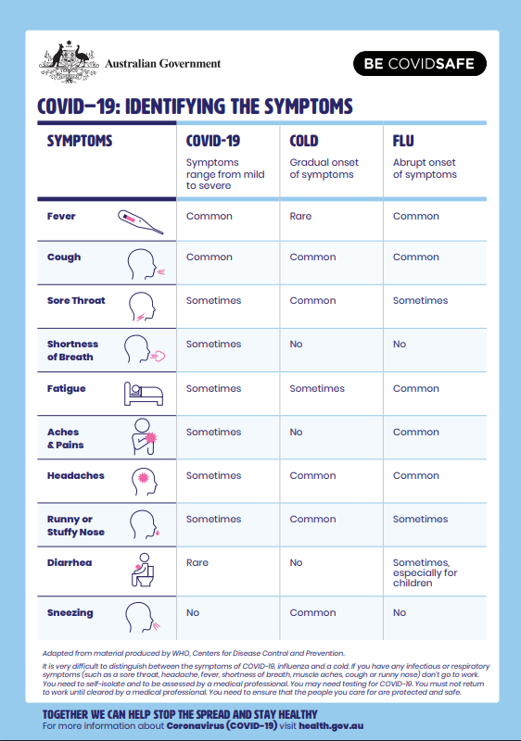  Identify the Symptoms

Procedure Examples and Suggestions

Pre-Worship Procedure

- Use of clear signage that describes church policies and best hygiene practices. [Signage listed below]
- Follow guidelines for cleaning and disinfecting all spaces prior to people arriving.
- Map clear routes of movement from the entryway into the worship space, and plan ways to maintain physical distancing while people move along those routes.
- Prior to the commencement of service, stipulate that worshipers should not be attending worship if they are feeling ill, have been exposed to COVID-19, have compromised immune systems, or are at high risk of exposing others. Let them know about other options such as online worship.
- Welcome attenders and advise of ‘housekeeping rules’ toilets and risks and ensure maximum numbers are not breached
- Prepare and outline expectations for restroom distancing. Limit the number who may enter at the same time, using tape on the floor for those waiting in order to maintain proper physical distancing.

Worship Procedure

- Refrain from passing a collection plate during the offering; have stations where people can place offerings and/or provide them with online giving options.
- Holy communion will be prepared and distributed following appropriate hygiene protocols.
One suggestion is as follows:
  - Those preparing and serving holy communion will sanitise their hands immediately before distributing communion in view of the congregation.
  - The congregation will process to receive Holy Communion in a continual pattern, maintaining social distancing procedures
  - Wafers will be emptied onto a paten with minimal touch – and distributer placed into open palm of recipient. OR Wafers will be placed into individual cups so that attenders can safely take a cup containing a wafer and a cup containing wine. Used cups will be disposed of.
  - Individual cups with be used spaced far enough apart to minimize people’s touching of other glasses.

Post Worship

- Share announcements and remind people to maintain social distancing.
- Invite people to enjoy fellowship whilst maintaining social distancing
- Ensure all surfaces touched are cleaned using appropriate solution
- Dispose of waste

Risk Assessment for Returning to Worship – NAME OF LOCATION
Assessed by XXXXXXX Date of Assessment: DATE
Position: XXXXXXXX Date of Review: DATE
Industry Plan Requirements | Hazard | Potential consequence | Existing Controls | Risk Rating with Existing Controls Low, Moderate, High |  |  | Additional controls required to reduce risk so far as reasonable possible | Risk Rating with Additional Control Low, Moderate, High
Gathering for worship (up to 50 people without opting into the Industry Plan)  OR  Gathering for worship (up to XXX people opting into the Industry Plan) | COVID-19  from congregants who are infected | Those present could catch COVID-19  (which could result in serious illness or death) | Sign in Register referring to appropriate questions associated to risk.  Visual screening of attenders for presenting symptoms and encourage them to be tested.  Attenders briefed on symptoms of COVID-19 and being told to stay home if they aren’t feeling well.  Physical distancing of 1.5m adhered to.  Correct ratio of people to size of room indoors is adhered to.  Refrain from handshaking and hugging |  | M |  | Cleaning and disinfecting in accordance with guidance from Safe Work Australia and Health authorities. (Before and After)  Frequently touched surfaces regularly cleaned.  Provision of alcohol based Hand Sanitizer and hand washing stations are accessible with soap and paper towel.  Prohibition of food or catering, including refreshments or beverages at Church gatherings/meetings.  Signage is to be displayed as a visual reminder.  If a leader or attendee displays any cold-like/flu-like symptoms, they will be provided a face mask and directed to leave to seek medical advice.  Record of attendees (name and contact details) must be kept and forwarded to Church Council as a measure to assist the Government in the case of infection. |  | L
Pre and post cleaning and sterilisation activities by designated cleaners. | COVID-19  infection from cleaning activities. | Contamination to designated cleaners. | Appropriate hygiene practices including washing hands. |  | M |  | Nominated cleaners to wear disposable gloves and use disposable wipes.  Used wipes, gloves and any rubbish to be placed in plastic garbage bags and removed from the building. |  | L

Activities worship activity (Holy Communion) | COVID-19  infection  from partaking in Holy Communion. | Cross infection of Covid-19 during Holy Communion Service. | Pastoral Assistants adhering to appropriate hygiene practices including hand sterilisation. |  | M |  | Individual disposable cups to be used.  Wafers to be dropped into hands of recipient  OR  Wafers placed in disposable individual cups  OR  other |  | L
Singing within worship. | COVID-19  infection  from partaking in singing. | Cross infection of Covid-19. | Maintenance of appropriate venue density rations |  | H |  | Emphasize social distancing requirements. |  | L
Anxiety associated with returning to worship after a prolonged absence. | Impacts on mental health of members and guests. | Increased anxiety Feeling stressed | Reassure members of the current situation and controls in place as outlined in this plan. |  | M |  | Communicate openly with realistic perspectives of the situation, based on facts.  Do not pressure any member for attendance in public worship |  | L

Sign In Register
Signing this form acknowledges that:

You do not have any symptoms associated with COVID-19 (eg., fever, cough, sore throat, shortness of breath, sneezing/runny nose or loss of sense of smell)

You do not have COVID-19 nor are you awaiting the results from being tested for COVID-19

You have not been in contact with any known or suspected cases of COVID-19 in the past 14 days

You have not returned, or been in contact with anyone else who has returned, from overseas or a declared COVID-19 hotspot within Australia in the past 14 days

Date:

Full Name | Phone | Email Address | Time IN | Time OUT | Signature

This form is to be retained for a minimum of 56 days from date of use.

