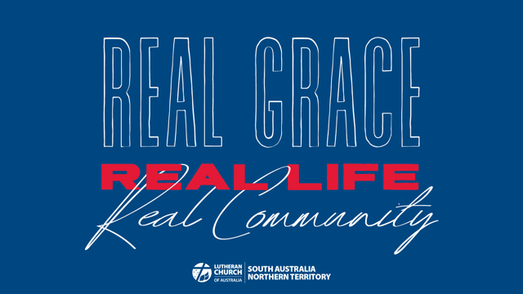

Bible Study Week 4
REAL COMMUNITY
Real Community is where we extend God’s love to others and learn to bring the good news into each other’s lives. The need for this real community leads us to go as God’s people.
Real Community was modelled by those who began the LCANZ journey in our countries. They put up with each other. They forgave and moved on. They cared for each other in the hard times. They taught real grace and ‘real faith’ not only on Sundays and in school rooms, but at camps and picnics and throughout the week — in real life.

We do Real Community as we live in grace together. The Church is a place where you can belong, where you can make real friends. Where you can discover your calling as we work together.

OPENING
When you have guests over for dinner, what do you do to welcome them? What is different from a normal family meal?

If you managed a boarding house or accommodation venue where would it be and what would it be like?

What does it look like when lost or lonely people to find acceptance and belonging?

STUDY
Read 1 Corinthians 12:12-27

The human body is such an interesting analogy to describe the church. What part of the body do you think you could use to describe yourself or the others in your group?

What does Paul mean in verse 22 when he says some parts that we think are weaker are actually indispensable?

How do you think the different parts of the body of Christ can serve the wider community outside your walls?

How could your spiritual gifts bring blessing to your neighbourhood?

What help do you need from the rest of the body to better serve your neighbour?

When people come to faith for the first time, or reengage with the Christian faith later in life they often come with many questions and a passion to learn. Describe the kind of environment you could create for them to explore these questions?

Read Ephesians 4:11-32

What kind of works of service has God put before you (either now or in the past) - in your congregation? In the wider community?

What works of service might he be putting before you and your congregation in the future?

How have pastors, teachers, church leaders and other church workers helped you to be prepared for the works of service that God has put before you? How could they help you more at this stage in your life?

Think of those in your church community who are younger or less experienced than yourselves. In what ways do they need our help to know God more and grow in Christian maturity? (see v13)

We certainly live in a crazy world blown about by pagan ideas and sinful desires (see vv14-16). How can we help the people around us find stability and grace in the midst of their busy lives? How can we help each other to shine the light of Christ?

APPLICATION
Where can you see God moving and working in the local community outside of your church walls? What might it look like for you to get more involved with him?

In what ways do people in your church community show welcome and kindness to new people when they come to worship with you?

What are some new ways you could extend warmth and hospitality to them?

FEEDBACK
As you finish up your study please take a moment to send us a few notes at the District Office. We’d love to hear any stories or responses that you would like to share with us.

Send us an email at administration.sa-nt@lca.org.au or post your notes to 137 Archer Street North Adelaide SA 5006

We look forward to sharing in stories from all around South Australia and the Northern Territory.

PERSONAL REFLECTION TIME
Read Psalm 1

What part of this psalm speaks to you today?
David says that when we are planted in God we yield fruit in season. What season do you feel like you are in at the moment?

At this stage in your life do you feel more like you are blown about or standing tall?

How would you like to be more planted in the streams of water that are God’s goodness?
Which part of the Scriptures do you delight in?

