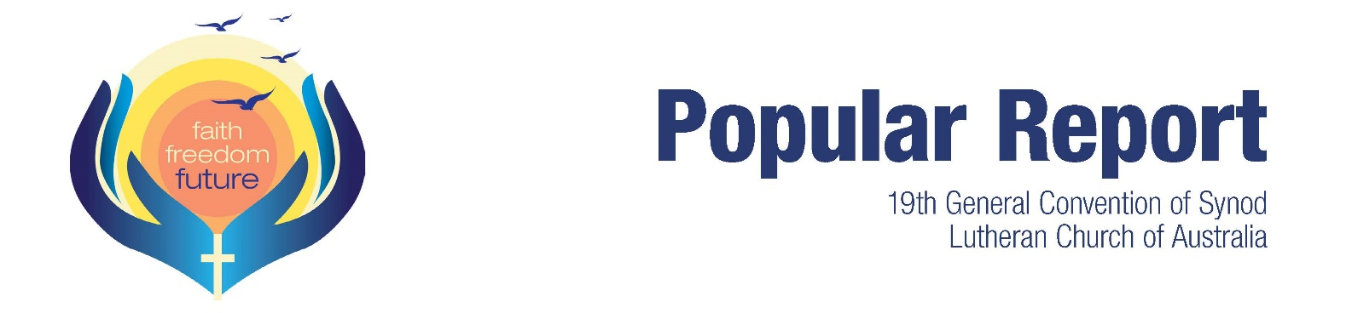
This report contains selected highlights of General Convention. For full coverage, visit the Worship and News pages at www.convention2018.lca.org.au Visit the Business page (Book of Reports) to read the reports and
proposals that came to Synod. Your delegate will be able to provide more information.
Ongoing, to keep abreast of all LCA/NZ news, sign up to the fortnightly LCA eNews via www.lca.org.au/enews
Prepared for LCA/NZ congregations by LCA Communications, 12 October 2018
What is Synod?
Every three years lay delegates from congregations and pastor delegates from districts meet at a General Convention of Synod to make decisions about the direction of the Lutheran Church of Australia. The ratio of lay to pastor delegates is approximately 2:1.
Synod is the highest decision-making body of our church. Our delegates have the power to make changes to the LCA Constitution and direct the General Church Board and other church bodies to perform certain tasks and report back to a subsequent Convention of Synod.
This year the 400-plus delegates who met in Sydney for the 19th General Convention of Synod (together with about 100 volunteers, exhibitors, visitors and staff) made some significant decisions on our behalf. This Popular Report gives you only a snapshot of those decisions; you should visit the Synod website or ask your local delegate if you’d like more information.
Worship
Once again delegates and visitors said worship was a highlight of Convention.
Every day commenced with a holy communion service, with the sermon (based on a text from Exodus) preached by one of our bishops. Worship styles and liturgies varied from day to day, with choirs, organists and bands adding diversity and richness to the songs and hymns.
Visual elements in the worship space reflected the Exodus journey out of Egypt. Entering the worship space, delegates and visitors walked between desert ‘rocks’ and rippling deep-blue velvet walls of ‘water’, before dipping their fingers in the water of the baptismal font. The altar was crafted in the dimensions of the altar in the tabernacle.
You can read the text of the daily sermons on the Worship page of the Synod website. The opening and closing services were live-streamed. You can watch them at https://livestream.com/luthworship
Ordination of women
General Synod again said ‘no’ to the ordination of women in the LCA.
Of the delegates registered at Convention, 161 voted against the resolution to ordain both men and women; 240 supported it. The LCA Constitution requires a two-thirds majority of registered delegates to bring about a change in matters of a theological or confessional nature. This was the fourth time Synod has voted on the issue.
The vote was the last item of business on the Friday. Immediately the next morning delegates gathered at tables to pray and listen with each other. The district bishops moved among them and reported back to Synod the feelings and concerns of the table groups.
NSW Bishop James Haak then proposed a motion, which Synod passed almost unanimously and without debate: ‘that Synod acknowledges the deep hurt and harm to individuals and groups that has been occasioned over the past years in the course of the debate regarding ordination; repents of the hurt, and seeks forgiveness and reconciliation with one another’.
The College of Bishops and General Church Board will meet this coming week. Members and friends of the LCA, please pray for our leaders, and for every-one experiencing strong emotions about the vote.
Reconciliation Action Plan
So far as we know, the LCA will become the first national church in Australia to develop a Reconciliation Action Plan (RAP) as part of its commitment to better hear, recognise and support Aboriginal people in the church.
Proposal presenter Shona Reid said the RAP would allow the LCA to draw on ‘existing relationships, knowledge and resources; provide greater support to its existing Aboriginal mission areas; develop stronger respect for Aboriginal and Torres Strait Islander cultures; and create opportunities for the LCA to work together, to grow strong in faith’.

‘At its core this proposal is about continuing to build upon our solid foundation of respectful and dignified relationships between the First Nations people and other Australians to enable us to come together and live reconciled in Christ’, Mrs Reid said. The resolution was carried with a standing ovation.
National Apology
During an evening devotion General Synod reflected in prayerful silence on our church’s part in failing to protect children in our care.
‘We acknowledge the harm suffered by victims of sexual abuse by pastors, other people in positions of trust, and members of the Lutheran Church of Australia and the synods that preceded it’, our delegates confessed.
The time of reflection and repentance preludes Prime Minister Scott Morrison’s National Apology on 22 October to people who were sexually abused as children in religious and non-religious institutions. The landmark step is an outcome of the Royal Commission into Institutional Responses to Child Sexual Abuse. In its final report, delivered to the Governor-General in December last year, the Royal Commission identified the Lutheran Church of Australia among churches that needed to acknowledge past failures to adequately protect children from abuse.
The LCA Commission on Worship is preparing resources for congregations to use in worship services on Sunday 21 October.
Earlier this year the LCA signed on to the Commonwealth Government’s National Redress Scheme for people who have experienced child sexual abuse in institutional settings.
LCA leadership elections
Pastors John Henderson and Andrew Pfeiffer were re-elected as LCA Bishop and LCA Assistant Bishop respectively for the next three years.
Synod elected to the re-named and leaner General Church Board (formerly General Church Council) Pastor James Haak, Paul Argyle, Charmaine Harch, Faye Schmidt, Tim Wiebusch, Mel Zerner and Peter Zweck. GCB members were elected under the new governance framework approved by Synod the previous day.
Aboriginal decision-making
Synod backed changes to the LCA’s Constitution to increase opportunities for Aboriginal representation and participation in church decisions.
Many Aboriginal Lutherans in Australia currently are not part of formally constituted LCA congregations. Therefore they have been significantly under-represented in LCA decision-making forums,

including conventions of synod and pastors conferences.
Subject to authorisation by the General Church Board, baptised Lutherans who gather as a body that is not formally constituted but which meets certain requirements will have the same representation and voting rights as those who are members of constituted congregations of the LCA.
Governance and
structural changes
Synod backed the formal introduction of changes to church governance and national functions, which have been trialled over the past three years.
Proposed at the 2015 Synod by the General Church Council (GCC), the changes were designed to provide more effective leadership and mission-centric activity within the LCA, and to deliver resources more efficiently in the church.
In 2017 GCC commissioned an independent review of the trial structure, which included consultation with individuals and groups directly impacted by the proposed changes, as well as those who were expected to benefit. The consultant reported that the majority of committees, boards and individuals which participated in the review reported greater effectiveness in focusing on the church’s core mission, with many also citing improvements in governance and administrative efficiency.
Among the key features of the governance changes are that nominations to all boards, committees and commissions will be competency-based, that GCC is renamed as the General Church Board (GCB) to more accurately reflect its governance role, and that the membership of the board is fully elected by General Synod rather than a combination of representation and election, and reduced from a maximum of fourteen members to nine, comprised of three pastors and six lay members (the same ratio as Synod itself).
Professional Standards and judicial system
Synod requested the General Church Board (GCB) to conduct an overarching review of the LCA’s ecclesiastical discipline, adjudication and appeals provisions, policies and processes.
The amended GCB proposal brought together a number of concerns about complaints handling and the judicial system that had been raised in proposals by two congregations and a district pastors conference. Synod requested that the independent review include the policies, procedures and practices of the Professional Standards Department, and that submissions be sought from interested parties.

