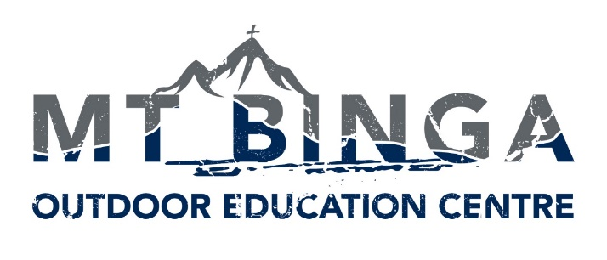

Mt Binga Outdoor Education Centre is owned and operated by Immanuel Lutheran College. It specialises in residential programs for groups in Years 5 - 10. Programs include high ropes / vertical rescue, navigation / expedition, horse riding and trail riding, mountain biking, archery, along with many other activities.

The main goal of the outdoor education program is that students experience community living and grow in their own self-sufficiency and confidence in who they are.

Mt Binga’s Values are that all participants will:-

- Show Initiative
- Persevere
- Collaborate
- Challenge Themselves
- Take Responsibility
- Respect Our Environment
- Have Gratitude
- Engage in Community

Suitably qualified instructors are invited to apply for the following:

Outdoor Education Instructors
Full-Time and Part-Time
Contract Positions are Available
(with a possibility of future permanency)
Commencing July 2022

A combination of the following skills are preferred:
- Live and work within the Christian ethos of the Centre
- Background in working with youth in a pastoral care or equivalent Outdoor Education role
- Cert IV in Outdoor Recreation
- Experience with a number of the following: high ropes, vertical rescue, navigation, expedition, horse riding and trail riding, mountain biking, archery, small and large group leadership and facilitation, pastoral care and 4-WD experience
- Ability to recognise potential risks and emergency situations in outdoor activities and a rural setting, and coordinate responses where required
- Senior First Aid certificate (Wilderness/Remote Area First Aid qualification will be considered favourably)

Further information, including position descriptions, are available here.
Electronic applications including the names of three current referees, and addressing the Selection Criteria as outlined in the Job and Person Specification to:

Head of Mt Binga
Mt Binga Outdoor Education Centre
Email: manager@mtbinga.com.au
Website: www.immanuel.qld.edu.au/our-college/employment

Applications close 4pm, Monday, 4 July 2022
Where: Mt Binga Outdoor Education Centre, near Blackbutt, Southern Queensland

