A Reflection on LUKE 9:1-6.

For 9.30 am (AEST) Saturday 26 September at our National Solemn Assembly,

**“for the healing of the land”**

**______________________________________________________________________________**

1. “Jesus called the 12 together”.

Yes, just as we are called together in this National Solemn Assembly, under the guidance of our First Nation Christian elders, led by Pastor Peter Walker.

1. Jesus “gave them power and authority over all devils and to cure diseases…”

We are called together now, in the Holy Spirit, to pray” for the healing of the land.”

We know the need.

There are so many who need the healing of their soul wounds.

Those hurt, from childhood to now, which can make people bitter and resentful, if there is no healing.

We know there are many people who carry around matters that diminish the glorious freedom of the children of God.

We know the land aches. The rivers too. The biodiversity of God’s beautiful creation needs healing and recuperation.

(Last week my cousin Doug showed me some native grasslands at Kinypanial, part of the country of the Dja Dja Wrung people, set aside to recover as a nature conservation area. The return, after twenty years, of rare and previously threatened native flora and fauna is wondrous to behold!)

I shall share the picture below…

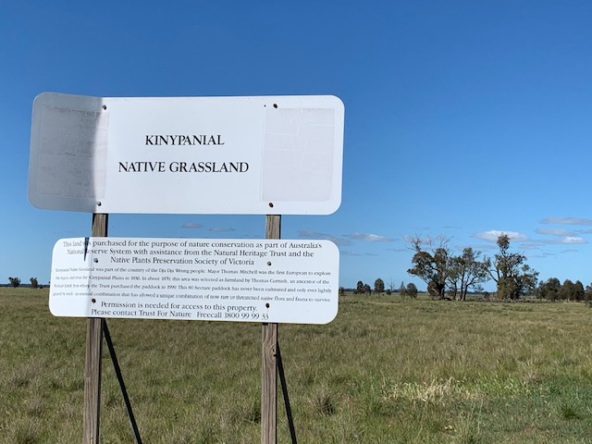

1. Jesus “ sent them out to proclaim the reign of God and to heal.”

So here we are.

Call and response, in the Holy Spirit, brought the Gospel from Galilee and Jerusalem to our “Great Southland of the Holy Spirit “.

The Gospel reached us but we know it did not come in cultural forms that were pure and undefiled by human sinfulness.

It is a miracle of God’s providence that the Gospel was able to be heard, given all the disease, the cruelty, the dispossession...all the soul - wounding that took place and takes place.

That is why, it seems, that our God has summoned us to gather now and pray together.

Our God governs the courses of this world by means so wonderful, even as we try to fully comprehend.

In our discipleship of Jesus, we are drawn to reverence before the mysteries of the divine providence.

As Pastor Peter said in our prayer meeting last Tuesday, a month ago we did not know where we were.

We knew something like this was on the horizon - the need to pray for the healing of the land.

It was an “Amen” we knew we needed to make.

Retrospectively, we have shared how we all knew this was the case.

We just did not know what to do next.

We did not know what might be best to do.

Even though there is always plenty of advice and plenty of noisy voices, none seemed quite of the right spirit.

By God’s grace, we have been brought together for this weekend of prayer.

That which was on the horizon has arrived.

So, in these preparatory weeks, we have listened to each other’s dreams and visions , some of them decades old but only now permitted by our sovereign God to be uttered …to be shared.

Poignantly, Pastor Peter and I have discovered how God has used the bond between Peter’s father and myself, about 20 years ago, to bring us together.

All that itself began for me, through the generous and faithful friendship of Noongar people towards our family when I was first a Bishop in Perth.

Especially, the gracious friendship of UCA Pastor, the Rev. Sealin Garlett, God rest his soul.

Rev.Sealin invited our family to join a reconciliation pilgrimage, facilitated by the WA Council of Churches, to Warburton and Uluru, just after the Royal Commission Report on the Stolen Generation was released.

We read the Report on that long bus ride with folk like Rev. Sealin who were reading their own story.

A few years later, Rev. Sealin came all the way to Grafton from Perth to “hand me over” to the Bundjalung elders with prayers and love.

That prayerful trust of Rev. Sealin meant I was received by Pastor Peter’s dad and the Bundjalung elders.

Thereafter, as you may have read, Pastor Peter’s dad asked me to come and pray in the Upper Clarence to prevent a mining company from using cyanide to capture gold. We walked on holy ground, the presence of the Lord was spine- tingling.

The river was thereafter protected from such damage.

When, this August, Pastor Peter spoke his Holy Spirit vision and dream of his dad swimming in the flowing pure, clear waters of the Clarence River, up the top of the bridge in Grafton, with kids of every tribe and colour, we had not then made these connections.

As I listened to Peter’s dream about his father (who had been dead for some years) and those children together, unified in the Holy Spirit, I just knew, it was timely and right to ask he and our First Nation Christian elders, to lead the Prayers we, at the NCCA, had been planning for this weekend of September 26-27, (following the August 2 National Day of Prayer as regards the pandemic.)

As we know, God wastes nothing.

This story, told briefly, is such a parable. When, at Revd. Sealin ‘s invitation, our family climbed into that dusty bus in Perth with lovely Noongar folk ,none of us could have foreseen how our God would use that time for this purpose…” to proclaim the reign of God and to heal.”(Luke 9:1-6).

As Pastor Peter said last week, “this is not a black or white thing. It is a God thing...”

So, we gather in the providence and presence of God.

As Pastor Peter also conveyed in our prayerful preparatory times, our guidance and direction is Jesus' oneness prayer in John 17. “May they all be one”.

So, here we all are!

One last note:

Listening these past weeks, God has revealed much beauty and much pain.

We are God’s “wounded healers”, each with our own story.

Lynora Geia spoke in Holy Spirit about the way ahead.

It has to be loving.

There’s been more than enough harsh talk. Enough judging and condemning.

Only agape love will get through and get us through.

As the old song goes: “What the world needs now is love, sweet love. It’s the only thing that there is just too little of.”

At Easter my film-maker friends Richard Keddie and Sebastian Broadbent helped me put that song together in a message sung by dear students at Lowther Hall Anglican School.

We might watch and listen now, before I offer a prayer.

<https://vimeo.com/405707686>

Bishop Philip Huggins.