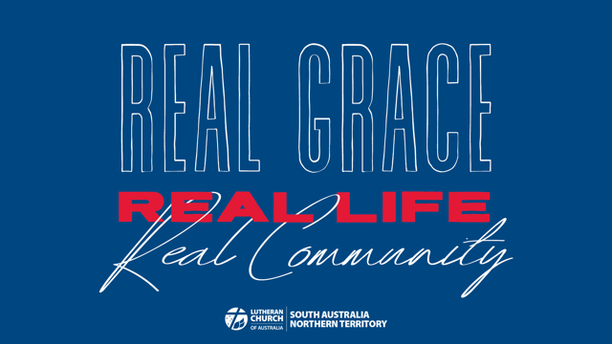
Sermon Week 3 – Real Life
Ephesians 6:1-18
The Apostle Paul wrote: ‘…don’t you know that all of us who were baptized into Christ Jesus were baptized into his death? We were therefore buried with him through baptism into death in order that, just as Christ was raised from the dead through the glory of the Father, we too may live a new life. For if we have been united with him in a death like his, we will certainly also be united with him in a resurrection like his’ (v3-5).
How many parents have told their children over the years: ‘don’t drag your dirty feet on my nice clean floor’? You can picture a child looking back at the incriminating trail of their very obvious and very muddy footprints and then looking at their parent again with an expression that seems to say: ‘…too late’!
Real life includes dirty footprints on nice clean floors. It is not ideal and it is not always welcome – but that is the reality.
You don’t get the benefit of having a sanitised version of life. It comes with dirt and mess and complications. It comes with pain and suffering, with grief and loss and with highs and lows and twists and turns.
It comes with our own mistakes and brokenness and sin.
We can try to hide that messy part of our lives behind closed doors and away from public view. And we seem to do that all the time. The picture people present of their lives publicly is rarely the full picture, the real picture.
So what about the church, the family of God? How real are we about life in the church?
Can we sometimes give the impression that we don’t really want people to drag their ‘dirty feet’ on our nice clean church floors? Have people stayed away because they don’t think they are good enough, holy enough or clean enough to walk into a church?
We dress up in our Sunday best and we sing our hymns and songs and put on the façade that everything is okay in our lives because we are believing Christians. We smile at each other, we pass the peace, we kneel at the altar and then we go home and take off our masks and get back to reality.
But real life in the church includes our dirty footprints on the nice clean church floor.
The Apostle Paul was not afraid to speak of our dirty footprint as humans in his letter to the Christians in Rome. In the 18 verses of our reading from Romans 6, Paul mentions ‘sin’ 13 times and ‘death’ and ‘dying’ 11 times!
He doesn’t try and hide the reality of these things.
This is the reality for the people of God as much as it is for everyone else. This is the real life we have to contend with. We don’t have to hide it or try and mask it. We don’t have to ignore it or pretend it is not the reality. Real life includes the struggle with sin and death and everything else that comes with it.
So we do drag our dirty feet, and everything else that is dirty in our lives, onto God’s nice clean floor. We do this collectively as the people of God. We might still come wearing our Sunday best, but we also come knowing the stark reality of the issues and challenges and brokenness we face in our lives.
We can come in this way because there is something else we know. We know the real life that we have through our baptism into Christ. As Paul said: ‘Don’t you know…?’
Yes we know.
We know of our struggle with sin and death. And we know that through our baptism into Jesus Christ that we have been united with him – joined to him and everything that he has done for us. We know that we don’t have to clean up our lives before we can come to Jesus. We come to Jesus because only he can clean up our lives.
He took upon himself our ‘dirt’ – that is, our sin and failure and death. He didn’t avoid it or ignore it. He confronted it and defeated it. He did this in a very real way by dragging all our dirt all the way to the cross.
He was crucified, dead and buried. You don’t get more real than that!
And the Apostle Paul tells us that through our baptism we are buried with Jesus. We are not spectators of all that Jesus did, Baptism drags us right into what Jesus has done so that it becomes real for us. We are crucified, dead and buried with him.
It is confronting and challenging. But the harsh reality is that there is so much in us that needs to be put to death. It is not swept under the carpet or hidden behind closed doors. It is dead and buried in Christ! You don’t get more real than that!
And that is only part one of what we are baptised into. It does not end there. It cannot end there. We were ‘buried with him through baptism into death…in order that’. In order that…what?
‘…in order that, just as Christ was raised from the dead through the glory of the Father, we too may live a new life. For if we have been united with him in a death like his, we will certainly also be united with him in a resurrection like his’.
We are joined to the resurrection of Jesus. We are joined to the new life that comes through him. That is the reality for us.
Jesus did this in a very real way through his resurrection from the dead. He walked away from an open and empty tomb. He walked into the locked room containing his fearful disciples and impressed on them the reality of his resurrection.
He showed them his hands and his side (John 20:20). He said to Thomas, “‘Put your finger here; see my hands. Reach out your hand and put it into my side’” (John 20:27). This is a real resurrection. This is real life!
And this resurrection and life is real for us.
When we fear that we have to hide our dirt and issues and brokenness and sin behind closed doors Jesus walks right through them. He stands among us as the crucified and risen Lord and he brings us his presence and peace.
We are a church that celebrates the real presence of Jesus. He is really present in the waters of baptism. He is really present in the bread and wine of the Lord’s Supper. He is really present in the Word of God that we read and hear. He is really present in our real lives – dirt and all.
We can be real with Jesus and with each other as brothers and sisters in Christ because collectively we are baptised in Christ. Together we have been buried with him through baptism and together we have been raised to new life in him.
We need to be real in this way because we will still drag our dirty feet (lives) onto the nice clean church floor. We try not to live in sin but we certainly have to live with sin – our own and that of others. If we can’t drag that into the church community so that it can be dealt with, then where can we take it?
We are called to live out the struggle of our real lives in the real grace of our baptism in Christ. The Apostle Paul had to remind the Christians in Rome of this and we need to be reminded too. ‘Don’t you know…’
As we enter our church communities we know what we are bringing with us week in and week out. And that is why our worship services as God’s gathered people begin with a reminder of whose name we have been baptised into – ‘in the name of the Father and of the Son and of the Holy Spirit’. Right at the start we are reminded of the real life we have in our gracious God.
So as the people of God we can confess our sins before God and each other. We can receive his forgiveness together, hear his word together, pray and praise together, kneel at the altar to be fed by him together and be blessed together.
That is the real life we enjoy as his baptised children in the body of Christ. We come to be buried in Christ and to be raised to new life in him. We need that death and resurrection each day of our lives so that we can get back to a new reality.
We don’t get the benefit of having a sanitised version of life. It comes with dirt and mess and complications. It comes with pain and suffering, with grief and loss and with highs and lows and twists and turns. It comes with our own mistakes and brokenness and sin. But is also comes with the real presence of Jesus.
He was crucified, dead and buried. He descended into hell. And on the third day he rose again from the dead! May we drag our dirty feet to Jesus, the same Lord who washed his disciples’ feet on the night when he was betrayed. And may we enjoy the real life we have with him, with our brothers and sisters in Christ and with the world that we are called to serve. Amen.

