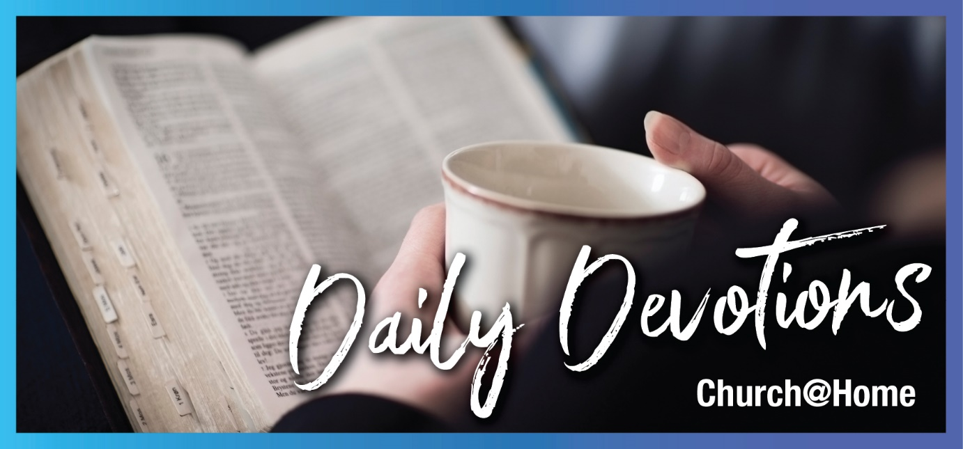

Sunday 26 March 2023 to Sunday 2 April 2023
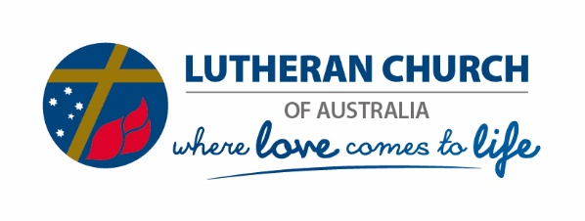
Sunday 26 March 2023
Yes, Lord
by Rachel Stelzer
‘Yes, Lord,’ she replied, ‘I believe that you are the Messiah, the Son of God, who is to come into the world’ (John 11:27).
Read John 11:1–45
In John’s beautifully crafted and deeply evocative gospel, there are 21 chapters. Ten chapters precede this one, and ten chapters follow it.
This personal and emotional chapter in John’s Gospel is the hinge, the crux of the matter. Jesus, confronted with his friend’s illness, chooses to stay where he is for two days, as he knows that ‘This sickness will not end in death. No, it is for God’s glory so that God’s Son may be glorified through it’ (verse 4). Jesus goes to his friends; he spends time, talks with them, and weeps.
Jesus’ beautiful conversation with Martha is the ultimate hospital bedside moment, the great graveside question. ‘I am the resurrection and the life. The one who believes in me will live, even though they die; and whoever lives by believing in me will never die. Do you believe this?’ (verses 25, 26).
And it is to us, too, that Jesus asks this question.
At the start of John’s Gospel, Nathanael declares, ‘Rabbi, you are the Son of God; you are the king of Israel’ (John 1:49). At the end of his gospel, John explains, ‘these are written that you may believe that Jesus is the Messiah, the Son of God and that by believing you may have life in his name’ (John 20:31).
And Martha’s answer, here in the centre of the middle chapter of John, is the central message of John’s Gospel. ‘Yes, Lord,’ she replied, ‘I believe that you are the Messiah, the Son of God, who is to come into the world’ (verse 27).
May we also have the courage and the faith, along with Martha, to proclaim our trust in Jesus, the resurrection and the life.
Lord, I believe. Help my unbelief. Be at the centre of my life, and help me to boldly bear witness to you, the Messiah, the Son of God. Amen.

Rachael Stelzer is Primary Lay Chaplain at Coomera Anglican College near Brisbane. She is a member of Our Saviour Lutheran Church in Rochedale, and teaches primary kids in the Growing Kids group. Rachael loves craft, reading, and sharing meals, coffee and life with her family and friends.

Monday 27 March 2023
The ground of the matter
by Rachael Stelzer
But Jesus bent down and started to write on the ground with his finger (John 8:6b).
Read John 8:1–20
I have always been confused by Jesus’ actions in this episode from John’s Gospel. I am not confused by the public spectacle of dragging a woman, perhaps half-covered or completely naked, out into the public area of the temple, in order to get two for the price of one. If Jesus let her off the hook, they could condemn him for his refusal to apply the law. Either way, the religious leaders were ready for a stoning. I love Jesus’ calmness. I love the way he shut down every Pharisee and teacher of the law with a single sentence. Yeah, Jesus! That’ll show ‘em! You can hear the stones thudding on the ground and the footsteps fading in the distance.
But I never understood why Jesus drew on the ground. Twice.
It only hit me about a month ago. And I couldn’t stop thinking about it.
He refused to look at the woman. We are told that even when everyone else left, Jesus straightened up, not that he looked at her.
Jesus would not play the game of adding to the woman’s shame. He deliberately averted his eyes so that all could see him looking away from her. He gave her back the dignity that no-one else felt she deserved. The dignity of being a child of God. The humanity that others had denied her due to her actions, Jesus restored to her with gentle exhortation. He got, as it were, to the ground of the matter.
‘For God did not send his Son into the world to condemn the world, but to save the world through him’ (John 3:17).
How are we going with that? In this world of easy clickbait, where we can find dirt and shame about people effortlessly online, and where rumour mills and chats by the photocopier are too easy to join in, it takes an effort of will for us to bend down and draw on the ground. Can we point to the ground of the matter? Can we restore the dignity of those whom others have condemned? This is where the gospel comes to life in a world full of cancel culture and condemnation.
Lord Jesus, you bent down, restored dignity, and touched the ground of the matter. Grant me the grace and discernment to avert my eyes when someone else’s dignity is on the line. May I straighten up and speak grace and a new start into the lives of those around me. Amen.

Tuesday 28 March 2023
Truly free
by Rachael Stelzer
So if the Son sets you free, you will be free indeed (John 8:36).
Read John 8:21–38

To the Jews, parentage was everything. For a young Jewish man to approach the father of a young woman to marry her, he would have to recite his ancestry back to Abraham. The people of Israel needed to show that Israel (or Jacob) was literally their forefather. This was part of God’s covenant to make the Israelites God’s chosen people.

So when a young preacher suggested that holding to his teaching would help them know the truth that would set them free, some of the Jews took offence. ‘We are Abraham’s descendants and have never been slaves of anyone. How can you say that we shall be set free?’

Jesus referred to their slavery as a sin, a slavery he does not share. ‘So if the Son sets you free, you will be free indeed’ or ‘truly free’ (verse 36).

Jesus goes further and suggests they are following their father, not Abraham. This is deeply offensive to the people, who wail, ‘we are not illegitimate children …’ Later in the chapter, Jesus even claims to know Abraham, which is the final straw for these proud people, who pick up stones, ready to kill him.

It’s easy for me to look down on these characters, but what am I a slave to? Is there anything in my life that blinds me from the truth? Has the Son set me free from my love of things? Of status? Of busyness? Of my own rightness? Of my goodness?

Every day, I need to return to the foot of the cross and lay down my cheap trophies. Then Jesus can set me free once again from the lies around me that I have picked up.

Lord Jesus, if the Son sets us free, we will be truly free. Set me free from the cheap trophies of this world – my family name, my goodness, my correctness, my power. Then I will be truly free to serve you in humility and joy. Amen.

Wednesday 29 March 2023
Children of God
by Rachael Stelzer
‘Very truly I tell you,’ Jesus answered, ‘before Abraham was born, I am!’ (John 8:58)
Read John 8:39–59

In today’s passage, Jesus continues his arguments with the leaders of the Jewish people. Their rumour mills have been working hard, and in verse 48, they throw at him, ‘Aren’t we right in saying that you are a Samaritan and demon-possessed?’

Jesus seems to be escalating the situation in his claims, and indeed, by the end of this passage, he claims to have talked to Abraham and to possess the very nature of God, ‘I am’ (verse 58).

His clear statements of the truth are unbearable to these people, and Jesus distinguishes between being someone’s descendant biologically and following the example of one’s father. He accuses the Jews of having diverged so far from their ancestor Abraham, a man of faith, that they are now children of the devil, desiring what he would desire – the apple not falling far from the tree.

It might seem frivolous or cavalier of Jesus to stir up this much anger and resentment early in his ministry. But in the light of John’s beautiful summary of Jesus’ life at the start of his gospel, we see here a demonstration that ‘he came to that which was his own, but his own did not receive him. Yet to all who did receive him, to those who believed in his name, he gave the right to become children of God – children born not of natural descent, nor of human decision or a husband’s will, but born of God’ (John 1:11–13).

Lord Jesus, you gave us a new understanding of what family is – a group of people connected in love, encouraging each other, and pointing to the truth that sets us free. Help us to know our Heavenly Father and share your truth in love. Amen.

Thursday 30 March 2023
Open our eyes
by Rachael Stelzer
‘Neither this man nor his parents sinned,’ said Jesus, ‘but this happened so that the works of God might be displayed in him’ (John 9:3).
Read John 9:1–23

As soon as Jesus walks away from the angry mob that is about to stone him, he sees a blind man. His disciples ask whose sin led to this misfortune. This was a common understanding of the Jewish people of the time. One only needs to read the Psalms to see the ‘If … then ...’ understanding that promised blessings to the righteous and calamity to the wicked. And it’s an understanding that persists, if more subtly, to this day.

Jesus explains that this happened so that the works of God might be displayed in him. He promptly heals the man and sends him to the pool of sending, and he can see. This happens so quickly in the text and is soon followed by a bizarre response to the healing. The man’s own neighbours can’t figure out if it’s the same bloke or just a lookalike, and he has to assure them that, yes, it’s him.

Then the Pharisees and teachers of the law descend on the scene, Keystone Cops-style, in full bluster and indignation, demanding to know what is going on, questioning the man and his parents about what has happened and refusing to believe what they have known for years – that the man was blind from birth. The fruit of their investigation is fear and confusion. The man’s parents are too scared to answer, as they know the consequences of speaking up on behalf of Jesus.

It is almost hysterical that in the view of a healing that is clearly beneficial to the man and his parents, a blessing and a miracle, people can be so outraged and see only evil. This further underscores Jesus’ words in the previous chapter that ‘the reason you do not hear is that you do not belong to God’.

How hilarious and tragic to see the leaders of the people blinded by their own importance and unable to see the truth right in front of them. God save us from becoming so wedded to our own rightness and importance that we cannot see a blessing when it is right in front of us.

Lord Jesus, you loved each of those Pharisees and teachers of the law, even as they denied your miracles and condemned you as demon-possessed. Show me when I am being a Pharisee, in love with being right and condemning others. Restore and forgive me. Show me your sacrificial love, so I can follow you and leave my importance behind. Amen.

Friday 31 March 2023
I was blind but now I see
by Rachael Stelzer
He replied, ‘Whether he is a sinner or not, I don’t know. One thing I do know. I was blind but now I see!’ (John 9:25)
Read John 9:24–41

Today we witness scenes two and three of the healing at the pool, otherwise known as ‘who is really the blind man here?’

In yesterday’s episode, Jesus healed a man born blind, and the religious leaders lost their minds over the event. In this scene, they summon the not-blind man again and ask him to give Jesus up as a sinner. His words are simple and powerful: ‘Whether he is a sinner or not, I don’t know. One thing I do know. I was blind but now I see!’

Here is a simple man who has been on the fringes of society his whole life. He is not educated. But he is beginning to make the leaders look like fools. When they ask him how Jesus did it, he says in verse 27, ‘I have told you already, and you did not listen. Why do you want to hear it again? Do you want to become his disciples too?’ I can only see this as a comedy, with the man looking innocently at the religious leaders, who are tearing their hair out. He continues speaking in simple terms but delivers his simple and beautiful version of the truth, which so offends them that they throw him out.

Then, in our final beautiful scene, Jesus finds the man, who earlier had called Jesus a prophet, and has one of his wonderful conversations that John records with such warmth. He asks if the man believes in the Son of Man and reveals himself to be the one. The man confesses his faith in Jesus and worships him. And the Pharisees and teachers of the law are still grumpy.

Who is blind, and who can see?

Lord Jesus, open my eyes to see your truth and love. Help me see the needs of those around me. Help me see the ways I put other priorities before my relationship with you. And help me see how I can love in your name. Amen.

Saturday 1 April 2023
Our cornerstone
by Rachael Stelzer
The stone the builders rejected has become the cornerstone; the Lord has done this, and it is marvellous in our eyes (Psalm 118:22,23).
Read Psalm 118:1,2,19–29

Today’s reading is an exuberant psalm of gratitude and praise to God, both on an individual and a corporate level. It is a psalm of entry into the temple and involves blessing to others and praise to God.

As Christians, we particularly notice verses 22 to 23, which talk about the capstone the builders rejected becoming the cornerstone. We recognise, particularly in the light of this week’s stories from John about Jesus’ rejection by the Jewish authorities, that Jesus was rejected by the religious leaders of the day while others were drawn to his light and truth.

But this psalm also contains hope for all of us who have ever felt rejected, marginalised or persecuted. It tells us that God can use those who do not seem to be the cream of society, those who are not strong, smart, tough or loud, to accomplish important things for God. This is the God of the meek, the mourning, the peacemaker, those persecuted for righteousness, and the poor in Spirit.

And we can only respond as the psalmist does, with thanks and praise to our loving God. ‘Give thanks to the Lord, for he is good; his love endures forever.’

Dear Lord, we can enter your gates with thanksgiving because of the righteousness Jesus has won for us. You are the God of the second chances and the God who uses the stone the builders rejected to become the cornerstone. We praise you and thank you. Amen.

Sunday 2 April 2023
Crucify him
by Neil Bergmann
‘What shall I do, then, with Jesus who is called the Messiah?’ Pilate asked. They all answered, ‘Crucify him!’ (Matthew 27:22)
Read Matthew 27:11–26

On this Palm Sunday, our reading is not about Jesus’ triumphant entry into Jerusalem as the Messiah, but it looks ahead a few days later to his crucifixion. The cries of ‘Hosanna’ (‘save us’) are replaced by cries of ‘Crucify him!’

This is a very appropriate way to start this week because the events of Jesus’ time in Jerusalem are best understood in the shadow of the cross of Good Friday. This week, all of Jesus’ teaching points to the looming cross and the end of Jesus’ earthly ministry. This ministry has two key purposes. Firstly, Jesus’ death and resurrection provide all believers with the free gift of salvation from sin and eternal life. Secondly, through his teaching, Jesus explains his new kingdom – that topsy-turvy heavenly kingdom where the first are last, and the last are first.

As redeemed and sanctified children of the light, we are invited to live in that kingdom, here and now, on this earth. Throughout the gospels, Jesus speaks about his new kingdom and invites us to make the conscious choice, through the power of the Holy Spirit, to live in that kingdom with him.

This new kingdom is not a place free from pain and suffering. Indeed, this kingdom is defined by the pain and suffering of the cross. As we journey through this week, Jesus reveals more about what his kingdom is like. It is a kingdom of humility, meekness, grief, servant leadership and compassion. But most of all, it is a kingdom where the crucified Jesus suffers with the suffering, grieves with the grieving, and comforts the fallen. We are most authentically Christian when we dwell in that kingdom and suffer with each other, grieve with each other, and comfort each other. It is in the faces of those who suffer, those who grieve, and those who need comfort that we most clearly see the face of Jesus, the crucified Messiah, the One who saves.

‘Hosanna, blessed is he who comes in the name of the Lord.’ Save us from the vain temptations of this world and set our hearts on your heavenly kingdom. Amen.

Neil Bergmann is currently the chair of Lutheran Earth Care, Australia and New Zealand. After retiring, he recently completed a research Master of Theology at Flinders University, Adelaide, on eco-theology. He worships at Our Saviour Lutheran Church, Rochedale, Queensland.

