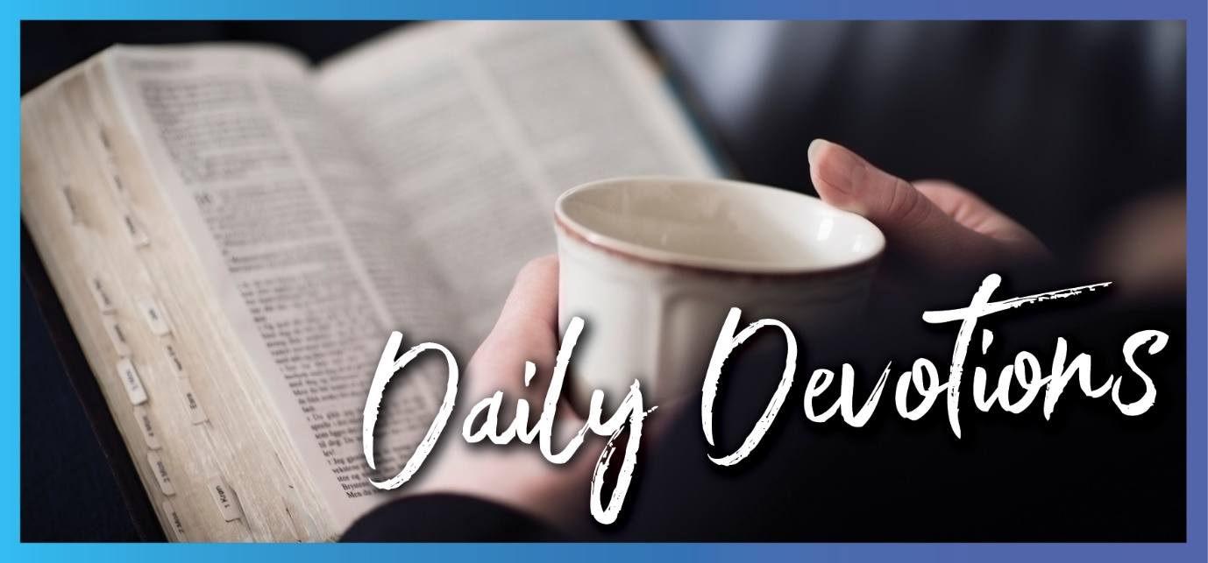

Sunday 19 September 2021 to Sunday 26 September 2021
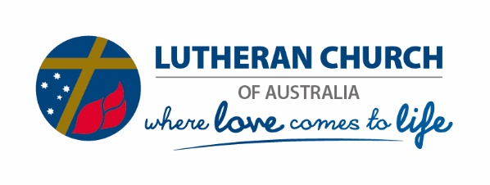
Sunday 19 September 2021

Childlike humility
by Carolyn Ehrlich
But they kept quiet because on the way they had argued about who was the greatest (Mark 9:34).
Read Mark 9:30–37
Jesus and his disciples were travelling from place to place. Jesus had already predicted his death (Mark 8:31–33), and he had taught that being a disciple meant denying self and following him (Mark 8:34).
Peter, James and John had witnessed Jesus’ transfiguration, and still, the disciples argued among themselves about who was the greatest. How often do we (you, me) do this? How often do we experience that Jesus has something profound to say to us about who he is, about what is happening, about something supernatural, something that we do not understand? How often has Jesus spoken to us, given us his direction and asked us to do something, and still, we are concerned about our own greatness?
We gloss over what is supremely important in our walk with God, and we focus on ourselves. We justify, saying, ‘I am okay, better, smarter, stronger, prettier, more important, greater than …’ Where is the humility and servitude in our approach?
Further along in this passage, we are instructed to welcome children. Yes, we are to take this literally, but we are also to embrace the childlike qualities of simplicity, innocence and humility. Instead of focusing on ourselves, on our own sense of self-importance and greatness, we are directed to welcome little children – because when we do, we welcome Jesus.
In Jesus’ time, welcoming implied service. A host serves their guest. Selfless serving is the hallmark of Christianity. So, we are to selflessly serve everybody, including children. How will you humble yourself and simply and innocently welcome God, our Father, today?
Father God, you are an amazing, gracious and wonderful God. Instead of welcoming you, I so often argue with others in ways that reflect my sense of self-importance and self-reported greatness. I do this privately and publicly. Search me, God, and know my heart; test me and know my anxious thoughts. See if there is any offensive way in me and lead me in the way everlasting. In Jesus’ awesome name, I pray, Amen.

Monday 20 September 2021

Making choices: hidden dangers
by Carolyn Ehrlich
The whole plain of the Jordan toward Zoar was well watered, like the garden of the Lord, like the land of Egypt (Genesis 13:10).
Read Genesis 13:1–18
Lot and Abram were family, and they had been blessed with such an increase in flocks and herds and tents that the land could not support them. The time had come for them to separate, to go their own ways, to make a choice. Lot got to choose first. He looked around and made a decision based on what he knew and understood. He knew and understood Egypt, and the plain of Jordan reminded him of Egypt. So, based on what he knew and understood, he made a responsible choice – he chose land that would support his family, herd and flocks. But there were unknown and hidden risks associated with his decision. Unwittingly, he had pitched his tents near Sodom, and the people of Sodom were wicked. So, did Lot make a good choice or a bad choice?
What does this mean for us? How do we make decisions? God has given us free will. He allows us to choose – just as Lot was able to choose. So, as we decide, how do we assess what is best? As we read further in this text, we note that Abram took what Lot did not. More importantly, the Lord was with Abram. God promised Abram. When Abram pitched his tent, he built an altar to the Lord. Yes, we choose. Yes, the choices we make are mostly responsible decisions. We weigh up the options, and then we decide. But in this text, we learn it is not so much the choice that is important but that God is with us. God with us changes everything. God with us protects us from evil, corruption and the things hidden from us but will harm us. God with us … God with me … God with you.
What we can see is never the whole picture. Even when we base our choices on what we think is sound and good information, we must have God with us.
Father God, you have promised you will be with us until the end of the earth. You have promised that your sheep know your voice. You are a good, good Father who does have the whole picture and does have a complete plan. Help me hear your voice and follow your direction. Instill in me a heart that listens to you and does what you command. In Jesus’ awesome name, I pray. Amen.

Tuesday 21 September 2021

Hosting banquets
by Carolyn Ehrlich
But when you give a banquet, invite the poor, the crippled, the lame, the blind (Luke 14:13).
Read Luke 14:7–14
Today’s reading starts with an instruction to be humble when we are invited to banquets and feasts. But then it goes on to instruct us about what we need to do when we are hosting. We are to host those who are less fortunate than ourselves, and we are to esteem them. We need to be careful here – careful to attend to our own pride and careful about our own humility. We should be genuine and authentic when we invite people less fortunate than ourselves to our banquets – lest we become proud and self-righteous.
Some of us will be in fortunate and privileged situations in life – we will have received accolades and honour for what we have done with the God-given talents we have been blessed with. Some of us will be less fortunate. Some of us will be among the poor and those with disabilities – both physically and spiritually. Look around. What are you doing? Irrespective of where you see yourself in this scenario, where are you seating yourself at the banquets and feasts of others? Who are you hosting?
If you can personally host others, what are you doing to host the poor, crippled, lame and blind? If you are hosting others as a church, then what are you doing in your community to host the physically and spiritually poor, crippled, lame and blind?
How do you look at people who are physically and spiritually afflicted? What is your perspective? Do you welcome them authentically, or do you welcome them at the same time as giving yourself a ‘pat on the back’? Are you humble? What are the quiet, authentic, genuine, Christ-like ways that you can do help others? Look around this week. Lift your gaze beyond what you usually do, and explore what is possible to host others who are less fortunate or privileged than you, or indeed those who might appear to be more fortunate than you but are spiritually disabled.
Father God, you have instructed us to be humble and invite the poor and those who live with disabilities and afflictions into our churches, homes and hearts. Jesus, you showed us how to love authentically and tend to those who are less fortunate than ourselves. As I step into your world today, show me who you are connecting me with and putting in my path, so I might humbly give to them whatever it is that you want them to have. In Jesus’ awesome name, I pray, Amen.
Wednesday 22 September 2021

The gods we worship
by Carolyn Ehrlich
When the crowd saw what Paul had done, they shouted in the Lycaonian language, ‘The gods have come down to us in human form!’ (Acts 14:11)
Read Acts 14:8–23
Paul was out and about doing the work that God had commanded him to do. He was performing healing miracles, but the crowds were attributing the miracles to him, praising and worshipping him, instead of recognising, praising and worshipping the real and only God who is the source of all miracles.
Of course, Paul and Barnabas were horrified and continued to teach the truth of God our Father. The question for us to consider regarding today’s verse is how and when we might be like the people of Lystra. How often do we place faith in our little ‘g’ gods as the source of healing? Likewise, how often do we fail to even recognise healing as a miracle from God in the first place? We live in a privileged country. We have a first-class health care system, and we have access to medical miracles every day. And we do not always see our God behind the healing we witness.
From a different but related perspective, do we even recognise miracles generally? Is it possible amazing and wonderful things are going on around us every day that is evidence there is a mighty, powerful and loving God active in our lives and communities? A God who just wants us to see him, worship him, love him, adore him, believe in him? And how often do we blindly follow our human gods and idols? These can include our little ‘g’ gods of sport, recreation, social media – whatever it is we spend most of our time and money on that we bring into our lives and worship daily at the expense of our wonderful, amazing and loving Father?
Today, reflect on the world you live in. Look behind what you usually do and think, and look to the only God that matters – the God of miracles and healing, the God of love and laughter.
Father God, today I choose to worship you. You have blessed my life with so much good, but I do not always or consistently recognise your hand in my life. Forgive me for all the times I have placed my faith in somebody or something in this world when my faith rightly belongs with you. Today and this week, help me see the miracles you perform in this world – miracles of rain and harvests, health and wellbeing and not always miracles for me but always miracles for your people. In Jesus’ awesome name, I pray, Amen.
Thursday 23 September 2021

Spirit-led
by Carolyn Ehrlich
But if you are led by the Spirit, you are not under the law (Galatians 5:18).
Read Galatians 5:16–24
The new covenant that came into existence with Jesus’ death and resurrection replaced the law of the Old Testament. But here, we read that not being under the law also means we are led by the Spirit. So, what does it mean to be led by the Spirit? We read that acts of the flesh and fruits of the Spirit are diametrically opposed. If we live by the Spirit, we keep in step with the Spirit (verse 25). The challenge here is to understand what it means to live by the Spirit, to Spirit-walk, to be Spirit-led. The Holy Spirit is the advocate in our relationship with God, sent by the Father, teaching us all things and reminding us of everything (see John 14:26). If we are not Spirit-led, we will not hear what we are being taught, nor will we be reminded of what we need to know.
What is your relationship with God like? Do you hear the lessons he has for you through the Holy Spirit? Are you Spirit-led, or do you rely on yourself to independently overcome acts of the flesh and trying to live a life you hope looks like a godly life? Spirit-led lives are turned 180 degrees from independence. We come to the foot of the cross, and we repent. Then we listen, hear and do what God is asking us through the Holy Spirit. When we ask and do, then the Holy Spirit leads us away from the acts of the flesh and fills us with his fruits. Then, and only then, are we free from the law. Freedom = dependence on God. Freedom ≠ independence from God.
Father God, thank you that you gave us the Holy Spirit to lead us and free us from being under the law. Forgive me for thinking that I can act independently of you. Speak into my life through the Holy Spirit so I might Spirit-walk in a life that belongs to Jesus. In Jesus’ awesome name, I pray, Amen.

Friday 24 September 2021

Straight and level faith walking
by Carolyn Ehrlich
Mark out a straight path … Look after each other so that none of you fails to receive the grace of God (Hebrews 12:12a,15).
Read Hebrews 12:12–17
In our modern and western world, we are often told we have an individualistic culture. We have moved away from a sense of community and look out for ourselves and our close family. We work hard to make sure that we provide for ourselves and our families. We plan for our first car, our first home, our work and our retirement. We are proud of what we do. And in our faith walk, many of us go about our daily lives separately, individually, coming together for worship on Sundays, maybe.
But here, the writer instructs us to do something completely different. We are to look out for one another. We are to make paths straight and level – so that no-one is disabled. Whoa … we are to take responsibility for others in our community. You and I are to make the faith walk of others straight and level. You and I are to look out for others. You and I are not to cause trouble. You and I are to see to it that no-one is immoral. You and I are to ensure that no-one is godless. You and I – not the pastor or elders or church council. You … me …
Why must we look out for others? Why must we mark out straight paths? Because ‘without holiness, no-one will see the Lord’ (verse 14b).
How must we mark out a straight path? Verse 14 tells us, ‘Make every effort to live in peace with everyone and to be holy’. A straight path is a holy path. We are being instructed to live out a holy life – to live in peace with everyone (yes, even the person we dislike the most). Living in peace means being on the lookout for the poison of bitterness. This is not just a one-hour-on-a-Sunday thing. We are to make every effort to live in peace with everyone – every second of every minute, hour, day and week. And we cannot do that without having our eyes firmly fixed on Jesus. We cannot do this without the Holy Spirit filling us and leading us always.
Loving Father, thank you for loving me. You desire that everyone loves you. You are asking me to live as part of my community, every moment of every day. You are asking me to walk a straight walk with you and live peacefully with everyone else in my community so that their path is straight too. I cannot do what you are asking without you. Holy Spirit, lead me as I go about this day and week. Show me who I need to live in peace with. Take my feeble arms and weak knees and strengthen them so that I can walk out my day and week as a follower of Jesus. In Jesus’ awesome name, I pray. Amen.
Saturday 25 September 2021

Precious and sweet
by Carolyn Ehrlich
They are more precious than gold, than much pure gold; they are sweeter than honey, than honey from the honeycomb (Psalm 19:10).
Read Psalm 19:7–14
How amazing are the first few verses of today’s reading? Read them again, please. Then once more, out loud! Do you want to feel refreshed, wise, full of joy? Do you want to have eyes that light up? Here we read how to have all these things – God tells us. His law is perfect! His statutes are trustworthy! His rules that guide our behaviour are right! His commands are radiant! Fear of him is pure and everlasting! His decrees are firm and righteous! They are more precious than gold, sweeter than honey. Perfection! Guaranteed!
But we are human. We cannot discern our own errors. We need God’s word, in which he reveals how to live as his servant so that we are kept from wilful sin. But what is wilful sin? Wilful sin is ongoing known sin. These are the sins we need to face up to. They might be entrenched, and we might be repeat offenders. There are some sins we need to confess again – and again and again. Each time we confess, we do indeed receive forgiveness. But we also learn to clearly recognise what we are doing to reach a point of remorse and sorrow which leads to repentance. ‘Yet now I am happy, not because you were made sorry, but because your sorrow led you to repentance’ (2 Corinthians 7:9a). God wants us to confess, be sorrowful and repent. He has given us his word so that we might be able to discern his ways. What sins do you need to face up to? What do you need to bring to God with remorse, repenting and asking for his forgiveness? Bring them to God, now, in this moment.
God’s words are precious and sweet. They warn us about our sins and hidden faults. They are there to guide us. We have read throughout the past week about the importance of listening to God’s word, Spirit-walking and being Spirit-led. Today, we read about the wisdom, joy and radiance that comes from his word. Let his word lead you today and always.
Thank you, Father, for your word. May the words of my mouth and the meditation of my heart be pleasing in your sight, Lord, my Rock and my Redeemer. Amen.
Sunday 26 September 2021

Watch your feet!
by Colleen Fitzpatrick
If any of you put a stumbling block before one of these little ones who believe in me, it would be better for you if a great millstone were hung around your neck and you were thrown into the sea (Mark 9:42).
Read Mark 9:38–50
As we age, the risk of stumbling and falling becomes more significant. We work hard to improve our balance, and, indeed, the exercise regime that my husband and I enjoy includes significant balance work. As we walk around the neighbourhood, we don’t see many stumbling blocks, but we have lots of uneven paving that can prove treacherous.
I am familiar with millstones because, on our farm, there was a rather large, old millstone in the yard. Now, my father was a big man and very strong. But even he could not lift this stone. If you had one of those hanging around your neck and were tossed into the sea, there is no way you could escape drowning.
Jesus’ desire is for all people – even the little ones – to believe in him. And woe betides anyone who puts a stumbling block in their way! The outcome is not just a skinned knee, gravel rash on your palms or even a broken pelvis. We are to do whatever needs to be done to ensure we enter the kingdom of God.
So what stumbling blocks are in our way? Or more importantly, what stumbling blocks are we putting in the way of others? Is our collective behaviour as a church a deterrent for people joining us? Do we as individuals present a less than winsome example of Christian life to our family, friends or neighbours?
The Royal Commission into Institutional Responses to Child Sexual Abuse highlighted some terrible examples of power being misused against children. Our church was not guilt-free in this. As a church, we can guard against further abuses by people with power and authority. One of the strategies for this is learning about what misuse of power looks like to vulnerable people and how we can prevent it.
Hands, feet and eyes are mentioned in the reading today, but what about spoken and written words? In our times, social media allows our voices to be heard more widely than ever before. May we use these opportunities to draw people to Jesus rather than becoming a stumbling block that could result in consequences quite contrary to our expectations.
Dear Jesus, we know that all people are precious to you, particularly children. We are all your children. Help us to encourage one another in our faith and strive to encourage and support the faith of others, rather than being stumbling blocks to the growth of your kingdom. Forgive us where we have got it wrong, and help us to be a reflection of your love in our lives. Amen.

