530 Lane Street
Broken Hill NSW 2880
4 September 2018
ian_hutchinson@wycliffe.org.au
Dear friends!
Yesterday, I finally received my PNG visa and have booked to fly out from Adelaide on Tuesday 30 October at 6 am, arriving at Pt Moresby at 12.20 pm.
I'll soon organise my flight to go from Pt Moresby to the Summer Institute of Linguistics centre at Ukarumpa, in the Eastern Highlands Province (EHP), about 1500 metres above sea level, where it's not as humid as the coast. Then I'll be able to start working out what my role will involve as the Highlands Audio Project Manager.
God's encouragement through His Word is amazing! On the same morning that I received back my Australian passport, now containing the PNG visa, I read from Philippians 3:20, "But our citizenship is in heaven," a wonderful reminder about the Christian's eternal home. Of course, our future hope inspires our present work!
There will be a Commissioning Service at St Paul's Lutheran Church, Broken Hill, on Sunday 28 October at 2 pm, after a lunch at 12.30 pm, prior to driving to Adelaide the next day.
My postal address will be: SUMMER INSTITUTE OF LINGUISTICS
PO BOX 1 (25)
UKARUMPA EHP 444
PAPUA NEW GUINEA
To keep my emails under control, I've cancelled all Facebook correspondence, something I've never really got into. I prefer to send and receive personal emails. I won't be using bigpond or hotmail in PNG, so please make sure you have made the change! My next group email will be next month from PNG at 1500 metres!
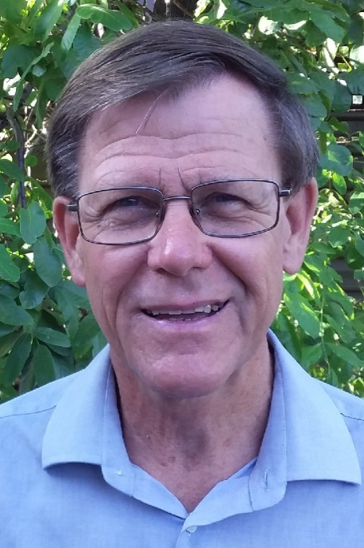
Thanks for your prayers as I tidy up many loose ends over the next 3 weeks. Please keep in your prayers the people I'll soon be working with, to transfer translated Scriptures into audio form.
Yours because His,
Ian Hutchinson
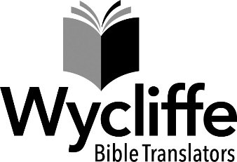
Australian National Centre
70 Graham Road
Kangaroo Ground Vic 3097
P: 03 9712 2777
E: info@wycliffe.org.au
W: wycliffe.org.au

