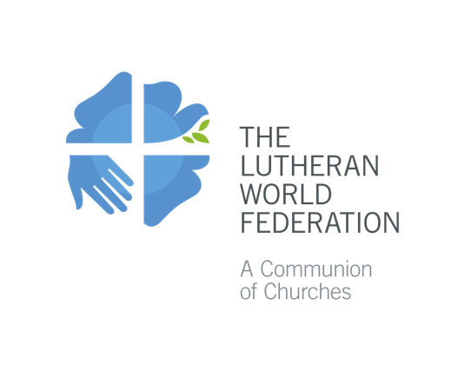

Reformation Day 2020

Suggested Sunday Gospel reading for the Commemoration of the Reformation: John 15:1-5
I am the true vine, and my Father is the vinegrower. He removes every branch in me that bears no fruit. Every branch that bears fruit he prunes to make it bear more fruit. You have already been cleansed by the word that I have spoken to you. Abide in me as I abide in you. Just as the branch cannot bear fruit by itself unless it abides in the vine, neither can you unless you abide in me. I am the vine, you are the branches. Those who abide in me and I in them bear much fruit, because apart from me you can do nothing.

Suggested intercessory prayer:
Presider:
As we commemorate the Reformation this year, we do so in a time of pandemic. With the ecumenical and global family, we bring our prayers for healing. And we join with our sisters and brothers of other communions in joint service to the neighbor, in restraint and vigilance, and in shared witness. Let us now pray for the world, the church and all those in need...
1. God of mercy, throughout history your goodness prevails, open the hearts of all people to discover the deep bond of community. Show us your goodness and mercy that endure forever.
Hear our prayer!
2. God of peace, bend that which is inflexible, the identity barriers that divide, the attachments that thwart reconciliation. Bring peace in this world, especially in [name countries, places...]. Restore wholeness among us and show us your mercy!
Hear our prayer!
3. God, our healer, come to our aid as COVID-19 continues to spread, heal those who are sick, protect families and friends from being infected. Support those in public health and medical services. Strengthen our resolve to eradicate all diseases, malaria, dengue, HIV & AIDS, and many others. Show us your mercy!
Hear our prayer!
4. God of justice, hasten justice for those suffering under the power of evil and every form of oppression and greed. Give new life to all. Show us your mercy!
Hear our prayer!
5. God, rock and fortress, protect refugees, those without homes or security, all the abandoned children. Help us always to defend human rights and dignity. Show us your mercy!
Hear our prayer!
6. God creator, all creation groans in expectation, convert us from exploitation. Teach us to live in harmony with your creation. Show us your mercy!
Hear our prayer!
7. God of mercy, strengthen and protect those who are persecuted for faith in you and those of other faiths who suffer persecution. Give us the courage to profess our faith. Your mercy endures forever.
Hear our prayer!
8. God of life, heal painful memories, transform complacency and indifference, inspire and sustain our ecumenical journey from conflict to communion, all of us branches on the one vine, Jesus Christ. Show us your mercy!
Hear our prayer!
9. God our sustenance, bring us together at your eucharistic table. Turn us to you and one another. Nurture within and among us a communion rooted in your love. Your mercy endures forever!
Hear our prayer!

