Advertisement
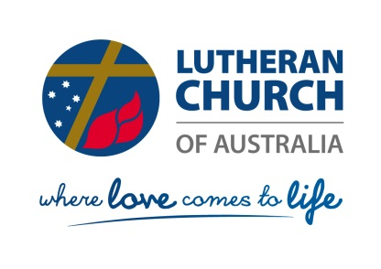
Lutheran Church of Australia Child Protection Project Officer

In December 2017, the Royal Commission into Institutional Responses to Child Sexual Abuse (Royal Commission) released its final report:
https://www.childabuseroyalcommission.gov.au/final-report

As well as providing numerous recommendations to governments, this report provided 48 recommendations directly to institutions.

The LCA is committed to making every effort to implement these 48 recommendations and the General Church Council has approved a related action plan.

The LCA is seeking a capable person, preferably with significant relevant professional experience, to plan and coordinate the implementation of the action plan and the Royal Commission’s recommendations.

Applications must be lodged with the Executive Officer of the Church (peter.schirmer@lca.org.au) by Monday 10 September 2018.

It is intended that interviews will take place during the week commencing Monday 17 September 2018.

