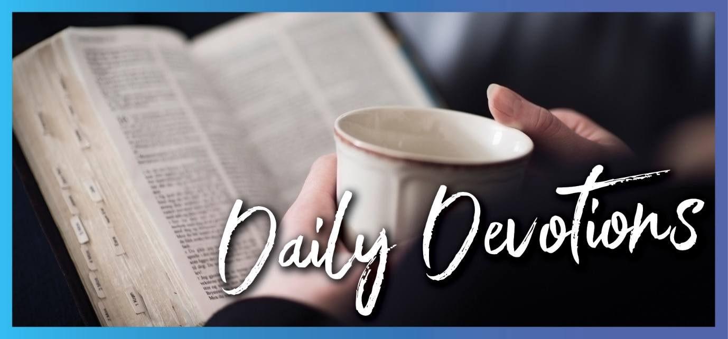

Sunday 11 April to Sunday 18 April
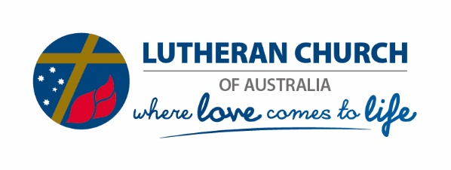
Sunday 11 April 2021

What’s on your breath?
by Pastor Reid Matthias
Jesus said to them again, ‘Peace be with you. As the Father has sent me, I also send you’. After saying this, he breathed on them and said, ‘Receive the Holy Spirit’ (John 20:21,22).
Read John 20:19–31
You can tell a lot about a person by how their breath smells, can’t you? What they’ve eaten, whether they’ve cleaned their teeth. Are they coffee drinkers, or have they recently consumed Doritos? To get a sense of what’s on their breath, you have to get close. Really, uncomfortably close.
After Jesus rose from the dead, the disciples huddled in a room wondering about the resurrection sighting of their Lord. They were afraid of the Jews, and perhaps even afraid that Jesus would return only as a ghost. The disciples felt surprised when Jesus made an appearance in their midst.
First, Jesus calmed them down – ‘Peace be with you’. Then he proved his resurrected reality: the physical, holes in his hands and feet, and the reality of being alive, breath. Only living things breathe.
But what does his ‘breath’ smell like? What is the aroma of his words?
Peace.
Sending.
Forgiveness.
The first words of the risen Saviour are of freedom from fear. Go on your way, faithful ones. Share the good news that no-one has to be afraid ever again. Death no longer has the final say. I’m sending you into a world gripped by the virus of fear, which replicates so easily in the cultured medium of a death-denying society. I’m sending you into this infected society to vaccinate it through forgiveness. Eradicating this fear will be a long, drawn-out process, and some will resist it, but true life comes from it.
Just as Jesus gave the disciples peace and purpose through his words, so he gives you peace and purpose.
What does your breath smell like?
Holy Spirit, let the words of my mouth and the meditations of my heart be a reflection of your peace and forgiveness in my life. Amen.
Monday 12 April 2021

Ultimate cage fighting – Old-Testament-style
by Pastor Reid Matthias
Jacob was left alone, and a man wrestled with him until daybreak (Genesis 32:24).
Read Genesis 32:21–32
Some Bible stories, like this one, are hard to believe, especially if you know how to wrestle.
Wrestling was a big sport in the US state of Iowa, where I grew up. It was a requirement for boys to take part during PE in Years 7 and 8. We learned how to grapple, yank on opponents’ legs and arms and mash their faces into the mat. If we wanted victory, we had to be aggressive.
But those matches never lasted for more than three minutes. It was exhausting and painful. I would have avoided it if possible. In our Bible reading today, it feels like Jacob actually seeks it out.
As I read the recap of the match in Genesis, I’m amazed by many things regarding Jacob’s wrestling: his tenacity, his precociousness, his endurance. All for what? What was he hoping to achieve?
Victory over God? Victory over an angel? Victory over a man?
I wrestle with God a lot. It’s never quite to the extreme of what Jacob had to go through. But God stretches me, mashes my face into all sorts of things, and he is aggressive – oh, yes, he is. By the end of my wrestling matches, all I can do is hold on for dear life and hope to be blessed by the activity of wrestling. I know that God could destroy me in an instant. I know that there is no possible way I can win. I know that no matter what I do, at the end of our time, God can simply dislocate me.
And just like with Jacob, God does not destroy me. Yes, it was a painful process. Yes, I know that I didn’t win. And, yes, I’m blessed by the wrestling because I’m now stronger, and God is preparing me for even better things.
Heavenly Father, as I wrestle with your will for my life, bless me like you did Jacob, to grow stronger in my life with you. Amen.

Tuesday 13 April 2021

Gone tenting
by Pastor Reid Matthias
Your eyes will see Jerusalem, a quiet habitation, an immovable tent, whose stakes will never be plucked up, nor will any of its cords be broken (Isaiah 33:20b).
Read Isaiah 33:13–24
Many years ago, my parents took me camping alongside a beautiful stream. It was exciting to unroll the sleeping bags inside the canvas tent with all its musty smells and dead bugs. So many things occur when camping that don’t happen in normal life.
That night, as we stayed along the banks of this lovely stream, a storm rolled up. And let me tell you, a tent is not a nice place to be when the wind is howling and rain is pounding against the fly. If you’re lucky, the tent will withstand the storm. But if you’re unlucky, the tent will collapse, and you’ll be screaming for a new shelter.
When the Israelites wandered in the wilderness, I’m sure they had some pretty terrifying nights in the tents. More than once, they might have been buffeted by all sorts of storms in the desert.
Throughout their journeys, they were always looking forward to the Promised Land. A place where they’d feel secure. A quiet habitation, where their tents would never be un-staked, nor their securing cords be broken.
Do you long for that vision, where life will be a quiet habitation? Do you long for the day when you can look out over the beauty of what God has made and not worry about a coming storm or whether your tent will collapse?
And that day is coming. ‘But there the Lord in majesty will be for us, a place of broad rivers and streams where no galley with oars can go, nor stately ship can pass’ (verse 21).
There, our God will be, and he will provide a place of safety for his people.
I’m looking forward to that camping experience.
Lord of all creation, guide me to safety and surround me with a shelter that can protect me from the storms. Remind me of the beautiful place you have for us all. Amen.

Wednesday 14 April 2021

Swallowed whole
by Pastor Reid Matthias
When my life was ebbing away, I remembered you, Lord, and my prayer rose to you, to your holy temple (Jonah 2:7).
Read Jonah 2:1-10
Just when you thought it was safe to go back into the water.
I can’t even begin to imagine what being swallowed by a fish is like. For certain, the smell would be rancid. It’s not like you’d be the only meal down there. Darkness, sea-sickness, the sounds of the fish’s heartbeat or even the water rushing past its gills.
I guess there could be no better description of Sheol, the Hebrew word for the place of the dead.
As the story of Jonah goes, he understands why he is in this dead space. Rejecting God’s call on his life to ‘Go to the great city of Ninevah’ (Jonah 1:2b), Jonah instead goes down the hill to Tarshish. He then goes down to the bottom of a boat, where he is ultimately thrown over into the sea. He ends up in the belly of the fish, down to the heart of the seas to the roots of the mountains (Jonah 2:6a).
You can’t go any lower.
And in this lowest place of the dead, Jonah recognises his error, and he calls out to God.
Have you ever been to that place where life seemed to swallow you whole? Have you been to that place of darkness and soundless fear?
God promises that even if we turn from him, he will be with us. Salvation comes from God even in that living Sheol. God promises that he will bring us from that place of darkness back onto dry land.
In what way have you run from God? How did God bring you back? What did you learn?
God of light, illuminate those dark places that I sometimes choose for myself. Give me hope and remind me of your promise of salvation through your Son, Jesus. Amen.
Thursday 15 April 2021

Daisy petals
by Pastor Reid Matthias
For the Spirit God gave us does not make us timid, but gives us power, love and self-discipline (2 Timothy 1:7).
Read 2 Timothy 1:5–10
Do you remember the first time a special someone caught your eye?
There are certain feelings associated with this, I think. Excitement, caution, fear, nervousness, elation … the list goes on and on. And then there’s the thought process like an endless daisy petal picking adventure. Should I? Shouldn’t I? Should I? Shouldn’t I?
The word for that is ‘timidity’. When we approach new situations, circumstances and people with ‘should I, shouldn’t I’, waffling back and forth, this is the opposite of what God does for us through the Holy Spirit.
In Paul’s letter to his dearly loved son, Timothy, Paul describes God’s activity in his son Jesus, ‘but it has now been revealed through the appearing of our Saviour, who has destroyed death and brought life and immortality to light through the gospel!’ (verse 10).
God was not timid in saving the world through his son and approaching the world, the apple of his eye, to free us from the fear of death so that we can live in him and through him.
Knowing this, the Spirit of God does not give us a timid nature to approach new situations, circumstances and people. The Spirit of God gives us power (a beautiful force to be reckoned with). He gives us love (a beautiful nature that draws people to Jesus). And he gives us self-discipline (a beautiful check and balance to ensure we experience life and immortality with joy).
After you read this today, I hope that God leads you to new situations, circumstances and especially people with whom you can share God’s gifts also.
Remember: God’s gift is power, love and self-disciple. Don’t be timid!
Spirit of gifts, help me to experience your love and grace to know the ultimate power in Jesus Christ. Amen.

Friday 16 April 2021

Christ the Conqueror
By Pastor Reid Matthias
Because everyone who has been born of God overcomes the world (1 John 5:4a).
Read 1 John 5:4–12
If I write the word ‘conqueror,’ who first comes to mind?
Throughout history, there have been military leaders who have, through often brutal means, enlarged their territory. Genghis Kahn, the Mongol leader, conquered territory from eastern Europe across the entirety of Asia to Japan on the east. According to history, his superior military tactics, along with the Mongols’ expertise on horseback and with bow and arrow, allowed him to subdue any group that tried to stand in his way.
From the Apostle John’s perspective, though, conquering the world is not about taking territory, but actually giving it up. Or, as the NIV translates, ‘overcomes’ the world.
How does this happen? Is it by our superior tactics? Our war-like tendencies? Cutting the world down with weapons of destruction?
No, it is by the power of God and his empowerment of love to his children. ‘Everyone who believes that Jesus is the Christ is born of God … and everyone who has been born of God [ie received the Holy Spirit] overcomes the world. This is the victory that has overcome the world, even our faith’ (1 John 5:4,5).
This is the victory. Christ the Conqueror through love. The free gift of grace through our faith in Christ Jesus allows us to give up our aspirations of conquering territory and allows God to conquer the terror of sin, death and the devil.
What kinds of things has the Holy Spirit helped you conquer in life? What are some things you’d like to ask for help with?
Heavenly Father, thank you for your amazing gift of faith. Thank you that it allows me to see that you have conquered the world so I might live freely in it. Your victory is immense! Praise Christ the Conqueror!
Saturday 17 April 2021

Sleep well
by Pastor Reid Matthias
In peace, I will lie down and sleep, for you alone, Lord, make me dwell in safety (Psalm 4:8).
Read Psalm 4
As I read through Psalm 4, I get a distinct impression that King David has not been sleeping well.
Maybe he is like I get sometimes. I’m so tired that falling asleep in the recliner seems like a foregone conclusion, but when I crawl between the covers to go to sleep, my brain wakes up. For some reason, all tiredness has left, and I can only think about the things that have stumped me during the day.
It sounds like Psalm 4. King David arose from lying on his royal sofa, went to bed, searched his heart and found a lot of noise.
‘Many, Lord, are asking, “Who will bring us prosperity?”’ (verse 6a).
Was he frustrated with his people? Was he angry with their doubt? Was he tired of his people ‘loving delusion [things that are worthless] and seeking lies?’ (verse 2).
Are you like this? Do you replay the day and all the frustrations and people who have angered you, and it keeps you awake?
Maybe our pathway to a peaceful sleep is a journey through the joy in God’s heart. God has set the faithful people apart for himself. He listens to us, and we trust him because he keeps his promises, and he allows us to live in safety.
At the end of the day, aren’t these the things that we most long for to settle our minds?
What kinds of things do you think about as you prepare for sleep? How do you find a peaceful mind and soul?
Lord, let the light of your face shine on me. Grant me joy, just like a celebration of life. Help me to find peace even in the midst of chaos. Help me not to be afraid, because you are in control of my life. Amen.

Sunday 18 April 2021

The One
by Rachael Stelzer
Then he opened their minds so they could understand the Scriptures (Luke 24:45).
Read Luke 24:36b–48
The disciples huddled in a closed room, confused and afraid. They had heard strange stories, first from the women and then from an out-of-breath Cleopas, of appearances by their teacher, whom they had seen taken down from the cross and placed in the tomb. And, suddenly, he was there in their midst. The One. The teacher. The master. And in their shock, panic and emotion, they cried out in fear. ‘It’s a ghost!’
What happened next could have come from a TV sitcom, complete with canned laughter. Jesus did everything he could to convince these overwhelmed people that he was alive, real and with them. He told them to look at his hands and side, to recognise the scars they had watched him receive. Then when that didn’t work for some, he asked them to bring him some food, to prove through normal human digestion that he wasn’t a ghost with food falling through him. What a hysterical picture he must have seemed! The disciples knew Jesus as one who loved to share food with them. Then he taught them, as he always had, of the importance of his role on earth, now with the benefit of hindsight and perspective. And they recognised his voice and teaching, and it all began to make sense.
Jesus went to such lengths to change his disciples’ fear and confusion to joy and confidence. And Jesus still transforms his followers today.
What fears, panic and confusion do we go through? What stories have we heard? And do we recognise the One, the teacher, the master, for who he really is when he stands among us?
Jesus still lovingly shows us who he is. Through his word, people and church, Jesus teaches us, laughs with us, calms us and speaks to us, despite the many other voices that clamour for our attention. May we continue to learn from him, to recognise his voice and ways, and know the confidence and joy of the risen King.
Risen Lord Jesus, open my eyes to see you. Open my ears to hear you. And open my mind to learn from you. Amen.

