Meditation for NAIDOC Week service – 2020 (8 – 15 November)
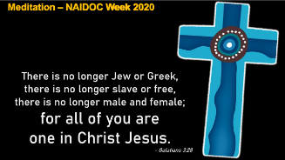
1
NAIDOC Week is observed each year as a celebration of Aboriginal and Torres Strait Islander peoples, their histories and cultures.
The text this meditation today is based on is Galatians 3:28 – There is neither Jew nor Gentile, neither slave nor free, nor is there male and female, for you are all one in Christ Jesus.
The theme chosen by the National NAIDOC Week Committee for this week’s observance is: Always Was; Always Will Be, to acknowledge the fact that First Nations peoples have occupied and cared for this continent for over 65,000 years.
For us as Christians (Aboriginal and non-Aboriginal together) we take this statement to yet a higher level as we believe there’s only One whose existence truly spans time and eternity, and that’s the triune God – Father, Son and Holy Spirit. He’s the only One of whom it can be said, he always was, and always will be.
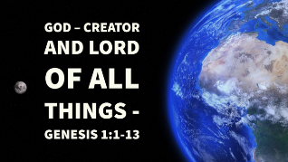
2
God created this whole vast cosmos, including our own small planet. He brought order out of chaos, and separated the land from the seas. In his own mysterious way, he brought time, and life and seasons to our planet.
The crowning glory of God’s creation was humanity, created in his very own image by a special act, and placed into an idyllic environment in the Garden of Eden, with the commission to work [the land] and take care of it.
However, it didn’t take long for the peace and harmony of God’s good Creation to be destroyed. First came the act of disobedience that broke the relationship between God and humanity, and led to expulsion from Eden. Adam blamed his wife, Eve, for what had happened. Then, in a jealous rage, one of the first two sons born into this world killed the other. The perfect harmony of human relations was broken forever. And now we’re all tainted with this corruption we call sin, and it shapes us and what we do and say, and even how we think, and how we interact with other people.
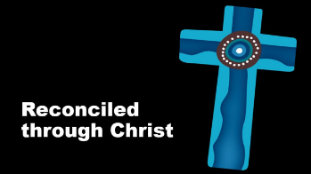
3
Faced with this situation, God promised forgiveness and redemption to all who would trust his promise. And then, when the time had fully come, God sent his Son, born of a woman, born under the law to redeem those under the law, as St Paul writes in his letter to the Galatians. Through the life, death and resurrection of Jesus Christ, everything that comes between us and God and between us and our fellow human beings has been dealt with. He suffered the punishment and paid the price for our sin and guilt. By his Spirit, God draws us to himself and into his church through his gospel, in word and sacrament.
So, as St Paul wrote to the Romans, there is therefore now no condemnation for those who are in Christ Jesus. God has reconciled us to himself through Christ, Paul wrote, but then he added that God has also given us the ministry of reconciliation.
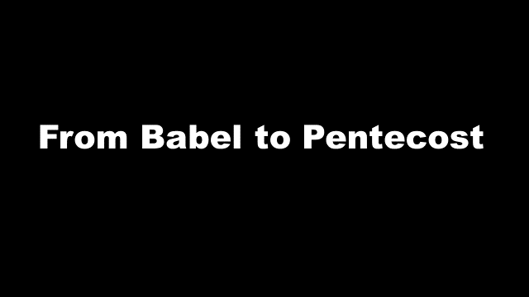
4
After people scattered across the earth when God confused their language at the tower of Babel, many different cultures developed. God’s church now includes people from many different cultures, and with many different languages.
From the beginning, the New Testament church in Jerusalem was a multi-cultural church comprising people of both Jewish and Gentile background. The 3000 people who were baptised at Pentecost came from many different countries and cultures.
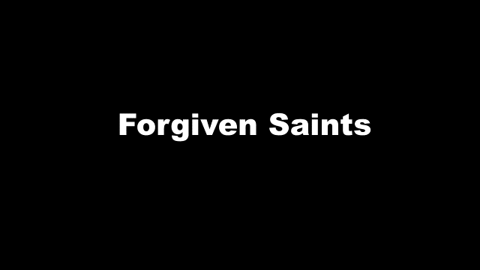
5
However, Christians aren’t perfect. We’re forgiven saints, but something of the sinner still clings to us, and shows up all too often in the way we relate to others, even within the church, as well as in our families, and in the wider community.
You can see this already in the New Testament church in Jerusalem. The first congregational meeting was called to address alleged favouritism in the way food was being provided to widows of Hebrew and Grecian background. You can read about it in Acts 6.
The first church conference was called to address cultural differences among members of Jewish and Gentile background. That’s in Acts 15.
And St Paul faced similar situations in some of the churches he established, particularly in Galatia. And our text is from his letter to just these people. Paul felt the need to make the point that there is neither Jew nor Gentile, neither slave nor free, nor is there male and female, for you are all one in Christ Jesus – you are all one in Christ Jesus.
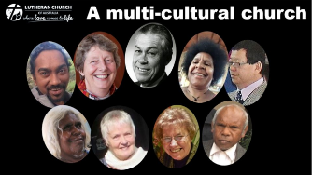
6
The Lutheran Church of Australia today is also a multicultural church. Post-War immigration has brought people of various European cultures to us as refugees – Estonians, Latvians, Lithuanians, Germans, Finns ... to mention just a few. More recently immigrants from Africa, Cambodia, Vietnam and China have become part of our church. Each has brought his or her own history and culture.
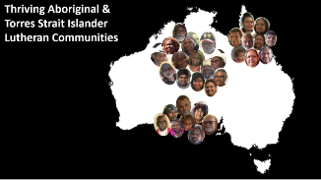
7
But from the earliest days of Lutheranism in this country, our church has also included significant numbers of Aboriginal members. Many of the first Lutherans to come to this country were refugees from religious persecution in Europe. But among them were also missionaries, who brought the gospel of reconciliation in Jesus Christ to various First Nations people, particularly in Central Australia, on South Australia’s west coast, and in north Queensland.
Today there are thriving congregations in these areas, and members have spread from there to other parts of the country into towns and cities, It’s estimated that there are now around 7000 Aboriginal and Torres Strait Island members in these LCA Many live in more than 40 communities, and are served by 22 ordained Aboriginal pastors. However, we need to be aware, that many more are also in local congregations in our towns and cities, perhaps even this congregation.
Sadly, however, from the time of European settlement in Australia, things haven’t always gone well for relations between Aboriginal and non-Aboriginal people. In recent years there’s been a growing recognition of this across Australian society.
In 2001 an organisation known as Reconciliation Australia was established to promote improved relationships between the wider Australian community and Aboriginal and Torres Strait Islander peoples. This body has developed a Reconciliation Action Plan (RAP) program to which committed and informed organisations around Australia are invited to sign up, in order to show their support for this initiative.
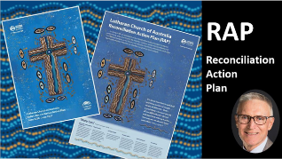
8
At its 2018 General Synod, the LCA agreed to adopt a Reconciliation Action Plan a RAP, as just one tool to hear better the Indigenous voice. For the church to intentionally speak with, work and walk together alongside First Nations people, each learning from and valuing the other. This is the nature of the reconciliation in a Reconciliation Action Plan. Reconciliation is at the very heart of the gospel.
In introducing the RAP, Bishop Henderson said: ‘The worth, dignity and equality of human beings is core to the Christian faith’. He added that, despite this basic belief, ‘we are often painfully separated by race, culture, power and prestige’.
Our participation in the RAP program is intended for us as church to reflect on relationships between Aboriginal/Torres Strait Islander peoples and other Australian members who make up our church.
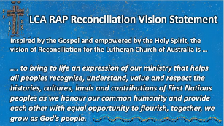
9
In the booklet introducing RAP to the church, the vision statement for reconciliation in this context is as follows:
‘Inspired by the Gospel and empowered by the Holy Spirit, the vision of reconciliation for the Lutheran Church of Australia is ...
‘to bring to life an expression of our ministry that helps all peoples recognise, understand, value and respect the histories, cultures, lands and contributions of First Nations peoples, as we honour our common humanity and provide each other with equal opportunity to flourish, as together we grow as God’s people.’
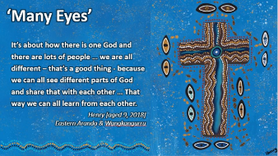
10
The logo being used for the LCA’s Reconciliation Action Program was designed by a nine-year-old Aboriginal boy, called Henry. It’s a sermon in itself ...
There are many eyes around the cross, showing that there are many ways in which reconciliation can be viewed.
The many coloured dots that make up the cross show the different paths our lives may take as we walk together.
The flowing shades of blue – the colour of water – meet at the centre of the cross, reminding us that we each are reconciled with Christ in our baptism, and that together we are all children of God.
You can also see the eye of our loving God at the centre of the cross. He is always watching over us as we come and go, and calling us back to himself when we falter in our life as baptised members of his church.
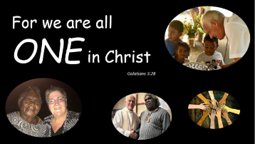
11
As our text teaches us, by our baptism we are all equally members of the holy Christian church, of which Jesus Christ is the Head.
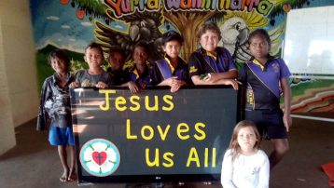
12
And, as this sign at the school at Hope Vale in far north Queensland, says: ‘Jesus loves us all’. This is the heart of the gospel. It’s the basis for our oneness, and it’s what motivates us in implementing a Reconciliation Action Plan.
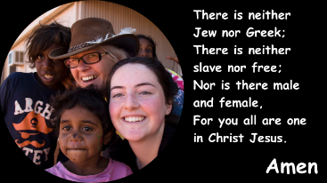
13
Amen.

