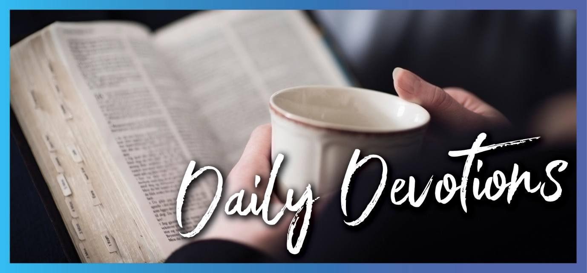

Sunday 22 November to Sunday 29 November
Sunday 22 November 2020

The eyes of your heart
by Verena Johnson
‘I pray that the eyes of your heart may be enlightened in order that you may know the hope to which he has called you’ (Ephesians 1:18).
Read Ephesians 1:15–23
Don’t just skim over this amazing verse. Read the verse once more, slowly, and soak up the words. (I’m not just saying that because this is one of my favourite prayers in the Bible.) Hear Paul’s prayer for you.
When you look around with your human eyes, you certainly see a fallen world. You see the struggles that many of us have faced and continue to face during this unprecedented year. You see an uncertain future in terms of the new normal that we are all navigating at the moment.
I have 20/20 vision when it comes to distance and driving, but when I try to see something close or read a book, it all becomes blurry. It’s so easy to have 20/20 vision when we look at the things that we are struggling with. It’s so easy that it can blur what the eyes of our heart should be seeing.
When God enlightens or opens the eyes of your heart to what he has done and is doing, you see something completely different.
You see the hope he has called you to. A hope that is sure and certain, regardless of your circumstances, the world around you, or the ‘normal’ you find yourself living in.
You see the richness of the inheritance that God has for you. He made us for far more than this world. He made us for something truly glorious. There is no uncertainty about that either.
You see his incomparably great power for you. The same power that created the universe and raised Jesus from the dead.
Ask God to enlighten the eyes of your heart, and practise ‘seeing’ with them in the midst of this life. Pray Paul’s prayer …
Dear God, I pray that the eyes of my heart may be enlightened so that I may know the hope to which you have called me, the riches of the glorious inheritance you have given me, and your incomparably great power for me. Amen.

Monday 23 November 2020

Don’t look back
by Verena Johnson
‘But Lot’s wife looked back, and she became a pillar of salt’ (Genesis 19:26).
Read Genesis 19:15–29
We know very little about Lot’s wife. We don’t know her name, but she has been called ‘Ado’ or ‘Edith’ in some Jewish traditions. We don’t know where she was from. What we do know is that despite the angel’s very specific instruction not to look back, she did.
There are a lot of varying theories out there on why she looked back. Some say it was a punishment and that when she looked back at the cities that were so evil, she betrayed her secret longing for that way of life. Other much kinder theories speculate she was looking to see if her daughters were following. Regardless of the reason, Lot’s wife became an instant pillar of salt when she looked back. It seems very harsh.
We can spend a lot of our lives looking backward for a whole range of reasons. Wondering ‘what if’, replaying actions and conversations, and regretting things we’ve done or not done, to name a few. The new one for this year has been, ‘If only I’d used all that time I had at home more wisely!’
We can spend so much time looking back that we don’t live in the moment and embrace all the joy and possibilities God gives us in the present.
Thank God that he doesn’t turn us all into pillars of salt but forgives us every day. Thank him that because of his grace, we don't have to live with what-ifs, replays and regrets. In him, each day is a new beginning with new potential (Lamentations 3:22,23).
Dear God, I thank you that you are a God of forgiveness and new beginnings. Help me not to look back. Help me to give you all my what-ifs, replays and regrets, and leave them with you. Help me to walk into each new day with you and embrace all the moments, joys and possibilities you give me. Amen.
Tuesday 24 November 2020

Judging ourselves
by Verena Johnson
‘For at whatever point you judge another, you are condemning yourself, because you who pass judgement do the same things’ (Romans 2:1).
Read Romans 2:1–16
We make hundreds of judgements every day – about other drivers on the way to work or the people we see on the bus, those we work with, the people we pass on the street or queue up with at the shops, the people we hear or read about in news items. Who hasn’t made judgements about the recent American elections!
It’s so easy to judge; however, as this verse points out, when we judge others, we are judging ourselves. We can’t make excuses for ourselves and judge others, as we are no different from anyone else. We all have our flaws. We all make mistakes and mess things up. We all say and do the wrong things.
We also can’t sit in judgement and rate sins on a scale of one to ten, with one being a small slip-up and ten being totally evil. It’s all sin. We’ve all sinned and deserve God’s judgement.
Verse 11 of this passage says, ‘For God does not show favouritism’. God does not show favouritism when it comes to judging sin, but he also shows no favouritism when it comes to his love or his grace and forgiveness. It’s there for everyone who believes and anyone who asks.
God loves us and also all those people we are so quick to judge. He wants to shower his grace and forgiveness on them as well as on us. What’s more, he wants you and me to show his love, grace and forgiveness towards them too.
One of my wise mentors once told me that whenever they are tempted to judge others, they remind themselves that the other is a person for whom Christ died.
Dear God, thank you for your love and the grace and forgiveness you shower on me. Help me to show that same love, grace and forgiveness toward others. Amen.

Wednesday 25 November 2020

Do not lose heart
by Verena Johnson
‘Therefore we do not lose heart … For our light and momentary troubles are achieving for us an eternal glory that far outweighs them all’ (2 Corinthians 4:16a,17).
Read 2 Corinthians 4:16–5:10
As you read through the text above, I wonder how you reacted to the phrase ‘light and momentary’. Did you think to yourself, ‘What does Paul know about my troubles? They are anything but light and momentary! This is one of the heaviest things I’ve gone through, and there’s no end in sight!’
Perhaps you can relate to feeling like you’re ‘wasting away’ because of the troubles you’re going through. Maybe you’re feeling disheartened and discouraged. Or maybe, you’re simply tired and worn out. This year has been a long and difficult one for many of us.
Paul didn’t write these words ‘lightly’; he knew all about troubles and had been through a lot. If you doubt this, check out the list a bit further on in this same letter (2 Corinthians 11:23–29). Despite everything Paul had been through, he could still say ‘do not lose heart’ because he believed without a doubt that even the most agonising trials of this life are minor when compared to the amazing eternal glory that awaits us.
I witnessed this when my mum was dying of cancer. Outwardly she was indeed wasting away, but she didn’t lose heart. Through it all, she kept her eyes firmly fixed on the unseen and the glory that awaited her. She comforted me, not the other way around! This was evident even the way she first told us, ‘I have good news and bad news. The bad news is I have terminal cancer. The good news is I get to be with Jesus in heaven much sooner than I expected’.
Like Paul and my mum, look to the unseen world for encouragement. During the very hard days, fix your eyes beyond what is seen and transient, and get a glorious glimpse of eternity.
Dear God, thank you that you are always with me in the midst of my troubles. Thank you for the amazing eternal glory that awaits me. Please help me to fix my eyes on what is unseen even as I struggle with what I see and feel. Amen.

Thursday 26 November 2020

First love
by Verena Johnson
‘You have persevered and have endured hardships for my name, and have not grown weary. Yet ... you have forsaken the love you had at first’ (Revelation 2:3,4).
Read Revelation 2:1–11
John commended the church in Ephesus for the way they endured and persevered through hardship, but he had an issue with them: they had forsaken their first love.
Do you remember what it felt like when you first fell in love? Do you remember the intensity of your emotion, the weak knees, the fluttering heart? What about the can’t-think-about-anything-else feeling?
However, love often wanes. We can find ourselves going through the motions, getting into a rut, taking each other for granted, and drifting apart. You have to work at a relationship.
It’s the same with our relationship with God. Our love and devotion for him can wane. We don’t intend to forsake him or our love for him, but we can find ourselves going through the motions before we even know it. We can do all the right things, but it becomes more of a ritual than a relationship.
I’m sure the Ephesians didn’t mean for it to happen either, but somewhere amid all the hardships and perseverance and even their good deeds and hard work, they drifted apart from God. Hopefully, this letter was the wake-up call they needed to refocus on their relationship with God.
The good news is that God’s love for us never wanes. He loves us literally in a way that is ‘to die for’, as they say. He loves us passionately, deeply and completely. Nothing and no-one can change that. His heart’s desire is for a close and intimate relationship with us. He keeps pursuing us, wooing us and calling us back to him.
Wherever you are in your relationship with God, he is calling to you today: ‘Come to me, be with me, let me show you how much I love you.’
Dear God, thank you that your love for me never changes. Open my heart and mind to the depth of your incredible love. Forgive me for the times I have neglected our relationship or drifted away. Help me to grow in my love for you. Amen.
Friday 27 November 2020

Seeing God
by Verena Johnson
‘Then I saw a great white throne and him who was seated on it. From his presence earth and sky fled away, and no place was found for them’ (Revelation 20:11).
Read Revelation 20:11–21:1
John has a vision of judgement day and tries to describe the indescribable without even having the benefit of a handy thesaurus. He sees God seated on a great white throne. His presence alone is so mighty and so magnificent that everything else pales into insignificance and flees away.
That is the holy, magnificent, awe-inspiring God that is our God.
That is also the same God that we can sometimes worship half-heartedly and can take for granted in our day-to-day lives. We even try to tame him, explain him, put him into a box, or remake him in our own image.
We can forget just how incredibly, extraordinarily, mind-bogglingly great our God is. We can stop being amazed by the staggering truth of who he is. We can fail to be astounded by the inconceivable fact that the God who created the whole universe actually knows and loves us despite how insignificant we are.
God will not be tamed, explained, boxed or remade, despite our best attempts to do so. (I should know because I’ve tried at times!) He is Almighty God, after all. Ultimately, he will not be taken for granted or forgotten either. Especially when we eventually face him seated on that great white throne, which symbolises both his absolute holiness and his judgement.
As I write this, I can only imagine what it will be like when that day comes. I think about what it will feel like to finally see my marvellous God with my own eyes, and everything else will fade away and flee in his presence. I think about all the questions I have for him and all the things I want to be explained (and I do have a list). All the stuff of my life that seems so important now won’t matter anymore besides the awe, joy and wonder of being there with him.
I can’t wait for that day.
Dear God, forgive me for the times when I have forgotten that you are God or tried to make you less than God. Please remind me of who you truly are. Thank you that you know me and love me. I look forwards to the day when I will finally see you face to face. Amen.
Saturday 28 November 2020

The view from up there
by Verena Johnson
‘Restore us, Lord God Almighty; make your face shine on us, that we may be saved’ (Psalm 80:19).
Read Psalm 80
Israel was going through some pretty tough times when they were being ravaged by a foreign power. This psalm is a lament and an agonised cry to God to save them.
The refrain, ‘Restore us, Lord God Almighty; make your face shine on us, that we may be saved’, is repeated three times in this psalm. It’s a familiar refrain to any of us who have been through or are going through tough times.
I remember one time when I had to fly interstate for work. When the plane took off, it was dark and stormy; rain was beating down on the windows, and the wind was buffeting the plane. We had a very bumpy take-off, and there were quite a few white knuckles, for instance, on the very nervous passenger seated next to me.
Then, all of a sudden, we burst through the clouds into a clear blue sky and bright sunshine. There was an audible sigh of relief and some applause. The passenger next to me was like a new woman. Everything had changed, even though the storm below was still going on. It was hard to believe that this was the same day that we’d taken off. It was all so different from up there above the clouds.
We don’t have to plead for God to shine his face on us; he already is. But, sometimes, we can’t see it or feel it because the clouds of our circumstances and the storms of life get in the way and block him from our view. That doesn’t change the fact that he still there. He is always there to save us and restore us, whether it feels like it or not.
He wants to lift us above the clouds. Our life and circumstances look quite different from up there, from his perspective. Even though the storm might still be going on, everything is changed when we see the brightness of his face and rest in the warmth of his love.
Dear God, thank you that your face is always shining on us and that you are always there to save and restore us. Please help me to always look to you. Lift me above the storms and tough times that I experience and help me to see them from your perspective. Amen.

Sunday 29 November 2020

Are you in shape?
by Pastor Mark Gierus
‘Yet you, Lord, are our Father. We are the clay, you are the potter; we are all the work of your hand’ (Isaiah 64:8).
Read Isaiah 64:1–9
Do you like to keep in shape?
Many of us during the different COVID lockdowns and restrictions had the best intention of keeping in shape so we would dodge the 'COVID spread', and some people have succeeded in keeping in shape during this challenging year. But have you ever thought about what shape you are in when it comes to your relationship with God?
Would you say you are in good shape? Perhaps you might say that you are doing okay but need to spend a little more time with God? You might, at this point, feel guilty that you are out of shape with God.
Yet, our Heavenly Father loves you no matter what shape you are in. He sent his only son, Jesus, to suffer and die for our sins to make us right with him. We are made right because we believe what Jesus has done for us. He died and rose again for us. God forgives us and saves us from sin, eternal death and the power of the devil. He gives us eternal life. All of this is done for you. All you need to do is receive this gift. We are not strangers who are out of shape with God. Instead, by God’s grace through Jesus, we are in the best shape we can be – we are children of God.
In our reading today, we hear that God is our Father, and if God is our Father, he has made you and me his children. We are the clay, and God is the potter. You and I are the work of his hand. No matter where you find yourself in life, God is shaping you by his hands through his word in Jesus. By the power of the Holy Spirit, God is shaping, changing and renewing your heart to be more and more like Jesus. All you need to do is receive God’s gift – the baby Jesus. As Jesus lives in you, by his word, you will continue to be shaped to share God’s love with the world in all you do.
Peace be with you.
Dear Heavenly Father, shape me daily by your word through your Spirit that I may continue to grow to be more like your son Jesus in whose name I pray. Amen.

