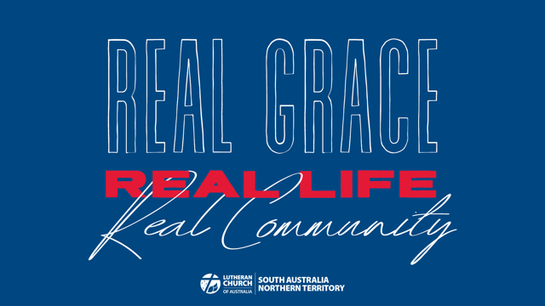

Week 4 Sunday School Activity Suggestions: Real Community
Resources adapted from ministry-to-children.com

Memory verse
“If one part of the body suffers, then all the other parts suffer with it. Or if one part of our body is honored, then all the other parts share its honor.” (1 Corinthians 12:26 ICB)

Share highs and lows together

Songs
Grow Up Like Jesus https://crossroadskidsclub.net/music-video-grow-up-like-jesus/
Cow Loves Moo https://crossroadskidsclub.net/music-video-cow-loves-moo/ (about friendship)

BODY OF CHRIST
Discussion questions
- How many parts of the human body can you name?
- What jobs do they do?
- How are they different from each other?
- Are there any we don't need?
- Which parts of the body can't you see?
- Do you know what they do?
- Think about the different people in your family and the different personalities and gifts they bring even though they are one family unit.
- What different things do Christians do to show they belong to Jesus and the Christian family?
- In church? At home? At work/ school?
- What gifts do you think that God has given you?

Group Activities
Below are a few quick body-related games that also illustrate teamwork…pick one or two depending on time and interest (and kid skill level):

- Play “teamwork tower…” have students work in pairs to see who can be the first to stack Cheerios up onto a raw spaghetti noodle…the catch is that each student may only use ONE hand and the other must assist to make up for it.
- Have a jigsaw race…work in pairs or teams to see who can quickly put together a puzzle (especially one that has to do with the body or skeleton).
- Play the “Cootie” game with bug body parts…
- Play “Twister” game
- Demonstrate making a snack or recipe, but leave out an important ingredient (maybe one that seems insignificant). You might bring in something that is already prepared, like bread without yeast or cake without eggs…
- Similar to the Cheerio stacking game, have students work in pairs or teams to complete a simple task like preparing a peanut butter and jelly sandwich…but limit the amount of body parts each kid can use (someone might have no arms, another only one hand, etc.)
- Play a “musical body parts” freeze dance game…every time the music pauses, call out two body parts. Have students find another student and put those parts together (if you holler “elbow/knee,” one kid puts elbow on another’s knee).

SHARING JOYS AND HARD TIMES TOGETHER
Lesson demonstration
Plastic Cup Unity
Suggested time: 5–10 minutes
Supplies: 24 plastic cups; a large tray or cookie sheet
Instructions:
- Invite a volunteer to help with the illustration.
- Place one plastic cup on the ground beside your volunteer. Ask the kid to try
- standing on this cup without crushing it.
- When the cup collapses or breaks, remove it.
- Take the remaining plastic cups and group them closely together on the floor
- so that their edges touch. Place the tray or cookie sheet on top of the cups.
- Ask the kid to try standing on the cups now without crushing them.
- LEADER: You may not realize it, but we are a lot like those cups. On our own, we cannot withstand the burdens and hardships of this world. That’s why God calls Christians to work together as a team. That’s what we saw happen with the cups: When they worked together, they were able to do the job.

Craft activities
Hand Hearts
Suggested time: 10–15 minutes
Supplies: Red construction paper; additional
pieces of construction paper in various colours;
pencils; scissors; glue sticks; markers

Instructions:
Give each kid a piece of red construction paper and a pencil. Instruct them to
outline their hands, one at a time, onto the paper, making sure to space the two handprints apart so that they don’t overlap.
Instruct each kid to use scissors to cut out both of their handprints.
Each kid should glue both handprints onto a clean piece of construction paper. They should orient the hands so that they overlap at the bottom of each hand and the fingers point out and toward the corners of the page forming a heart shape.
Instruct the kids to write the memory verse at the top of the page or on a separate
page and then glue onto their paper.

