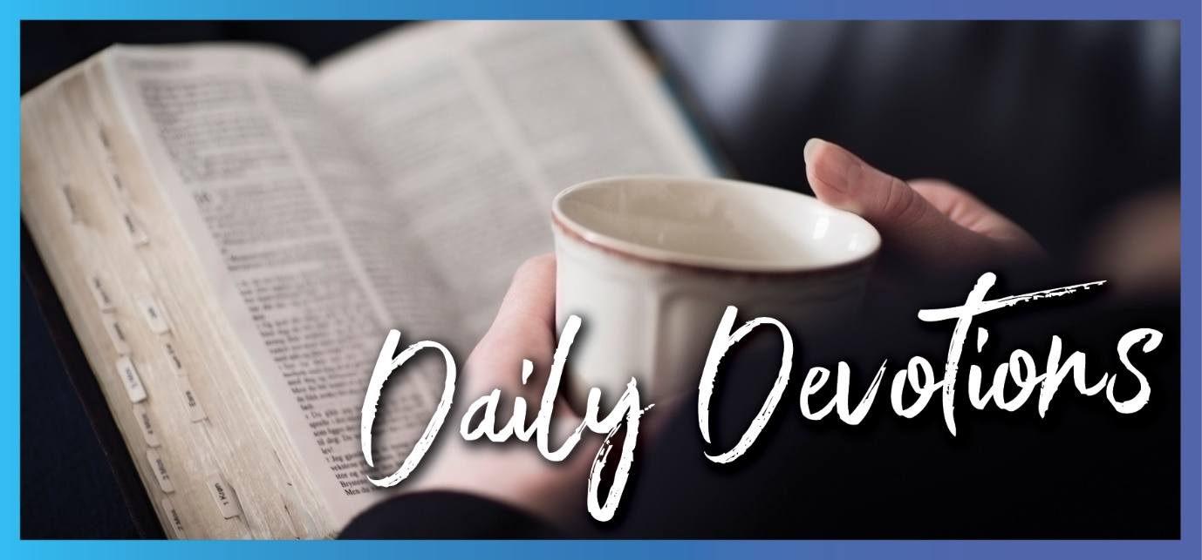

Sunday 24 October 2021 to Sunday 31 October 2021
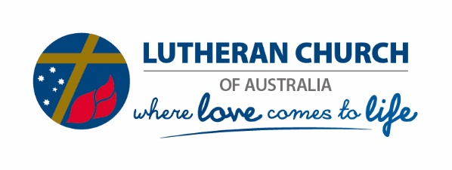
Sunday 24 October 2021

What do you want?
by Pastor Jim Strelan
‘What do you want me to do for you?’ Jesus asked him. The blind man said, ‘Rabbi, I want to see’ (Mark 10:51).
Read Mark 10:46–52
‘What do you want me to do for you?’ What a fantastic question coming from the mouth of Jesus – if only he would ask me that! And such a simple reply: ‘I want to see!’ No long stories about what a miserable life it is when you’re blind, how nobody cares, or how you have to beg for help just to survive. No promises about what he will do if Jesus heals him, how he will follow him and give his life to him. This man has one need, one thing above everything else. Nothing else matters. He needs change in his life, and he says it straight out: ‘I want to see’. From deep in his heart, he screams his need to Jesus, and, most likely in tears, he places his burden at Jesus’ feet and says, ‘You want to know what you can do for me? Here it is quite simply: I want to see’.
Can you hear Jesus asking the same question of you? What do you want? We know that we need change. We know there are areas of our lives that aren’t what they should be. We live with worry, confusion, uncertainty. We know that we need healing in our marriage, family and relationships with others. The blind man says it straight, and Jesus responds immediately. And on receiving his sight, the healed man follows Jesus.
Be daring like this blind man, and say it straight: ‘This is my biggest issue’. And hear Jesus offer you the word of healing.
Jesus, I bring to you that part of my life which most needs healing. Heal me, walk ahead of me, and I will follow. Amen.

Monday 25 October 2021

In the light
by Pastor Jim Strelan
The people walking in darkness have seen a great light (Isaiah 9:2a).
Read Isaiah 9:2–4
When we were in Papua New Guinea, we often experienced the phenomenon of flying ants swarming to the night light, especially if there was rain around. It would get so bad that we had no option but to switch the lights off and go to bed. In the morning, there would be a big pile of ants on the floor. Having no light to attract them, the ants couldn’t survive.
I’m sure you know what it’s like to be in darkness. You know what it is to be in despair, to be confused, to be wracked with guilt or just feeling broken. We all do. If we look inwards, often, what we see is pretty dark. We don’t like being in a dark place. Without light, we just stumble around. We may as well be blind. It’s as though there is no hope.
The passage from Isaiah promises us light because it points to Jesus, the Messiah (read verses 6 and 7). The blind man in yesterday’s reading called Jesus the ‘son of David’, a messianic title. Jesus rescues the man from his darkness by giving him light. That’s what Jesus does. He opens eyes. He makes new. He brings change. He dispels the darkness and brings things into the light. He is ‘the light of the world’ (John 8:12).
Jesus calls us to look out, look up and see his light, bathe in his light and then be light to those around us.
Dietrich Bonhoeffer, a pastor who was imprisoned by the Nazis, knew darkness. But in that place, he kept being drawn to the light. He said it like this: ‘In me there is darkness, but with you there is light. I am lonely, but you do not leave me. I am feeble in heart, but with you there is help. I am restless, but with you there is peace.’
Lord Jesus, dispel the darkness and shine your light into my life. Amen.

Tuesday 26 October 2021

Do you believe?
by Pastor Jim Strelan
When he had gone indoors, the blind men came to him, and he asked them, ‘Do you believe that I am able to do this?’ (Matthew 9:28a).
Read Matthew 9:27–31
Do you believe? Now that’s a question! Yes, I believe. I believe in God. Every Sunday, I stand up in church and say, ‘I believe’. Facts. Facts about God the Father, God the Son, God the Holy Spirit. But to know facts is one thing. To trust those facts and act on them is another. I know at night, when the room is dark, if I go over to the wall and flick a switch, the lights will come on. But knowing that fact and acting on it is something else.
We actually don’t know the depth of belief that these men had. They did call Jesus ‘son of David’, so they did have some concept of who he might be. They knew some facts about the One who had been promised. But those facts didn’t just stay in their heads, it led them to trust that this Jesus could bring them sight, and they acted on it. When Jesus asked them whether they believed that he could heal their eyes, their response was simple and categorical: ‘Yes, Lord’ (verse 28b). That was enough for Jesus.
Recently, I took the funeral of someone whom I described as having a ‘simple’ faith. That wasn’t putting her down or criticising her faith. I was saying that for her, believing was uncomplicated. She just did. She may not have had all the answers to the big questions about God, but she trusted him in her life and death.
What about you? Do you believe in simple, childlike trust that Jesus can bring you out of the darkness that wants to smother you, and take you into a place of light? These two men show us the way. They follow after Jesus, they persevere, and they ask quite simply. And their sight is restored.
Jesus, I call you ‘Lord’, which means I believe you are Lord over everything and every aspect of my life. Reach out your hand and heal where I am most sick. Amen.
Wednesday 27 October 2021

Made whole
by Pastor Jim Strelan
Great crowds came to him, bringing the lame, the blind, the crippled, the mute and many others, and laid them at his feet; and he healed them (Matthew 15:30).
Read Matthew 15:29–31
Can you imagine the scene? Perhaps Jesus sitting on a rock on the mountainside and the crowds bringing to him ‘the lame, the blind, the crippled, the mute and many others’. Expectations. Anticipation. And Jesus heals them. Lives changed forever. Imagine the wonder as things happened that they never thought would happen. Imagine the joy, both for those who were healed and for those who had brought them to Jesus. Amazing.
We’ve seen in the past few days of devotional readings how Jesus brought sight to the blind. Today’s reading shows us that he healed many others. That’s what God promised the Messiah would do and what Jesus was doing. God’s ultimate desire, acted out in Jesus, is that this broken world be made whole. That you are made whole – in your body, spirit and relationships. Not just you but all of creation – made whole as God originally intended it to be.
Some of that ‘making whole’ God does directly. He still heals miraculously in ways we can’t explain. God still mends us when we are riddled with guilt and shame, and God turns our eyes to the cross. He still allows nature to take its course as he intended – for example, by returning life after devastating bushfires. Doctors, surgeons, scientists and amazing people like Fred Hollows, who brought sight to so many blind people, all do God’s work of making whole. And we wait in anticipation for that time when all things will be made new, complete and whole (Revelation 21:1–5).
Don’t let Jesus just be someone captured in the pages of a book that describes long-ago events. He is with us always, for all time. And he still wants to make you whole. Place yourself at his feet, as did those who brought their sick to Jesus on that mountainside.
Lord Jesus, make everything in me that is broken whole, and equip me to be an agent of healing to those around me. Amen.

Thursday 28 October 2021

Who rules?
by Pastor Jim Strelan
He gave them permission, and the evil spirits came out and went into the pigs (Mark 5:13a).
Read Mark 5:1–20
Do you ever wonder why things happen to you? Things like sickness, a scary diagnosis, a tragedy, a loss of someone close, a broken relationship. If God is on our side, then how is it that these things happen? And not just to other people but to you? Does God rule or not?
It’s puzzling when bad things happen to God’s own. When Jesus heals the lame, the blind, the deaf and the dumb and drives out evil spirits from one who is possessed, he demonstrates who is in charge. Sickness, disease and brokenness aren’t in charge, and the demons don’t rule. Death isn’t the winning card because Jesus trumps that.
In today’s reading, it is clear who is beholden to whom. The evil spirit boasts in his name, ‘Legion’, but by giving Jesus his name, he surrenders to a higher authority. And he ‘begs’ Jesus not to drive the legion of spirits out of the area. Notice ‘begs’. And again, the spirits ‘beg’ Jesus to send them into the pigs. ‘He gave them permission.’
In yesterday’s reading, we saw God’s intention – his will – for all things to be whole. For you to be whole. Jesus’ healing demonstrates how things are when God reigns completely. Things are in harmony. We are in harmony – with God, ourselves, each other and all creation. For evil to rear its head, it needs permission (compare Job 1:6–12). But notice where the final authority lies: it lies with Jesus.
Yes, we wonder why some things happen – why we have to go through such difficult times. Why that particular thing seems to almost possess us. But Jesus has the authority. With him in front of you, any evil thing has to deal with him first.
Though devils all the world should fill, all eager to devour us, we tremble not, we fear no ill, they shall not overpower us [Martin Luther’s hymn: A Mighty Fortress]. Amen.
Friday 29 October 2021

Another kind of blindess
by Pastor Jim Strelan
‘What? Are we blind too?’ (John 9:40b).
Read John 9:24–41
Have you ever played the game of trying to decide which would be worse: being unable to hear, not being able to speak, or not being able to see? That’s a difficult one, isn’t it? None of these options would be very good.
John’s Gospel (chapter 9) speaks of another kind of disability, worse than any physical one. John calls Jesus’ miracles a sign, pointing to a deep spiritual reality. And so, in this chapter, we have a dialogue between a blind man who can now see and people who claim they can see but actually are blind. And what is the main way in which they are blind? It’s in their inability to acknowledge who Jesus is. The blind man wasn’t sure of this at first. But after speaking with Jesus, he said, ‘Lord, I believe’, and he worshipped him (verse 38). By contrast, some who claim to see and pride themselves on the clarity of their seeing are actually blind.
Could that be true of you? I know that sometimes Jesus is right there in front of me, and I don’t see him. Too preoccupied, too anxious and worried, expecting to only see him in some special circumstances, not in the ordinary or the simple. I’m looking for an answer, a solution, his help, and failing to see it when it’s right in front of me. Feeling pretty good about myself, about my moral status (especially in contrast to some people), and pretending my darkness isn’t there. Unwilling to let go because it’s a bit risky to just leave it in Jesus’ hands.
The good news is that Jesus wants to make whole in every sense of the word. He can make the blind see, whether their blindness is physical or spiritual. He can make you and me whole.
Open my eyes, Lord, so that I see and acknowledge you as being over all things. Amen.
Saturday 30 October 2021

Blessed
by Pastor Jim Strelan
Oh, that my ways were steadfast in obeying your decrees! (Psalm 119:5).
Read Psalm 119:1–8
Are you everything you would like to be? More importantly, are you everything God would like you to be? It’s frustrating, isn’t it? Most of us long to be better, to be as God wants us to be, and we are so aware of our shortcomings. Can we be blessed by God when we keep failing to measure up?
The opening verses of Psalm 119 have two parts. The first describes those who are blessed. They ‘walk according to the law of the Lord’ (verse 1b); ‘they do nothing wrong’ (verse 3a). Do such people actually exist? If they do, the psalmist says in the second part, ‘I wish I was one of them’. He acknowledges that he falls short. ‘Oh, that my ways were steadfast’ (verse 5) is the aspiration he expresses. I don’t know about you, but I identify with that second part. I long to be blessed.
It’s hard to read the Old Testament without reading it through a ‘Jesus lens’. Jesus says that these are blessed: the poor in spirit, the mourners needing comfort, the meek, the ones hungry and thirsty for righteousness, the merciful, the pure in heart, the peacemakers and those who are persecuted because of righteousness (Matthew 5:1–10). The Jesus lens tells us more. It tells us that he gave his life to pay for all shortcomings, even for the very worst. To you and me, he says that he loves us unconditionally. And because of that, we are blessed. That’s the essence of the Reformation message on which we reflect tomorrow. We are blessed; now, we are called and equipped to live the blessed life.
The psalmist knew the two-part battle. I’m sure you do too. You are a child of God, so you are blessed. Live as a blessed one!
Bless me, Lord God. Shine the cross of Jesus before my eyes. Help me to walk in your way. Amen.
Sunday 31 October 2021

What’s the most important commandment?
by Pastor Glenn Crouch
Love the Lord your God with all your heart and with all your soul and with all your mind and with all your strength (Mark 12:30).
Read Mark 12:28–34
As you read through the Ten Commandments in Luther’s Small Catechism, you will notice that in each and every reply to ‘what does this mean for us?’, he begins: ‘We should honour and love God …’. Go grab a small catechism and read through the Ten Commandments, and you will see how today’s passage (and the similar one in Matthew 22:34–40) echoes through Luther’s comments. As we go through the commandments that give us instructions on ‘how to love our neighbour’, notice they are always tied to the first requirement: honour and love God.
So how do we love God? Well, the Small Catechism argues that one good way is to love our neighbour. Just as a mirror shows us what a mess our hair is or that we have spinach caught in our teeth – and thus can fix the situation – so God’s law is good at showing us how we are failing when it comes to loving God and loving our neighbour. But rather than lead us to despair, we turn back to our baptism and, at the foot of the cross, we receive forgiveness.
On this Reformation Day, it is good to remember the first of the 95 Theses: When our Lord and Master Jesus Christ said ‘Repent’, he intended that the entire life of believers should be repentance.
So let us daily come back to our baptism, let us daily receive forgiveness, and may we daily follow the Holy Spirit as he gently shows us how to love God and love our neighbour.
Heavenly Father, I want to love you more! I want to love those who you have placed around me. Forgive me for how often I fail in these areas. Help me to better follow your Spirit as he leads me, through your word, to love you and love my neighbour. Amen.

