Lord, have mercy (Kyrie)
Simon Schmidt
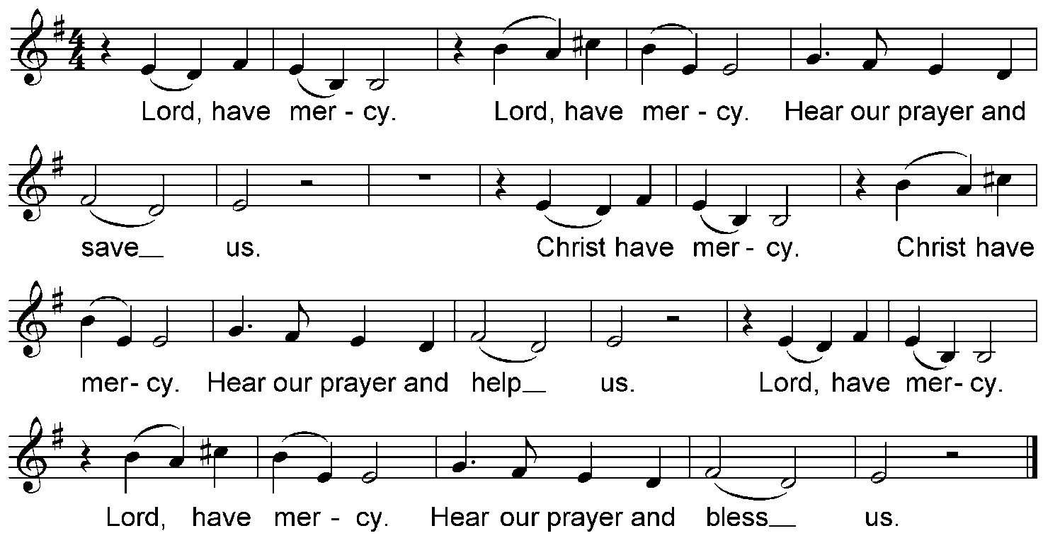

Glory to God (Gloria)
Simon Schmidt
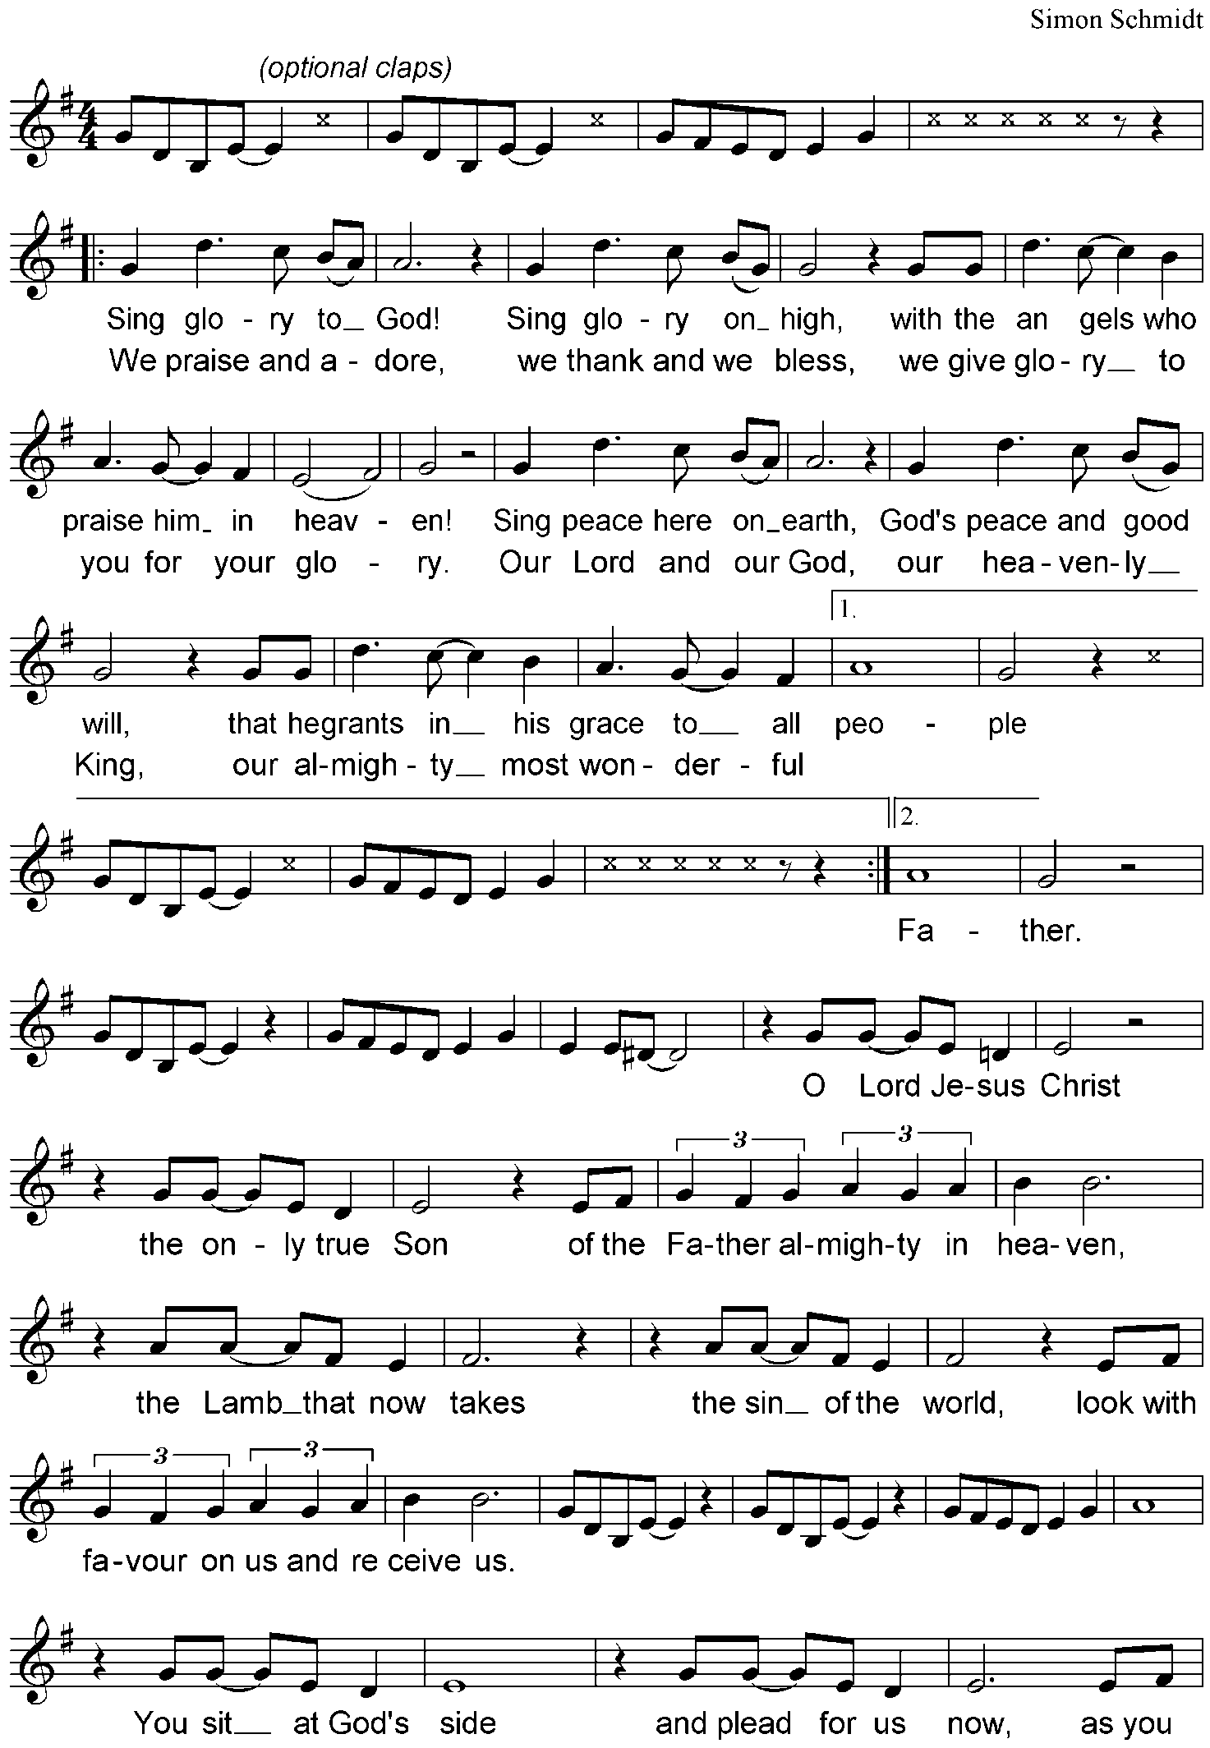

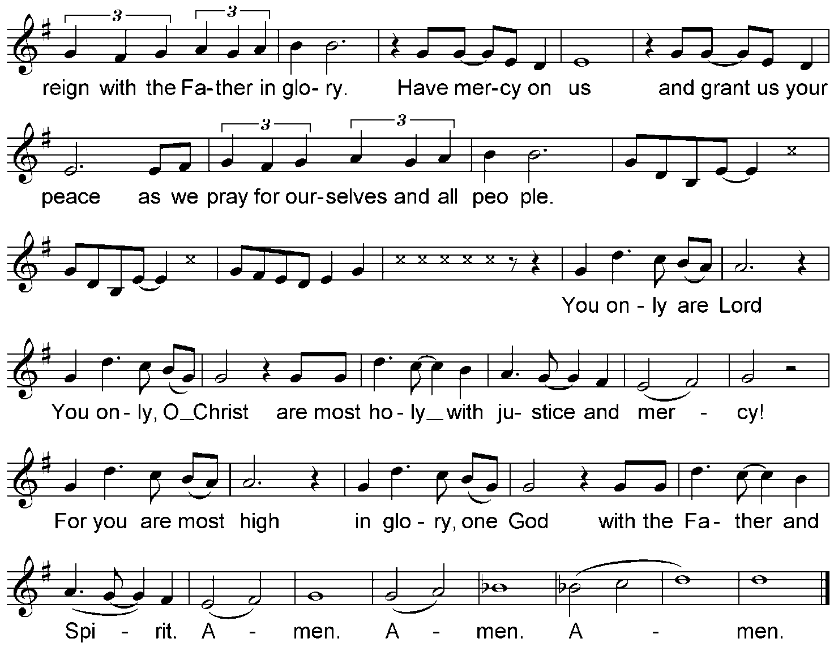

Holy, Holy, Holy (Sanctus)
Simon Schmidt
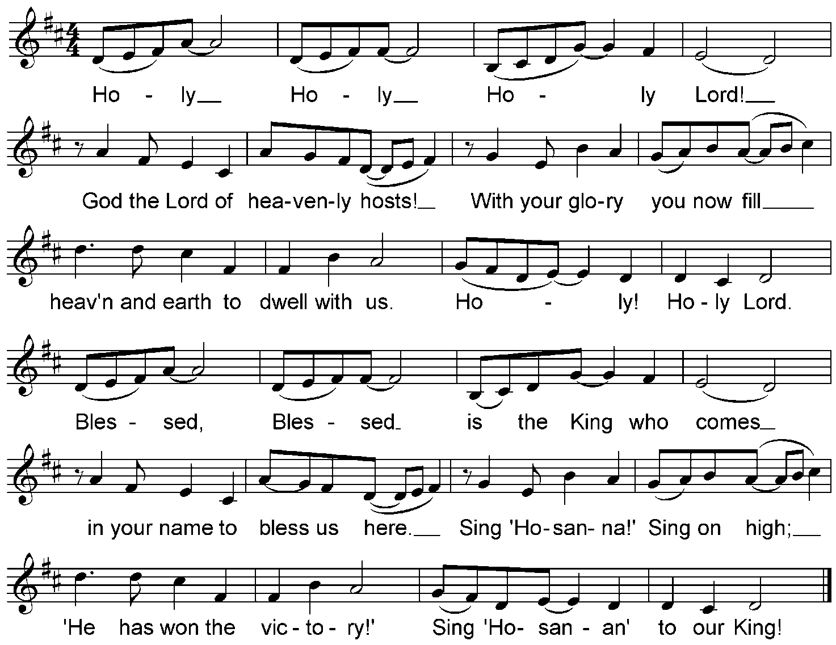

Lamb of God (Agnus Dei)
Simon Schmidt
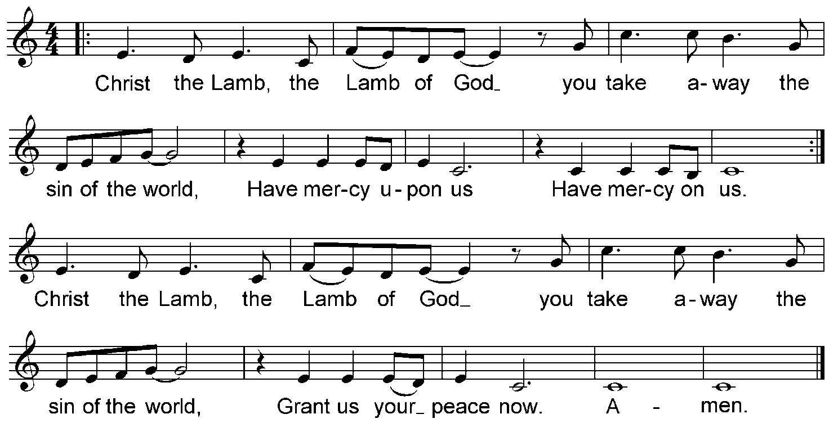

Song of Simeon (Nunc Dimittis)
Simon Schmidt

